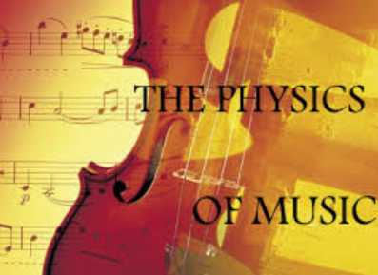

Sound
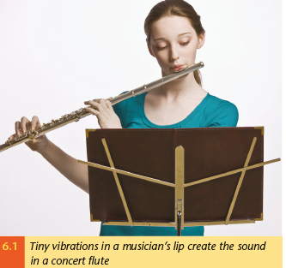
Sound is a form of energy. It is closely associated in particular with kinetic energy, as all sounds are created by moving objects. Sometimes this movement is very obvious: clap your hands beside your ear and you will always hear a sound, and the harder you clap, the louder the sound will be. Sometimes the motion is more subtle: the vibrations of most speakers can be very small, but if you remove the protective covers and watch carefully they are usually visible on larger, bass speakers (often called woofers). Sometimes the motion can be so small it is almost impossible to see directly: a concert flute works when the tiny vibrations in the players upper lips are transmitted through the air inside. But whether the movement is obvious or not, it is always present
In each of these instruments, note down where the vibration is created:
 | lips | Reed | string | vocal chord | speakers
Trumpet
Saxophone
Guitar
Piano
human voice
concert flute
Electric keyboard
Trombone
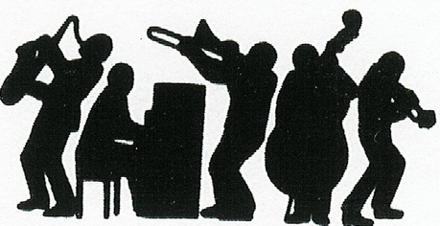
Wave Behaviour
Pay attention to the presentation. The information you need is there, and not in this booklet.
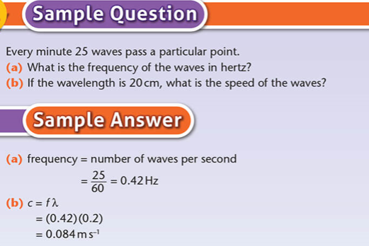
Attempt these questions
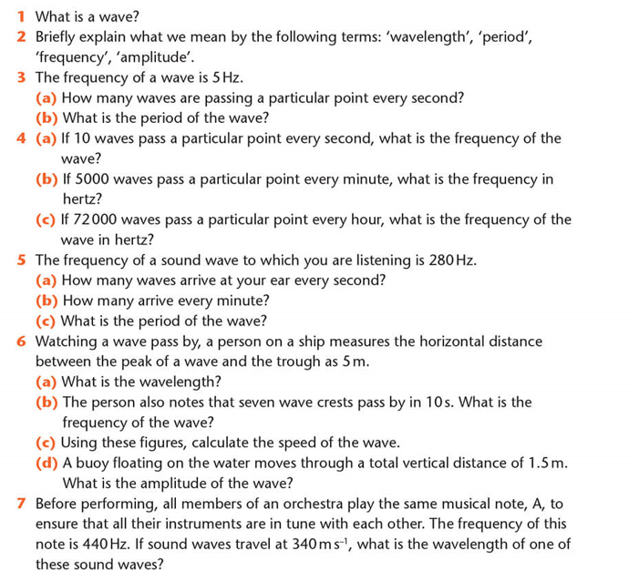
Answers:

Wave characteristics of sound
Reflection and Refraction
Sound waves are reflected, as we find when we hear an echo. They are also refracted. Sound travels more slowly in cold air. On a cold night there is cold air near the cooling surface of the earth. A rising sound wave is refracted downward as it hits the warmer air above, allowing us to hear better by night than during the day.

Diffraction describes how waves spread out after passing an obstacle.
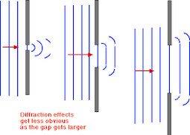
Sound travels easily around corners and through doorways and windows. This is partially due to reflection of course, but also to diffraction. Sound waves are relatively long - typically measuring close to a metre. This compare with light-waves of a few millionths of a metre in length. Long waves diffract much more than short waves. This is why it easy to hear around a corner, when it impossible to see around it.

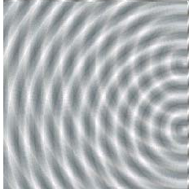

Interference
When waves meet, they will combine with each other to create what we call an interference pattern. This pattern can take on many different forms. On water, the choppy surface of the sea is a very complex interference pattern, created by the many hundreds of different waves that are travelling across the surface of the sea. Sometimes we get poor reception on a radio or TV, or on a mobile phone. This is also caused by interference.

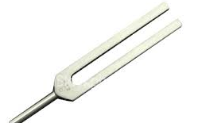
To show that sound is a wave motion

Take a tuning fork and strike it so that it vibrates, giving out a clear steady sound.
Hold it to your ear and rotate it as shown in the diagram.
You should hear the sound repeatedly grow and fall in volume.

The only explanation for this effect is that it is an interference pattern, created by the two coherent waves spreading out from each prong of the tuning fork.

As only waves demonstrate diffraction and interference, this shows that sound is a wave
Concert Hall Acoustics

The existence of echoes within enclosed spaces, as well as the tendency of waves to create either constructive or destructive interference when they meet causes a great deal of difficulty in music venues.
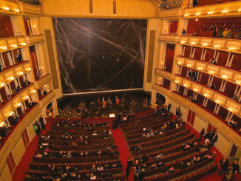
to further complicate matter, each venue will have different acoustics: Sound waves will reflect off hard surfaces throughout the venue and they will tend to be absorbed by softer materials such as curtains. As the sound-waves will be reflected off a number of different surfaces this means that in some places in the venue the sound will be louder due to constructive interference and in other places quieter due to destructive interference. This effect will be further complicated by the fact that some frequencies will tend to travel and reflect more than others, so that in some places bass sounds might be too loud and in other places, the higher pitched notes could predominate. There is no easy way to deal with this. Sound engineers do their best to create a good sound in each venue by carefully choosing the placement and alignment of the speakers and by varying the loudness of each set of frequencies for each of the musicians involved. Also, of course, the presence of many people in a room will affect the acoustics, so that they have to monitor the sound throughout the performance.
In purpose built concert halls, a lot of these problems are dealt with in the design stage. One typical feature is that there should be soft fabrics on the rear of each seat, so that the sound will reflect off it in a similar way whether or not there is somebody sitting in it. Even with such careful planning, it is only when a hall is complete that the engineers will know how well their design has worked.

Characteristics of a musical note

The main characteristics of a musical note, and their corresponding wave characteristics are:

Pitch which corresponds to frequency
Loudness which corresponds to amplitude
Quality which corresponds to the presence of harmonics

Pitch

A high pitched musical note, often described by musical terms such as treble or soprano, is therefore one created by a high frequency wave. A low pitched, or bass, note is one created by a low frequency wave.
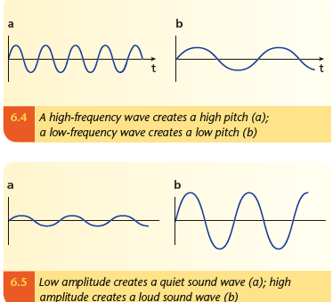

Loudness
To an extent, the loudness of a sound corresponds in a simple way to the amplitude of the wave producing it. Basically, bigger waves are louder. What we usually refer to as the volume of a wave, however, is actually a very difficult thing to measure in a meaningful way. We hear some frequencies better than others, for example, and it also requires an enormous increase in the amount of energy in a wave to create an audible difference.

Quality
Even a person without musical training will be able to tell the difference between, say, the musical note A (440Hz) played on a piano and a guitar. Yet if both notes are of the same frequency and loudness, what is the actual difference in the sound waves that we hear so clearly? The answer lies in the fact that we rarely hear a single frequency note. Most instruments create a mix of frequencies alongside the note being played. These are called harmonics.

Questions
- What do we normally call the reflection of a sound wave?
........................................................

- Why is that we can hear around corners when we cannot see around the same corners?
………………………………………………………………………………………………………………………………………………………………………………………………………………………………………………………………………………………………………………………………………………………………………………………………………………………………………

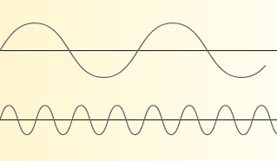
- The diagrams below represent two musical notes travelling through air. Indicate in the gap which would have the higher pitch, and which one would be louder?

This wave would be……………………..

This wave would be ……………………..

- Describe at least one problem that has to be dealt with in the design of concert halls ……………………………………………………………………………………………………………………………………………………………………………………………………………………………………………………………………………………………………………………………………………………………………………………………………………………………………………………………………………………………………………………………………………………………………………………

- Briefly describe how we can use tuning forks to show that sound creates interference patterns
…………………………………………………………………………………………
………………………………………………………………………………………..
………………………………………………………………………………………..
…………………………………………………………………………………………
……………………………………………………………………………………….. ……………………………………………………………………………………….
……………………………………………………………………………………….
Natural Frequency and Resonance

Strike a piano key and you will hear a particular musical note or frequency. Strike a different key and a different frequency is produced. Tap on the skin of a drum and again a particular frequency is created. Larger drum-skins will generally create lower frequencies and smaller skins will tend to produce higher frequencies. You can pluck a guitar string, blow into a saxophone or trumpet. In each case you hear a distinctive frequency. The same is true even with objects not designed as musical instruments: tap on the surface of your desk, or on a window sill or on a door. In each case you will hear a particular sound. What you are hearing in each case is the natural frequency of vibration of the object in question. Remember that the frequency, or frequencies, at which an object will vibrate when disturbed is known as the natural frequency of the body.

The Natural Frequency of a body is the lowest frequency standing wave that can be created within that body
To investigate natural frequencies
If you cup your hands together over one ear and listen carefully, you will tend to hear a gentle hissing sound. This is the sound you also hear when you hold a shell to your ear – children are sometimes told that it is the sound of the sea. The air moving about inside your hands is setting up a standing wave in a manner quite similar to how the air inside the wooden box of an acoustic guitar sets up a standing wave. If you change the shape you have created with your hands you will notice that the sound either rises or falls in pitch. This is because the shape created by your hands has changed, and this new shape has a new natural frequency.
The fundamental / first harmonic f_{o}

Factors controlling the Natural Frequency
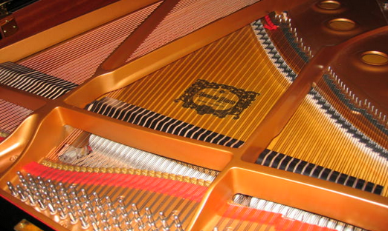
Of course not all string stretched between two points will produce the same frequencies. If we tighten the string the natural frequency increases, if we loosen it, the natural frequency is reduced. Similarly, long strings tend to create low frequencies and shorter string will produce higher frequencies. The other main factor is the linear density of the string, or its mass per unit length.

The frequency of a stretched string follows this formula:
$$f= \frac{1}{2l}\sqrt{\frac{T}{μ}}$$

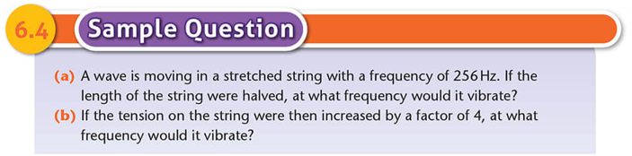

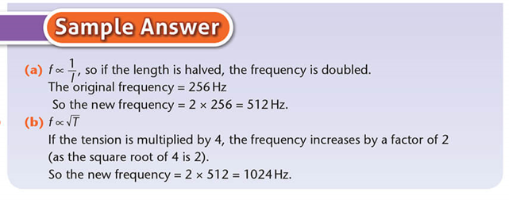

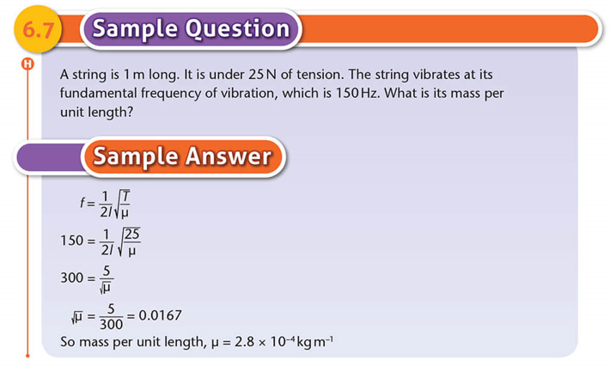
Questions
- What are the factors that control the natural frequency of vibration of a stretched string?
- …………………………………….
- ……………………………………
- ……………………………………
- What formula links together those factors?

- If the tension of a stretched string is doubled, will its frequency of vibration increase or decrease?
It will ………………………………………..

- A string is 80cm long. It has a mass per unit length of 0.005kgm⁻¹. It is placed under a tension of 25N. At what frequency will it vibrate?

- If the length of the string was doubled, at what frequency would it vibrate?
……………………………………….

- A string is 50cm long. It is under 15N of tension. The string vibrates at its fundamental frequency of vibration, which is 120Hz. What is its mass per unit length? What is its mass?

The Piano
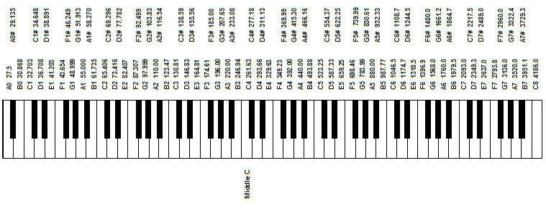The frequencies of all the keys on a standard piano keyboard are shown here. Making use of harmonics, a number of keys can be struck together in ways that we almost all find pleasing to the ear. These are known as chords. If you examine it, you will see that there is some very clear maths underlying the sounds.

Questions
1 Write down the frequencies of C3……………, C4……………., and C5…………………
2 To the nearest whole number, calculate the values of
What do you notice?............................................................................................................
3 Try the following:
4 The chord of C Major includes the notes C and E played together:
To 2 decimal places, calculate the values of

Compare it to the chord of G major, which includes G and B played together:
To 2 decimal places, calculate the values of

What do you notice about each chord?...................................................................................

5 Can you predict a note that would go with F, to the chord make F major?..............................
Explain your answer
……………………………………………………………………………………………………………………………………………………………………………………………………
This Booklet uses some material from Physics Plus,
© Edco, Tom Tierney

