The Physics of Time Travel
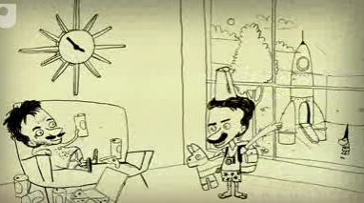

Name:

Before we start, 3 questions…..
- Do you believe that time travel is ever going to be possible?
(don’t look it up. Just give your first impression, and tick a box)
Yes | no

- If time travel was possible, would you travel…..

…into the future
…into the past
...and what year would you choose to travel to….
Year:

- Imagine the world of 2070.
Do you think that the world then will be better than it is now, or worse?

better | worse

Predicting the Future:
You will watch a few clips from Back to the Future too, which predicted what the world would look like today. Comment on one thing they got right. And one thing they got wrong….
Right…..

Wrong….

Have a go yourself:
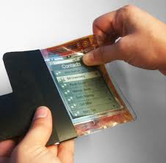
List (and explain) a few features you think will be common on mobile phones in 30 years time….
1

2

3

4

5

6

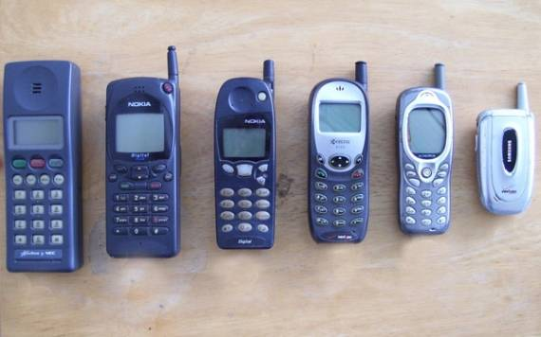
Future Shopping
Let’s assume (for the moment) that clothes shops will still exist in 30 years time. Describe what it might be like to visit a shop, try on some clothes and make a purchase, or at least make an order for delivery…

Describe…

Explain one new technology that might be used to sell you clothes, and how it might be used.…

Do you think such shops will exist. Explain why, or why not….

What are the advantages of online shopping…..

What are the disadvantages of online shopping

List a few technological items that are common today but that you think will die out in your lifetime…

List a few technological items you think will be common when you are an old man…

What effects do you think climate change will have on our attitude to technology?

Time Dilation:
Time Dilation is a part of Einstein’s Theory of Special Relativity. In it, he showed that the passage of time varies depending on how fast you travel. It tells us, for example, that if two twins are 16 years old and one of them travels at ultra-high speeds for even a few hours in space and then returns to earth, they will still be 16 years of age. But they could find that their twin, who remained on earth, is now several years – or even decades – older than them.
This effect is real, and it has been proven true many times. But the effect is only noticeable at extremely high speeds.
Pay attention to the PowerPoint presentation on Einstein’s theory of relativity. In it we see Einstein’s equation, explaining how time travel is possible (in a way) if we travel at very high speeds:
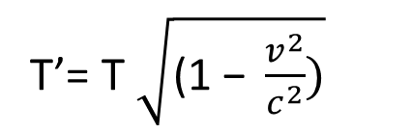
speed of light
(300,000,000 m/s)
speed of travel
Time for a clock moving at speed ‘v’

Time for a clock not moving
Complete the following calculations.
If 1 year passes on earth for a ‘stationary’ clock, how long passes for a clock in a spacecraft flying at 30 m/s?

$$T^{'}=(1)\sqrt{1-\frac{{( )}^{2}}{{(300,000,000)}^{2}}}$$

$$T^{'}=\left( \right) years$$

Is this difference significant?

If 1 year passes on earth for a ‘stationary’ clock, how long passes for a clock in a spacecraft flying at 30000 m/s?

$$T^{'}=(1)\sqrt{1-\frac{{( )}^{2}}{{(300,000,000)}^{2}}}$$

$$T^{'}=\left( \right) years$$

Is this difference significant?

If 1 year passes on earth for a ‘stationary’ clock, how long passes for a clock in a spacecraft flying at 280,000,000 m/s?

$$T^{'}=(1)\sqrt{1-\frac{{( )}^{2}}{{(300,000,000)}^{2}}}$$

$$T^{'}=\left( \right) years$$

Is this difference significant?
Roughly how many months would have passed for people travelling on that spacecraft?

From watching the PowerPoint or from your own study, answer these questions…
Explain briefly what is meant by the phrase: ‘Time Dilation’ ………………………………………………………………………………………………………………………………………………………………………………………………………………………………………………………………………………………………………………………………………………………………………………………………………………………………………………………………………………………………………………………………………………………………………………………………………………………………………………………………………………………………………………………………………………………………………………………………………………………………………………………………………………………………………………………………………………………………………………………………………………………………………………………………………………………………………………………………………………………………………………………………………………………………………………………………………………………………………………………………………………………………………………………………………………………………

Imagine you are offered an opportunity to travel on a space ship leaving tomorrow. It will travel at extremely high speed and you will see some of the solar system as you travel. The journey will take a few hours for you to complete, but when you return, 60 years will have passed here on earth.
You are getting to see into the future. But is a one-way journey.
 | yes | no
Would you definitely go
Would you be tempted to go?

Explain why, or why not
……………………………………………………………………………………………………………………………………………………………………………………………………………………………………………………………………………………………………………………………………………………………………………………………………………………………………………………………………………………………………………………………………………………………………………………………………………………………………………………………………………………………………………………………………………………………………………………………………………………………………………………………………………………………………………………………………………………………………………..………………………………………………………………………………………………………………………………………………………………………………………………………………………………………………………………………………………………………………………………………………………………………………………………………………………………………………………………………………………………………………………………………………………………………………………………………………………………………………………………………………………………………………………………………………………………………………………………………………………………………………………………………………………………………………………………………………………………………………………………………………………………………………………………………………………………………………………………………………………………………………………………………………………………………………………………………………………………………………………………………..………………………………………………………………………………………………………………………………………………………………………………………………………………………………………………………………………………………………………………………………………………………………………………………………………………………………………………………
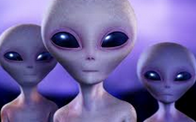
Could Time Dilation help us to travel in space?
Do you believe that there is life elsewhere in the universe?
Explain why, or why not. …………………………………………………………………………………………………………………………………………………………………………………………………………………………………………………………………………………………………………………………………………………………………………………………………………………………………………………………………………………………………………………………………………………………………………………………………………………………………………………………………………………………………………………………………………………………………………………………………………………
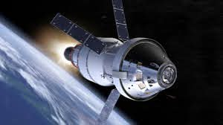
The nearest stars to the earth are Alpha Centauri. They are 4 light years away.
1 light year is about 9, 500, 000, 000, 000 km
The planned Orion Nasa spacecraft might carry humans through space at speeds of 32,000 km/hr
How far away is Alpha Centauri, in Kilometres?
Travelling on the Orion spacecraft, how long would it take human to reach Alpha Centauri in hours?
How many years is that?

Any planets likely to support life are even further away than Alpha Centauri. Do you think we will ever visit them? Explain your answer.
………………………………………………………………………………………………………………………………………………………………………………………………………………………………………………………………………………………………………………………………………………………………………………………………………………………………………………………………………………………
Research and explain how time dilation could (possibly) make such a journey more manageable
…………………………………………………………………………………………………………………………………………………………………………………………………………………………………………………………………………………………………………………………………………………………………………………………………………………………………………………………………………………………………………………………………………………………………………………………………………………………………………………………………………………………………………………………………………………………………………………………………………………

