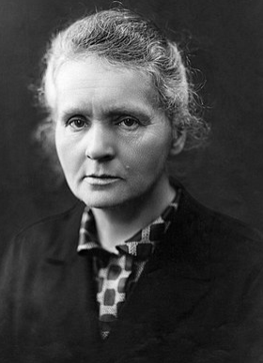
Marie Skłodowska Curie was the first woman to win a Nobel Prize, the first person to win a Nobel Prize twice, and the only person to win a Nobel Prize in two scientific fields.
She was born in Warsaw. In 1891, aged 24, she followed her elder sister Bronisława to study in Paris, where she earned her higher degrees and conducted her subsequent scientific work. She shared the 1903 Nobel Prize in Physics with her husband Pierre and with the physicist Henri Becquerel for their pioneering work developing the theory of "radioactivity"—a term she coined.
Marie also won the 1911 Nobel Prize in Chemistry for her discovery of the elements polonium and radium, using techniques she invented for isolating radioactive isotopes. Under her direction, the world's first studies were conducted into the treatment of cancer by the use of radioactive isotopes. During World War I she developed mobile radiography units to provide X-ray services to field hospitals.
Marie Curie died in 1934, aged 66, from a type of cancer that may have been caused by exposure to radiation in the course of her scientific research and in the course of her radiological work at field hospitals during World War I.
- What is radioactivity?
- What is meant by the term ‘isotopes’?
- Polonium-210 has a half-life of 138 days. What is its decay constant?
- Polonium decays to lead-206 by emitting an alpha particle, Write an equation to represent this decay.
- Cobalt-60 was used in early cancer treatment. It undergoes beta-decay. Write an equation to represent this decay.
- If Co-60 has a half life of 5.27 years. What activity would you expect in a sample that contained $2×{10}^{10}$ atoms?
- Which is the most penetrating – alpha-particles, beta-particle or gamma rays?
- Which is the most ionising – alpha-particles, beta-particle or gamma rays?
- Define the Becquerel.
- An earlier, non-SI unit for radioactivity as the Curie, which as equivalent to 30 GBq. At that level activity, how many decays are occurring every second?

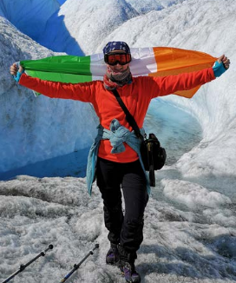
Emily Gleeson
Meteorologist
(with material taken from the IoP booklet, Limit Less)
When I started working as a meteorologist with Met Éireann, I went to UCD to study for a Masters Degree in Meteorology and more recently, I completed a diploma in Statistics in TCD and am on my second course of professional Irish. My hobbies include travel, especially to the Arctic, theatre, escape rooming, learning the drums in the National Concert Hall and hiking around Ireland.
Can you tell us what first got you interested in physics? Learning science in secondary school! I always liked maths and then got into science and physics. The school I went to had great labs and all the equipment. My teachers definitely inspired me to study science.
How did you get into your current job? Another student told me about jobs in Met Éireann. I love extreme weather, so I applied. And here I am!
Do you still use the physics you learned in secondary school? Of course! Physics is problem solving, so the methods can be applied to any scientific or technical task. I now lead a team in Europe who develop the physics of the weather model that we use for operational weather forecasting. I specialise in solar radiation, radiation-aerosol interactions and surface physiography – so both surface and upper-air physics. My job requires lots of different skills. Problem solving, definitely, but also communication, adaptability, teamwork and patience.
How did you get into your current job? Another Ph.D. student told me about jobs in Met Éireann and I love extreme weather, so I applied. And here I am!
What do you like best about your role? I love my job because it’s also my hobby. Every day is different and there are so many different aspects to the job. And so many opportunities within the organisation! I work with so many fantastic people in Ireland and all over Europe.
Do you have any advice for someone who’s considering studying physics? To steal a line from Dr Seuss, you can steer yourself in any direction you choose! I’ve gone from submillimetre astronomy, to engineering in Intel, to weather forecasting, to climate change modelling, to short range numerical weather prediction model development. There are so many different paths.
- Understanding the sun is key to understanding our weather. What is the solar constant?
- What is meant by the term, U-Value?
- If an external wall has a surface area of 15 m², and a U Value of a wall is 0.3 Wm⁻² K⁻¹, how much energy will escape through that wall in an hour when it is 10ºC outside and 18ºC inside
- Explain how perspiration helps to keep us cool on hot days. In humid weather, why do we feel hotter?
- What is specific latent heat?
- What is the relation relationship between pressure and depth inside a fluid
- What difference in atmospheric pressure would you expect between the top of a hill of height 120 m and the bottom?
- How much heat energy is required to heat up the air in a room of volume 90 m³ from 10ºC to 18ºC?
density of air = 1.225 kgm⁻³, specific heat capacity of air = 1.2 kJ kg⁻¹ K
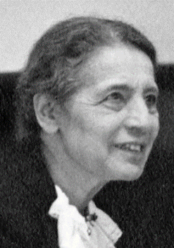
Lise Meitner (1878 – 1968)
Born in Austria, Meitner spent most of her scientific career in Berlin, Germany, where she was the first woman to be a physics professor and a department head at the Kaiser Wilhelm Institute. She lost these positions in the 1930s because of the anti-Jewish Nuremberg Laws of Nazi Germany, and in 1938 she fled to Sweden, where she lived for many years, ultimately becoming a Swedish citizen.
In mid-1938, Meitner with chemists Otto Hahn and Fritz Strassmann found that bombarding thorium with neutrons produced different isotopes. Hahn and Strassmann later in the year showed that isotopes of barium could be formed by bombardment of uranium with neutrons. In late December, Meitner and her nephew, Otto Frisch worked out the phenomenon of such a splitting process. In their report in February issue of Nature in 1939, they gave it the name "fission". This principle led to the development of the first atomic bomb during World War II, and subsequently other nuclear weapons and nuclear reactors.
Meitner did not share the 1944 Nobel Prize in Chemistry for nuclear fission, which was awarded exclusively to her long-time collaborator Otto Hahn. Several scientists and journalists have called her exclusion "unjust". According to the Nobel Prize archive, she was nominated 19 times for the Nobel Prize in Chemistry between 1924 and 1948, and 29 times for the Nobel Prize in Physics between 1937 and 1965. Despite not having been awarded the Nobel Prize, She received many other honours, including the naming of chemical element 109 meitnerium after her in 1997.
- What is an isotope?
- What is nuclear fission?
- What is meant by the term, ‘critical mass’?
- What is meant the term, ‘chain reaction’?
- U-235 is an isotope of Uranium and will undergo fission when struck by a neutron. If it produces Barium-141 and releases 3 neutrons, what else must be produced?
- Write an equation to represent that reaction
- If 200 MeV of energy is converted from mass in a fission reaction, what mass has been lost?
- In a nuclear reactor, what is the purpose of (i) the control rods, (ii) the moderators
- if a target of bismuth(Bi)-209 is bombarded with accelerated nuclei of iron(Fe)-58, meitnerium-266 can be formed. Write an equation to represent that reaction
- The most stable known isotope Meitnerium has a half life of 4.5 seconds. How long would it take for 75% of a sample to decay?
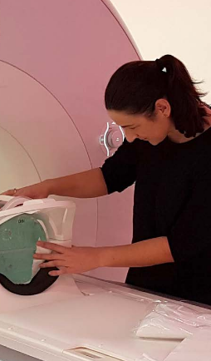
Deirdre King
Medical Physicist
(with material taken from the IoP booklet, Limit Less)
Hi, Deirdre! How did you first get into physics? By accident! I was doing music for my Leaving Cert and realised it wasn’t for me. I actually wanted to do chemistry instead, but the class was full, so the only option was to do physics. From the first class, I knew it was the right fit for me. When I was very young, I was always taking things apart, playing with them and putting them back together. I was fascinated by how things work. I discovered that physics is essentially the study of how everything in the universe works.
Who inspired you when you were a teenager? As a teenager who was into sport, Sonia O’Sullivan was someone who greatly inspired me. It wasn’t just her winning medals; it was her personality. Her passion and determination were clear from the interviews we would watch on TV. She inspired me to do something that sparked an interest, something I enjoyed, then to work hard to be the best I could be. Having a strong female role model like Sonia helped me follow my interests even when they led down different paths to the typical ones girls my age took.
Did you face any challenges in taking that different path? In college I chose to do physics and biology in my undergraduate science degree – and I was the only one in my year to do so! Everyone told me to take maths or chemistry but that wasn’t where my interest lay. Then in fourth year of college, I discovered Medical Physics and my unusual subject choice was the perfect combination for this.
How did you get into your current job? In the fourth year of my undergraduate degree, I read an article in Physics World about the field of medical physics. I knew absolutely nothing about how to become a medical physicist, so I volunteered in a Dublin hospital to gain experience. As soon as I started, I knew this was the area I wanted to work in. There are a number of sub-specialities within medical physics. I found diagnostic imaging and nuclear medicine really interesting. I’ve trained and worked in the USA, the UK and here in Ireland.
What’s your favourite part of your job? The work is very diverse and every day there’s a new problem to solve or project to develop – all with the aim of improving our patient care. I could start my day meeting with doctors to introduce new technologies and end it reviewing building designs with architects to make sure radiation protection measures are in place.
- X-ray is the most widely used device in diagnostic imaging. What are X-rays?
- Nuclear medicine makes use of radioactivity. What is radioactivity
- What is meant by the half-life of a radioactive isotope?
- In designing radiation protection, the penetrating power of radioactivity must be understood. Which the most penetrating: alpha particles, beta particles or gamma rays?
- How far does an alpha particle typically travel through air before losing its energy
- PET scanners use positrons. What are positrons?
- Ultra sound machines use high frequency sound waves to create images. What is generally taken as highest frequency that humans can hear?

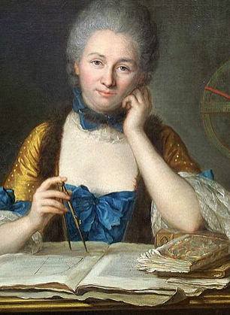
Emile de Chatelet
Gabrielle Émilie Le Tonnelier de Breteuil, Marquise du Châtelet was a French scientist and mathematician from the early 1730s until her death due to complications during childbirth in 1749.
Her most recognized achievement is her translation of Isaac Newton's work, which introduced the new scientific ideas and methods to France and went beyond that to the suggest the idea of the conservation for total energy, Particular, she studied kinetic energy and derived the formula $E=1/2mv^{2}$. Her own book The Foundations of Physics which circulated widely, generated heated debates, and was republished and translated into several other languages within two years of its original publication.
She participated in the famous vis viva debate, concerning the best way to measure the force of a body and the best means of thinking about conservation principles. Posthumously, her ideas were heavily represented in the most famous text of the French Enlightenment, the Encyclopédie of Denis Diderot and Jean le Rond d'Alembert, first published shortly after du Châtelet's death.
She had a long relationship with the philosopher, Voltaire and it is likely that some of his published work on Optics, was largely based on hers.
In 1737 du Châtelet published a paper on her research into the science of fire. In it she speculated that there may be colours in other suns that are not found in the spectrum of sunlight on Earth.

- State the principle of conservation of energy.
- Distinguish between kinetic energy and gravitational potential energy.
- Object A is dropped from height h. Object B is dropped from a height 2h. What is the ratio of the speed of the two objects when they strike the ground?
- State Newton’s Laws of Motion
- Do stars emit wavelengths other than those of visible light?
- Is a red flame likely to be hotter or colder than a blue flame?
- What colour is created by the mixing of red and green beams of light?
- If an object of mass 2 kg has a velocity of 5 ms-1, what is its kinetic energy?
- If an object is dropped from a height of 3m, with what speed will it hit the ground?

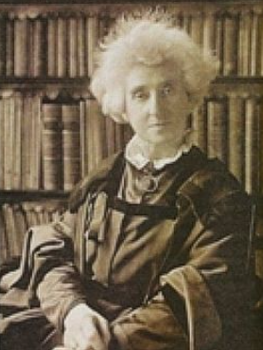
Margaret Lindsay Huggins (1848 – 1915), was an Irish-English scientific investigator and astronomer. She co-wrote the Atlas of Representative Stellar Spectra with her husband, William. Their partnership was described as being "one of the most successful husband and wife partnerships in the whole of astronomy"
Margaret Huggins learnt the basic skills of photography early on in her life, and used these skills to assist her research at the Tulse Hill observatory in London. Their early experiments photographed Sirius and Venus, and they quickly rose to the forefront of spectroscopic astrophotography. They became the first to observe and to identify the series of hydrogen lines in the spectrum of the star Vega and their publication in 1889, discussed the studies of the spectra of planets.
They were also among those who observed the Nova of 1892, Nova Aurigae.
During the 1880s, the pair were devoted to two projects; the first attempting to photograph the solar corona, and the second examining different Nebulae. The second project marked a milestone for Margaret, it was the first time she would be mentioned as the co-author of the paper alongside William. The Huggins' worked together for thirty-five years as equal collaborative investigative partners.
In their later years, they examined the spectra of newly discovered radioactive substances.
Margaret Huggins died on 24 March 1915, at the age of 66. There is a plaque marking the house where she grew up in on 23 Longford Terrace, Monkstown Dublin.
- Outline the process by which atomic spectra are formed
- What is radioactivity?
- Sirius is the brightest star in the night sky. It is 8.6 light years from earth. How far is that in kilometres?
- A nova consists of the rapid creation of helium atoms from hydrogen, through nuclear fusion. What is nuclear fusion?
- Write an equation to represent the creation of Helium-3 from two Hydrogen-2 atoms
- Early photography relied on the creation of real images on a photographic plate. What is a real image?
- Draw a ray diagram to show how an image is formed for a distant object, using a converging lens.
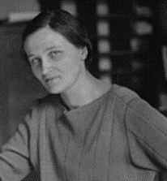
Cecelia Payne (1900 – 1979)
Cecelia Payne was a British-born American astronomer who proposed in her 1925 doctoral thesis that stars were composed primarily of hydrogen and helium. Her ground-breaking conclusion was initially rejected because it contradicted the scientific wisdom of the time, which held that there were no significant differences between the composition of the Sun and the Earth. Independent observations eventually proved she was correct.
She did this work in becoming the first person to earn a PhD in astronomy from Radcliffe College of Harvard University. her work found that silicon, carbon, and other common metals seen in the Sun's spectrum were present in about the same relative amounts as on Earth, in agreement with the accepted belief of the time. However, she found that helium and particularly hydrogen were vastly more abundant and concluded that hydrogen was the overwhelming constituent of stars, and the most abundant element in the Universe.^{[14]}
Initially Payne’s supervisor, Henry Russel, convinced her she was mistaken. A few years later, another astronomer Otto Struve described her work as "the most brilliant PhD thesis ever written in astronomy", and Russell also came to see she was correct. In 1929, he published his findings in a paper that only briefly acknowledged Payne's earlier work and discovery.

- What is Nuclear Fusion?
- Deuterium is an isotope of hydrogen. What is an isotope?
- Write a reaction which shows the creation of He-3 from two atoms of Deuterium.
- What is meant by the term atomic spectra?
- Briefly outline how the spectrum of an element formed
- The sun releases about 3.8 x 10²⁶ joules of energy each second. By how much is its mass reduced each second?
- Will the sun ever run out of Hydrogen?
- What benefits would nuclear fusion have an energy source on earth compared to either fossil fuels or nuclear fission?
- What are the difficulties in using nuclear fusion as an energy source on earth?

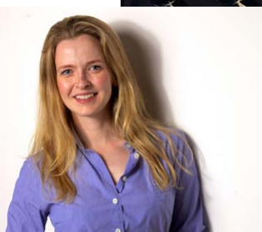
Kristina Bordas
AI Product Manager
(with material taken from the IoP booklet, Limit Less)

What first got you excited about physics? I loved things like telescopes and magnets as a child. And being able to discover lessons for yourself through experimentation made physics a clear favourite of mine throughout school too.
What is your favourite physics memory? I remember viewing nano structures on an electron microscope at university. I processed the images from these tiny, and normally invisible-to-the-eye structures – seeing them blew my mind!
Who inspired you when you were a teenager? As well as my grandparents, my physics teacher was really inspirational. The effort and lengths they went to include extra demonstrations was incredibly admirable and opened my eyes to the world beyond the curriculum.
How did you get into your current job? I now work in artificial intelligence, which requires similar problem-solving skills and the ability to think about the world in an alternative way. The computer modelling systems we’re building will completely change the way we work in the future, which is really exciting.
Have you overcome any challenges in your physics study or career? Early in my career it certainly felt that there were opportunities open to male graduates that I was actively discouraged from applying for. Finance was a very male dominated place at the time and I was aware going into the field that I might be expected to prove myself more than my male peers.
Do you use the physics you learned in school in your current role?
I think school physics encourages you to start exploring around a base topic and gather proof for yourself with experiments or further research. I use these skills a lot now when creating prototypes of AI products. I have to judge the success or failure of an idea purely on data.
- How many nano-metres in a metre?
- If an atomic nucleus has a radius of $1×{10}^{-15}$ m, how many nuclei could be lined up to form a length of 1 nm?
- An astronomical telescope uses two converging lenses to form an image. Draw a ray diagram to show how an image is formed with a converging lens for a very distant object.
- Magnetic flux density is measured in Tesla. Define the Tesla.
- Electron microscopes make use of the wave nature of electrons – which exhibit wave-particle duality, just like visible light. What is wave-particle duality
- What is meant by the term intrinsic conduction, when discussing semi-conductors
- Computers make extensive use of diodes. Draw a diagram to show the structure of a diode.

Hedy Lamarr (1914 – 2000)

Better known as a star of the silver screen in the 1930s and 40s, actress Hedy Lamarr was also an inventor. In fact, if it wasn’t for Hedy, we likely wouldn’t have WiFi today. Although she was primarily self-taught, she tinkered in her spare time on various hobbies and ideas, which included a traffic stoplight and a tablet that would dissolve in water to create a carbonated drink.

During World War II, Lamarr read that radio-controlled torpedoes had been proposed. However, an enemy might be able to jam such a torpedo's guidance system and set it off course. Working with a musician friend, George Anthiel, she realised that a frequency-hopping signal might prevent the torpedo's radio guidance system from being tracked or jammed, and the pair succeeded in synchronizing a player piano mechanism with radio signals. Antheil sketched out the idea for the frequency-hopping system, which was to use a perforated paper tape which actuated pneumatic controls (as was already used in player pianos) (and which were later used for programming early computers)
Although the U.S. Navy did not adopt the technology until the 1960s, the principles of their work are incorporated into Bluetooth and GPS technology and are similar to methods used in legacy versions of CDMA and Wi-Fi. This work led to their induction into the National Inventors Hall of Fame in 2014.

- WW2 torpedos could travel at about 25 ms^{-1,} and were used against targets up to 10 km away. How long would it take such a torpedo to travel 10 km?
- If the path of the torpedo was changed by just 2 degrees, by how much would it miss a target 10km away?
- Bluetooth operates at about 2.4 GHz. How long would the associated waves be?
- Most early telephone-line modems used audio frequency-shifting to send and receive data at rates up to about 1200 bps (bits per second, where 1 bit is one piece of information). A modern fibre system often sends and receives at 100 Mbps. How much more information is carried every second at this higher rate?
- At 100 Mbps, how much information (bits) can be carried in one hour
- Traffic lights often make use of two of the primary colours. What are they? And what colour do the form when they combine?
- If in carbonated (fizzy) water, the volume of a bubble is increased by a factor of 2 when it rises to the top, what is the change in its pressure?

