Leaving Cert Physics Higher Level 2021
Section A
Section A Q1
(i) Draw a labelled diagram of how the apparatus was arranged in this experiment.
(ii) Indicate on the diagram
(a) the fixed point of suspension,
(b) the distance l

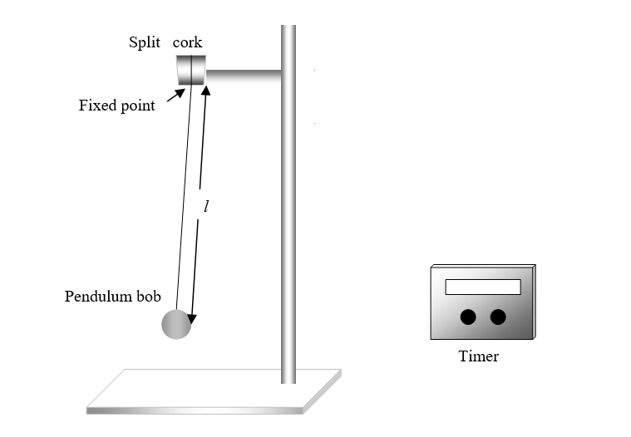

(ii) Why did the student measure the 20 oscillations rather than the time for one oscillation?
This helps to reduce percentage error.
If the timing is inaccurate due to human error and is out by, say, 0.5 s for a measurement that should be 1 s, that represents a 50% error.
If, on the other hand, the time for 20 oscillations should be 20 s and is out by 0.5 s, that represents an error of 2.5%, which is clearly better.

(iii) Use the data to draw a suitable graph to calculate the acceleration due to gravity, g.

adapted results
l / mm | 300 | 400 | 500 | 600 | 700 | 800
t / s | 22 | 25.4 | 28.4 | 31.1 | 33.6 | 35.9
T / s | 1.1 | 1.27 | 1.42 | 1.555 | 1.68 | 1.795
T² / s² | 1.21 | 1.61 | 2.02 | 2.42 | 2.82 | 3.22

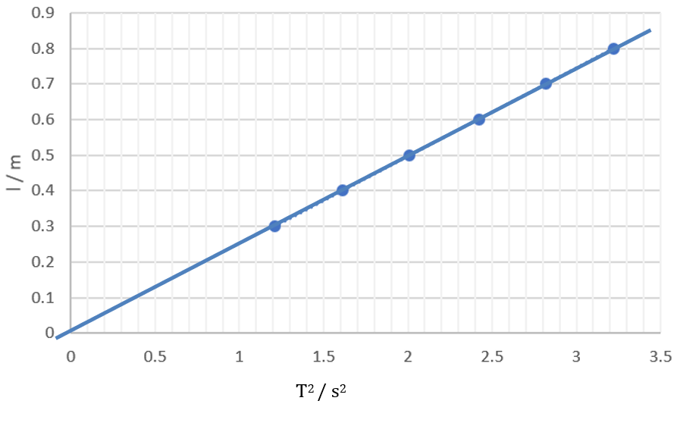
(iv) Hence determine g
Following the formula: T$=2π\sqrt{\frac{l}{g}}$
We can say that: $T^{z}=4π^{2}\frac{l}{g}$
Rearranging this gives the equation of the above line: l $=\frac{g}{4π^{2}}T^{2}$
This means that the slope of the line is: slope $=\frac{g}{4π^{2}}$
Or that: $g=4π^{2}\left(slope\right)$
From the graph: $s=\frac{y_{2}-y_{1}}{x_{2}-χ_{1}}= \frac{0.5-0}{2-0}=0.25$
And therefore, : $g=4π^{2}\left(0.25\right)=9.87$
We have found that the acceleration doe to gravity is g$=9.87ms^{-2}$

Question 2
- Why did the student first make an approximate measurement of the focal length?
A real image cannot be formed for an object that is inside the focal point of a concave mirror. By determining the approximate value for the focal length before carrying out the rest of the experiment, the student could avoid trying to do so – which would waste time and effort.
It also helps to have an approximate value which can be compared to the final calculated value. If there is a large discrepancy, it would suggest that the student should check both their experimental and mathematical work again.
- How did the student determine the image positions?
- Draw a labelled diagram of how the apparatus was arranged.
- On your diagram, indicate u and v.

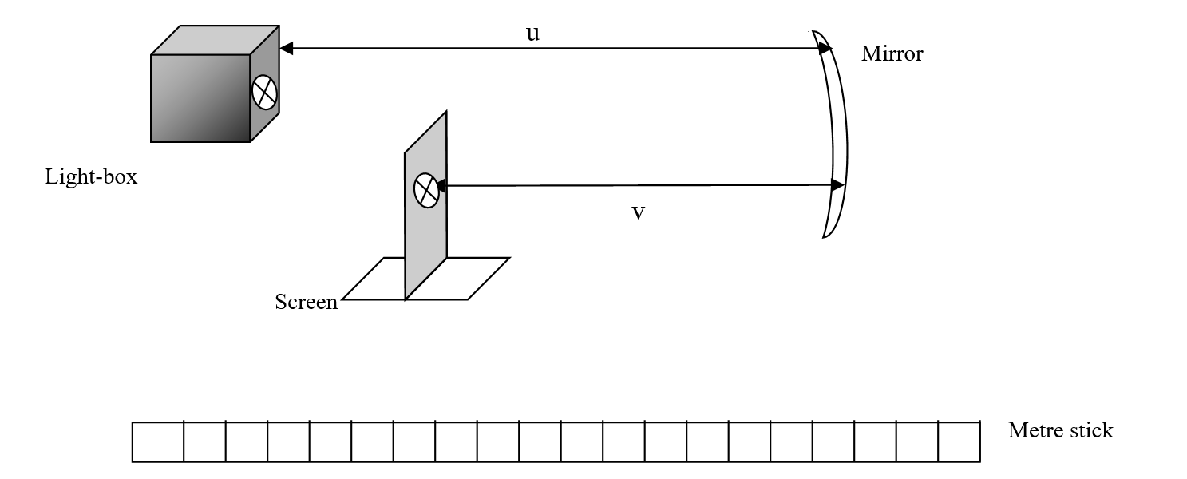
- The student would set up the apparatus as shown, in which a lightbox and cross-wires acts as an object.
- Move the screen until a clear inverted image of the cross-wires is obtained.
- Measure the distances for u (the object distance) and v (the image distance) as shown .
- Repeat this procedure for different values of u.
- Use all of the data to calculate the focal length of the mirror.

The formula: $\frac{1}{f}=\frac{1}{u}+\frac{1}{v}$ applies:
We can re-arrange this to be: $f=\frac{uv}{u+v}$
Subbing in:
$f=\frac{uv}{u+v}= \frac{(20)(31.2)}{20+31.2}=12.19 cm$
$$f=\frac{uv}{u+v}= \frac{(25)(23.2)}{25+23.2}=12.03 cm$$

We can average these to find a value for the focal length: $f=12.11 cm$

- Sketch a suitable graph that might have been drawn.
The formula: $\frac{1}{f}=\frac{1}{u}+\frac{1}{v}$ can be rearranged to give:
$\frac{1}{u}=-\frac{1}{v}+\frac{1}{f}$ , which can be seen as the equation of a line in the form:
$$y=mx+c$$
This would give us a graph similar to the one shown here.
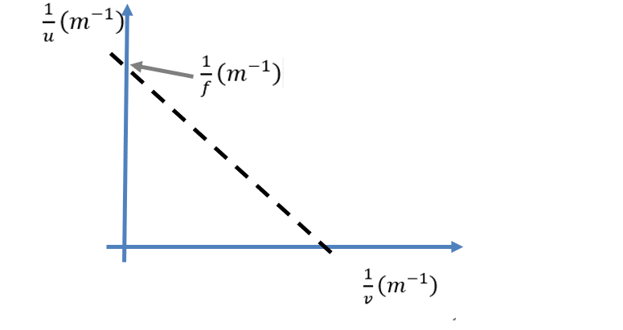
- How could this graph be used to calculate the focal length?
The value of f would be found by finding the inverse of the y – intercept
(the slope would be: $slope= -1$)

Question 3
- Draw a labelled diagram of how the apparatus was arranged in this experiment.

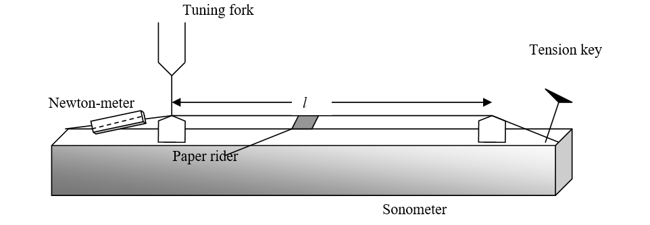

- Describe how the student used the apparatus.
- Set up the apparatus as shown
- Select a wire length l (e.g. 30 cm), by suitable placement of the bridges. Keep this length fixed throughout the experiment.
- Strike a tuning fork and place it on the sonometer. Vary the tension until the string begins to vibrate.
- Repeat the procedure several times.
- Plot a graph of frequency f against the square root of tension .

- Draw a suitable graph to show the relationship between f and T

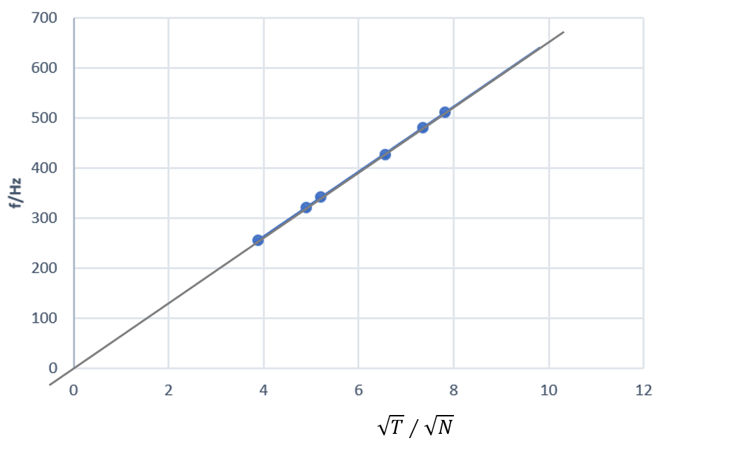

- Use your graph to calculate the mass per unit length (linear density) of the string.

The formula $f=\frac{1}{2l}\sqrt{\frac{T}{μ}}$ applies, where μ = mass per unit length
We can arrange this into the form y = mx+c…
$f=\frac{1}{2l\sqrt{μ}}\sqrt{T}$ where the slope will be given by $slopⅇ=\frac{1}{2l\sqrt{μ}}$
Finding the slope: $m=\frac{y_{2}-y_{1}}{x_{2}-x_{1}}= \frac{385-0}{6-0}=64.2$
Comparing this with our formula, we can say that,
$$\sqrt{μ}=\frac{1}{2l(slope)}= \frac{1}{2(0.65)(64.2)}=0.01$$
We can then see that the mass per unit length is:
$$μ={\left(0.012\right)}^{2}=1.44 ×{10}^{-4}kg m^{-1}$$

Question 4
- Draw a labelled diagram of how the apparatus was arranged in this experiment.
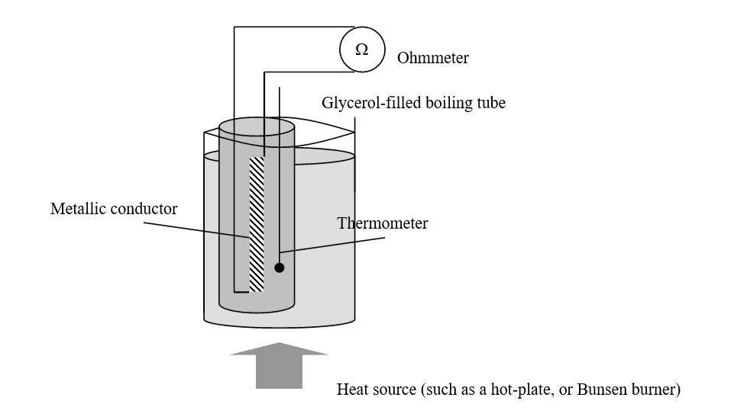
- How did the student make the temperature of the wire 0 °C?

It is likely that the student managed this by beginning with a mass of melting ice in the beaker, which will have a temperature of 0 °C in normal conditions.
This temperature will have reduced the temperature of the glycerol in the boiling tube and ultimately that of the metal wire to 0 °C.

- Draw a suitable graph to show the relationship between R and θ.

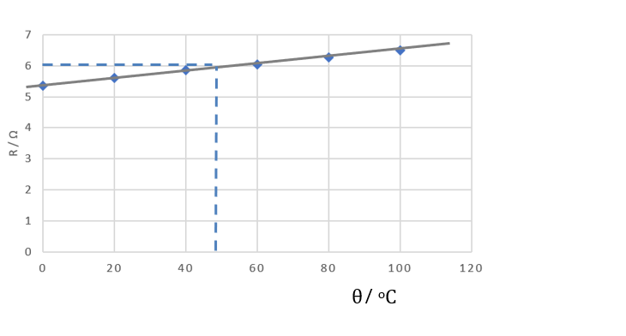

- Use your graph to determine the temperature when the resistance is 6 Ω.

As is shown on the graph, the temperature would be 44 ºC when the resistance is 6 Ω
The student measured the diameter of the wire to be 2.4 mm.
- How did the student measure the diameter of the wire?
The student would have used a Vernier calipers to measure the diameter
- Calculate the resistivity of the metal at a temperature of 20 °C.

The resistance of the wire was 5.6 Ω when the temperature was 20 °C
The relationship between the resistance and the resistivity is:

$$ρ=\frac{RA}{l}$$
As it has diameter, we can assume the wire has a circular cross section, and therefore its cross-sectional area would be:

$A=πr^{2}=π{(1.2 ×10^{-3})}^{2}=4.52 ×10^{-6} m^{2}$
Subbing in we can find the resistivity, $ρ$
$ρ=\frac{RA}{l}= \frac{5.6(4.52 ×10^{-6})}{.3}=8.44 ×10^{-6}$ Ωm

Question 5
- Draw a labelled diagram of how the apparatus was arranged in this experiment.
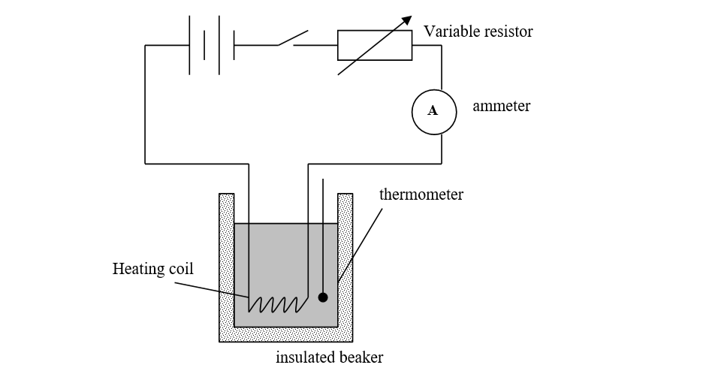
- Why was the current allowed to flow for a constant period of time?

Joule’s Law actually states that , where P is the power
But
If mass and time are kept constant, as is the case here, we can say that
Therefore, if α I ², we can conclude that
This is why the current flows for exactly the same amount of time for each measurement

- Draw a suitable graph to verify Joule’s law.
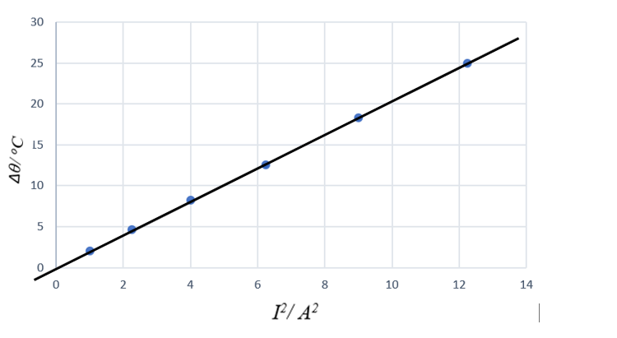
- Use your graph to calculate the average resistance of the heating coil.

First, we find the slope:

$$m=\frac{y_{2}-y_{1}}{x_{2}-x_{1}}= \frac{20.5-0}{10-0}=2.05$$
Then we look at both Joules Law: P$=RI^{2}$
And the maths laid out on section (ii) above:
Equating these, we can say that $RI^{2}$
Rearranging this to match the formula for the equation of any line (y = mx+c), we can say that the equation of the above line is:
$$Δθ=\frac{Rt}{mc}I^{2}$$
This means that slope of the line is given by $slope =\frac{Rt}{mc}$

This allows us to find the resistance: $R=\frac{mc\left(slope\right)}{t}$
The resistance is: $R=\frac{(0.105)(4180)(2.05)}{4×60}=3.75 Ω$

Section B
Question 6
(a) Define acceleration. Hence derive the expression v = u + at.
Acceleration is the rate of change of velocity:
This can be expressed as:
we can rearrange to give:
And therefore: $v=u+at$

(b) A ball is kicked with an initial velocity of 20 m s^{–1} at an angle of 50° to the horizontal.
Calculate the horizontal distance it travels in 1.2 seconds.
We can use a triangle find the horizontal component of the velocity, V_{H}:
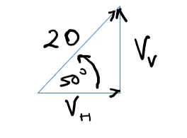
$\cos{{50}^{0}}=\frac{v_{H}}{20}$
$$v_{H}=2^{0}\cos{{50}^{o}}=12⋅86 ms^{-1}$$
Carrying out a simple distance-speed-time calculation allows us to find the horizontal distance, d, then travelled in 1.2 seconds.
$$d=\left(12.86\right)\left(1.2\right)=15.43 m$$
(c) State the laws of equilibrium for a set of co planar forces.
The Laws for Equilibrium
- The sum of the forces in any direction equals the sum of the forces in the opposite direction
- The sum of the moments about any point is zero

(d) State an expression for the acceleration due to gravity at a distance of 2R above the surface of a planet of mass M and radius R.
Following the equation: $g=\frac{GM}{d^{2}}$
We can say that the acceleration due to gravity at a distance of 2R above the surface (where d = 3R) is given by:
: $g=\frac{GM}{{(3R)}^{2}}$
Or $g=\frac{GM}{{9R}^{2}}$

(e) Two different types of thermometer can give different readings when placed in the same environment.
Explain why this happens.
Due to variations within thermometric properties, even well calibrated thermometers can give different readings at the same temperature (when that temperature is neither 0 ºC or 100 ºC)
The Celsius scale is based on the idea that a thermometric property will vary in a linear manner between the two fixed points used (the freezing and boiling points of water), In most situations this assumption is reasonable, but it may not be entirely valid and this can cause the effect described here.
(f) Draw a labelled diagram to represent the second harmonic of a stationary wave in a pipe that is open at both ends.

(g) Calculate the sound intensity 6 m from a loudspeaker of power 20 mW.
$$I=\frac{P}{A}= \frac{20×{10}^{-3}}{4π6^{2}}=4.42×{10}^{-5} Wm^{-2}$$

(h) List two primary colours of light. What colour of light is produced when equal intensities of these two primary colours are mixed?
Red and green are primary colours of light. When combined in equal intensities, they produce yellow light.
(i) Distinguish between earthing and bonding in domestic electricity.
All metal appliances should be earthed. This means they should have a third wire connecting them directly to earth. If a fault develops, the current will flow to earth, rather than through the next person who touches the appliance.
Also, all metal surfaces used near water (pipes, taps etc) should be bonded. That is they should be connected to earth. This is to protect from injury, should any part of them become connected to a power supply.
(j) Draw a circuit diagram to show how voltage and current are measured for a diode in reverse bias.
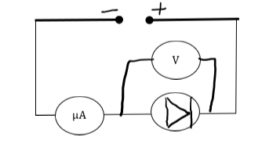
(k) Carbon–14 undergoes nuclear decay. The daughter nucleus is nitrogen 14. Write a nuclear equation for this decay.
$$C_{6}^{14}=N_{7}^{14}+e_{-1}^{0}$$

(l) In terms of how they interact with the neutrons in a fission reactor, distinguish between a moderator and a control rod
The moderator slows down neutrons emitted during fission so that they are travelling at the speed where they are most likely to cause nuclear fission should they hit the nucleus of an atom of, say, U-235.
Control rods absorb emitted neutrons so that they will not go on to cause fission in another nucleus. If fully deployed, they cause the reaction to die out.

Question 7
- State Newton’s second law of motion.
The rate of change of a body’s momentum is proportional to the force which causes it and takes place in the direction of that force. (F = ma)
- State the principle of conservation of momentum
The principle of conservation of momentum states that in any interaction between bodies, the total momentum before the interaction will equal the total momentum after the interaction, provided no external forces act upon the bodies
- State the principle of conservation of energy.
The principle of conservation of energy states that energy can neither be created or destroyed, but that it can be converted from one form to another.
Calculate
- the force exerted by B on A,

For object A:
u = 6.2
v = -1.1
a = a
s = s
t = .025

$$a=\frac{v-u}{t}=\frac{-1.1-6.2}{0.025}=-292 ms^{-2}$$
$$F=ma$$
$$F=\left(0.045\right)\left(-146\right)=-13.14 N$$

The force on A is 13.14 N, to the right as directions are indicated in the diagram

- the maximum velocity of B,
The maximum velocity of B will be immediately after the collision, and can be found using conservation of momentum

$$P_{after}=P_{before}$$
$$\left(0.08\right)u +\left(0.045\right)\left(-1.1\right)=\left(0.045\right)\left(6.2\right)$$
$$u=\frac{(0.045\left(6⋅2\right)+\left(0.045\right)\left(1.1\right)}{0.08}=4.106 ms^{-1}$$

The max velocity of B is 4.11 $ms^{-1}$

- the magnitude and direction of the maximum centripetal force on B,
$$F=\frac{mv^{2}}{r}$$
$$F=\frac{(0.08){(4.11)}^{2}}{1.2}1.126 N$$
The max value of the centripetal force will be 1.13 N
The direction will be to the top of the string – the direction of a centripetal force is always towards the centre of the circle.
- the maximum height gained by B,
from the conservation of energy we can say that the max potential energy will be equal to the max kinetic energy:
$$mgh=\frac{1}{2}mv^{2}$$
$$h_{max}=\frac{v^{2}}{2g}=\frac{{(4.11)}^{2}}{2(9.8)}=0.86 m$$
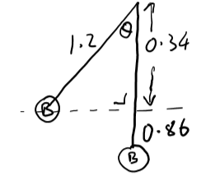
The max height gained by B will be 0.86 m
- the maximum angular displacement of the string.

$\cos{θ}=\frac{0.34}{1⋅2}=0.2833$

The max angular displacement therefore would be 73.54º

- Draw a labelled diagram to show the force(s) acting on B when it is at its maximum height.
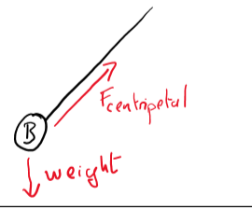

- What is the magnitude and direction of the acceleration of B after the string is cut?
At that point, the only force acting on B is its own weight. Therefore the magnitude of the direction is 9.8 ms⁻² and its direction is downwards.

Question 8
- What is meant by diffraction?
Diffraction is the ability of a wave to recover after meeting an obstacle
- A diffraction experiment can be used to demonstrate the wave nature of light. Describe such an experiment.

To show that Light is a Wave
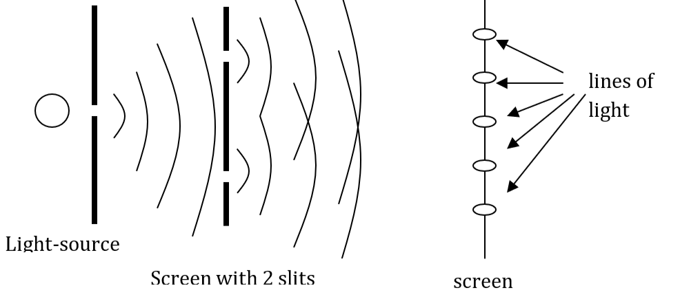
Method: A single light source is placed behind a screen. The light passes through this screen and encounters another, with two slits. A third and final screen is found beyond this one.
Observation: A pattern is found on it as shown above. The pattern can only be explained if light is a wave, which diffracts at each other two slits, and creates an interference pattern as the resulting waves meet.
Conclusion: As diffraction and interference are wave characteristics, this demonstrates that light is a wave.
- What is a diffraction grating?

A diffraction grating is a piece of glass into which many dark lines have been vertically etched.
- Derive the diffraction grating formula, nλ = dsinθ.

Consider a light beam shining through a diffraction grating. It is ‘split’ into many different waves, as shown.
For constructive interference to occur, two of these light rays must meet.
That tells us that one has travelled further than the other, by a distance equal to nλ
From this we can look at the triangle shown below, and derive the formula

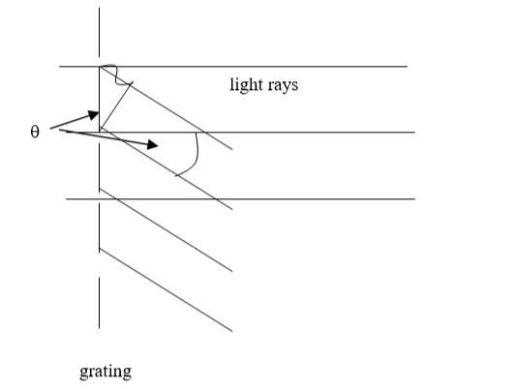
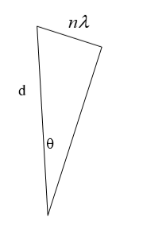

$$\sin{θ}=\frac{nλ}{d}$$
$$nλ=ⅆ\sin{ϑ}$$

- Calculate the angular separation between the two 3rd order images formed when blue light of wavelength 442 nm is incident on a diffraction grating of 600 lines per mm.

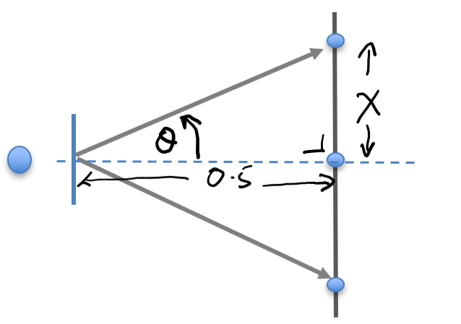
$$nλ=ⅆ\sin{ϑ}$$
$$(3)(4⋅42×{10}^{-7})=\frac{1}{600,000}\sin{ϑ}$$
$$\sin{ϑ}=\left(3\right)\left(4⋅42×{10}^{-7}\right)\left(600,000\right)=0.7956$$
$$θ=52⋅{71}^{0}$$

This means the angular separation between the two lines would be 105.42º
- Calculate the distance between these images on a screen placed 50 cm from the grating.

From the above diagram:

$$\tan{52}⋅71=\frac{x}{0⋅5}$$
$$x=0⋅5\tan{52.71}=0.655 m$$
This means that the distance between the 3rd order images would be 1.31 m

- What changes would be observed if the blue light was replaced (a) with red light, (b) with white light?
- As red light has a longer wavelength than blue, the value of θ
would increase. The angular separation and the distance between the images would also increase.
- There is a mixture of colours, and therefore wavelengths, in white light. Because of this, a spectrum would form at each point where a blue image exists with the blue light (with the red colours furthest away from the centre and the blues closer to the centre). This does not include the straight-through position, where all colours would meet and a white image is formed.

- Compare the wavelengths of radio waves with those of visible light.
Radio waves have a much longer wavelength than visible light. Radio waves can be metres or even kilometres in length. Visible light waves tend to be a of the order of a few hundred nanometers.
- Why are radio waves not observed to undergo diffraction when incident on a diffraction grating of 600 lines per mm?
When waves pass through a gap in an obstacle, the diffraction effects are greater when the wavelength is similar to the width of the gap. The gaps in a diffraction grating with 600 lines per mm is given by:
$d=\frac{1}{600,000}=1.67×{10}^{-6} m$
This is comparable to the wavelength of visible light, but the wavelengths of radio waves are many orders of magnitude greater than that, and therefore the diffraction effects will be too small to be noticeable.

Question 9
- What is meant by specific heat capacity?
The specific heat capacity, c, of a substance is the amount of energy required to raise the temperature of 1 kg of the substance by 1K
- Why does the high specific latent heat of fusion of ice make it a good coolant?
The specific latent heat, l, of a substance is the amount of energy required to change the state of I kg of that substance. As the specific latent heat of fusion of ice is quite high compared to other easily available materials this means that as it slowly melts, it absorbs large quantities of heat from its surroundings (e.g. the picnic box) and this reduces the temperature of the picnic box.
- Suggest two reasons why the walls of a picnic box are made from hollow plastic rather than solid plastic.
The fact that it is hollow, means that it traps a layer of air. As air is not a good conductor of heat, it acts as an insulator, preventing heat from entering in to the picnic box.
Being hollow rather than solid also reduced the density of the material, and therefore the overall weight of the box, which will make it easier to carry.
- Calculate the final temperature inside the picnic box when its contents have reached thermal equilibrium.

$heat lost (food)=heat gained$ (ice)
$${\left(CΔϑ\right)}_{food}={{\left(mcΔϑ\right)}_{warming ice}+\left(ml\right)}_{ice}+{\left(mcΔϑ\right)}_{melted ice}$$
$$\left(17, 800\right)\left(10.5-X\right)=\left(0.25\right)\left(2100\right)\left(18\right)+\left(0.25)(3.3×{10}^{5}\right)+(0.25)(4180)(X)$$
$$18845 X=94950$$
The final temperature is therefore given by: $X=5.04^{o}C$

- Draw a labelled diagram of a heat pump.
Heat Pump: A volatile gas – liquid mix is circulated as shown using pumps. In the low pressure area, it evaporates. In the high pressure area, it condenses.
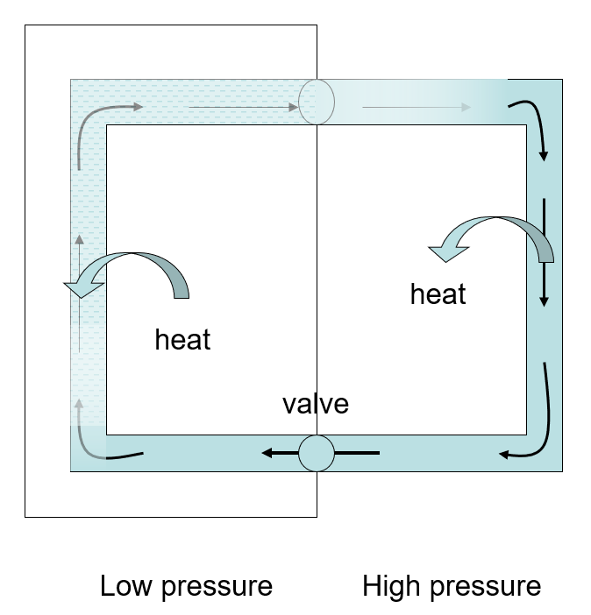
- Explain how a heat pump works.
A heat pump allows heat to be moved from an area that is already quite cold to an area that is warmer.
- In the heat pump, the area that is to be cooled is surrounded by a network of tubes, through which a chemical mix is forced to circulate using pumps.
- As the chemicals enter that part of the tubes which surround this area, the pressure is reduced. This causes the liquid inside to boil. As it turns from a liquid into a gas, it must absorb latent heat of vaporisation. This heat energy, drawn from the surroundings, causes the temperature inside the fridge to fall.
- When the circulating chemicals move into the area outside the fridge, or just behind it, the pressure is increased again and the gas turns back into a liquid. The latent heat is emitted into the surrounding air.
- In this way heat is constantly removed from the fridge and transferred into the air.

- What observations did the student make?
The student will have noticed that the water at the top of the tube heats up and even boils, but that the ice at the bottom of the tube does not melt.
- What conclusion could the student have made?
The student could conclude that heat does not travel through water via conduction, which would by its nature have no preference for the direction of travel – it would as easily move down as up.
This would imply that heat does travel through water via convection currents.

Question 10
- What is a magnetic field?
A magnetic field is the area around a magnet where it has an effect.
- Describe an experiment to show the magnetic field around the conductor
- Set up a circuit as shown. The wire should be attached to the poles of a battery and arranged so that the current will from plus to minus down through the wire as it passes through the card
- Place a plotting compass – or a number of them – on the card.
- Note how the direction in which the compass needle points varies when the current is switched on and off.
- Note also how the needle’s direction changes as it is moved around the card.
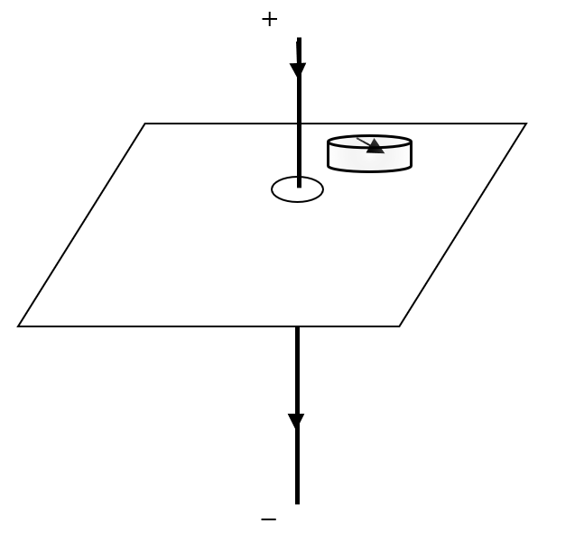
- Draw the shape and direction of this magnetic field.

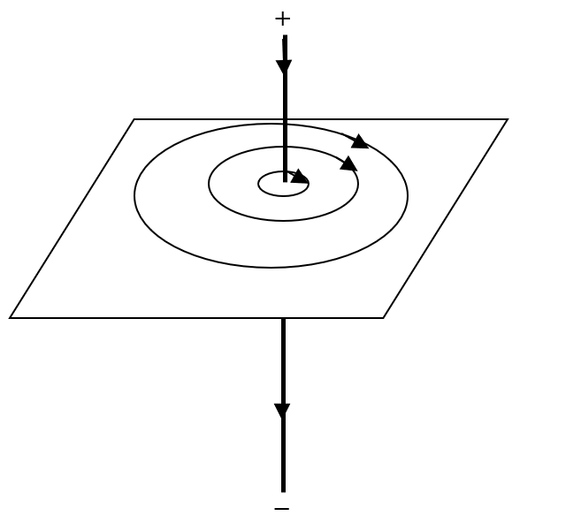
The magnetic field consists of concentric circles surrounding the wire. The direction of the filed will be as shown – following the right-hand rule.
- When placed in an external magnetic field, a current‐carrying conductor may experience a force. The magnitude of this force depends on a number of factors. Name three of them.
Following the formula, $F=IlB$, we can say that the force (F) is controlled by the current (I), the length of the current passing through the magnetic field (l) and the magnetic flux density (B)

- Derive an expression for the force F experienced by a charge q travelling with velocity v perpendicular to a magnetic field of flux density B.
Again following the formula, $F=IlB$, we can say that a similar force exists on a charge, q, moving through a magnetic field at velocity v.
We can say that the current in this case is the quantity of charge passing any point per second, () , and the effective length of the charge in the magnetic field is given by
Subbing into
Gives
And yields: $F=qvB$

- Use Faraday’s law of electromagnetic induction to calculate the average emf induced in the loop as it enters the field.

From Faraday: $E=n\frac{change in flux}{timⅇ}$
When the square loop is outside the magnetic field we can say that the flux passing through it is given by: $Φ=0$
When the square loop is fully inside the magnetic field we can say that the flux passing through it is given by: $Φ=BA=\left(0.4\right)\left(0.05×0.05\right)=0.001 Wb$
We can therefore say that change in flux as the loop moves into the magnetic field is: $change in flux=0.001 Wb$

To find the time over which this change takes place, the diagram shows the loop as it begins to move into the field. To be fully inside the field, it must move forward by 0.05m, travelling at a speed of 6 ms⁻¹.
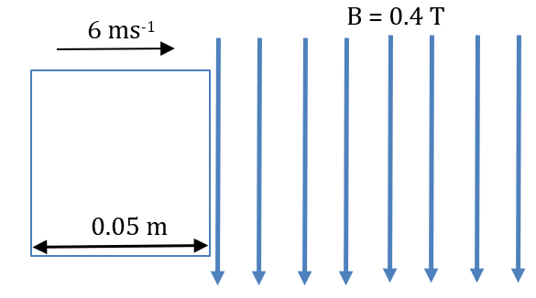

At a constant speed this is a straightforward distance-speed-time calculation:
$$t=\frac{d}{s}=\frac{.05}{6}=0.0083 s$$

We can now say that the induced voltage, E, is:$$E=\left(1\right)\frac{0.001}{0.0083}=0.12 V$$

- State Lenz’s law.
Electromagnetic induction is the phenomenon where a change in the magnetic flux linking a coil, causes an emf to be induced in that coil, which will create an induced current if a circuit exists.
Lenz’s Law states that the direction of an induced current is such as to oppose the change causing it
- Explain how Lenz’s law is a special case of the principle of conservation of energy.

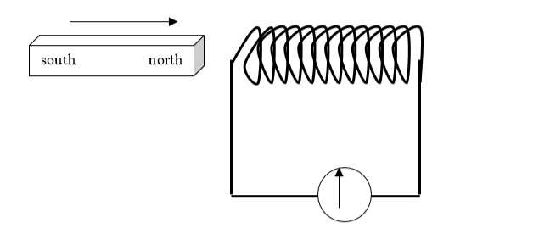

Consider the situation shown here. As the magnet moves into the coil, an emf is induced and this causes a current to flow in the coil.
The current flowing in the coil creates a magnetic field similar to that created by a bar magnet. Following Lenz’s Law, the direction of the current – and the magnetic field – opposes the change. This means that the north pole of the coil’s field is adjacent to the bar magnet’s north pole and acts to slow down the movement of the magnet.
This is consistent with the conservation of energy: work is done in moving the coil into the coil, and this work results in the transformation of kinetic energy into electric energy (and also heat energy, due to the heating effect of an electric current)
If the opposite was true and a south pole was created adjacent to the bar magnet’s south pole, the magnet would be drawn into the coil with increasing speed. The increasing speed of the magnet would also give rise to the creation of increasing voltages.
This would contradict the conservation of momentum, as kinetic, electric and heat energy would be simultaneously created, without any corresponding loss in another form of energy.
In this way we can say that Lenz’s Law is a special case (or an example) of the Principle of conservation of energy.

Question 11
- Write the nuclear equation for this event.

$$Be_{4}^{9}+He_{2}^{4}=C_{6}^{l2}+n_{0}^{1}$$

- Calculate the increase in kinetic energy during this event.
Using the values in the tables,
Mass before: $\left(9.012182×1.660 5402×10^{-27}\right)+6.6446565×10^{-27}=2.1609747×10^{-26}Kg$
Mass after: $12.000000×1.660 5402×10^{-27}+1.67492728×10^{-27}=2.160140968×10^{-26}kg$
The change in mass: $m= 8.33732×10^{-30}kg$
The energy released (as kinetic energy)
E$=mc^{2}=(8.33732×10^{-30}){(2.997924 ×10^{8})}^{2}=7.493×10^{-13}J$
Taking the mass of the alpha particle to be that of a helium atom yields a slightly larger answer of 9.13$×10^{-13} J .$ Both would earn full marks
- A G‐M tube and a solid‐state detector have the same function. What is this function?
Both serve as detectors of radioactivity
- Describe, with the aid of a labelled diagram, the principle of operation of a detector of this sort
The Geiger-Mueller Tube
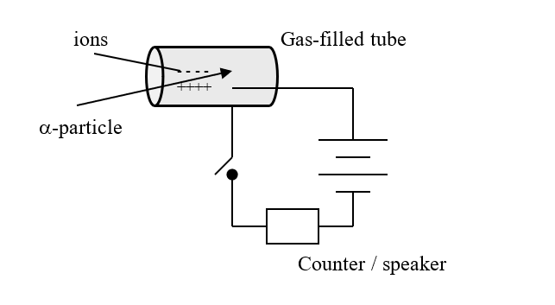
- This a metal cylinder containing a mixture of argon and bromine at low pressure.
- An electric field exists in the tube as shown
- If ionizing radiation should enter the chamber, the ions it creates flow towards either the anode or cathode.
- For a few moments a current will flow.
- The counter can be used to register for how long the current flows, and therefore how much radiation is present

- Describe with the aid of a labelled diagram the gold foil experiment

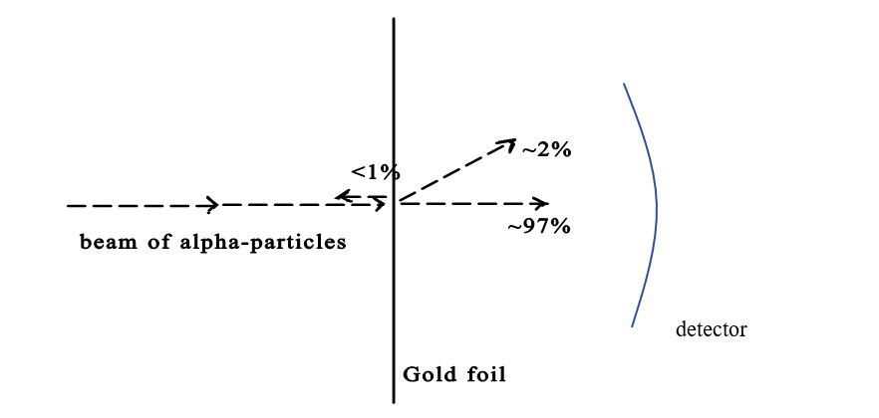

Using a radium source, Rutherford fired a beam of alpha-particles towards a thin sheet of gold.
Alpha particles are small, positively charged particles. He chose gold because it can be pressed very thin, so thin that it is only a few atoms from front to back
- What observations were made during the experiment?
As noted in the diagram above, Rutherford noticed that the vast majority (97%) of alpha particles went through the gold and was undeflected from its original path.
A small percentage (about 3%) was deflected through small and unpredictable angles.
A very small percentage – less than 1% - of the alpha particles rebounded from the gold foil – as of bouncing off it.
- What did Rutherford conclude about the structure of the atom?
Rutherford concluded that
- the atom was mainly empty space
- there is a small area of positive charge that also contains most of the mass of the atom. This became known as the nucleus.
- That the electrons are found surrounding the nucleus.

- How did Niels Bohr improve Rutherford’s model to explain emission line spectra?
Bohr developed the idea that the electrons are arranged in ‘shell’s’ or energy levels.
- The electrons close to the nucleus have less energy than those further away from the nucleus. The electrons at each level can only contain specific discrete amounts of energy.
- When atoms gain energy some of this energy will be taken by individual electrons. As they have gained energy they have to move to higher energy level, to an outer shell. This process is known as a quantum leap.
- When the electron later drops back to its original level, it releases the energy it had gained. Regardless of how this energy was originally sourced, it is always released as electromagnetic radiation. Specific quantities of energy will create waves of specific wavelength.
- Because each element has a unique arrangement of electrons, each element will release a characteristic pattern of electromagnetic radiation – known as its spectrum.
- When these are released by simple monatomic molecules, they are known collectively as emission line spectra.
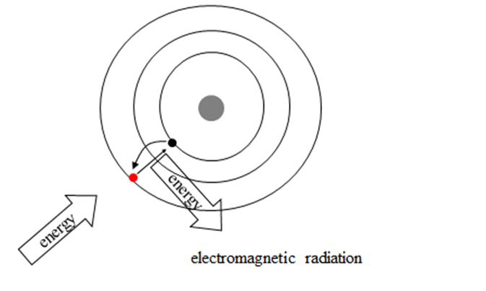

Question 12
- Describe a laboratory experiment to demonstrate charging by induction.
To demonstrate charging by induction:
Take an uncharged electroscope, where the leaves are flat – indicating the absence of a charge.
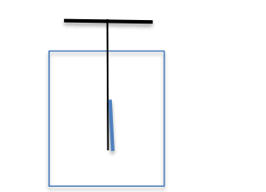
Take a plastic rod and rub it against your hair.
This should build up a charge by contact.
Hold the charged end of the rod near to the cap of the electroscope.
The leaf of the electroscope should rise, indicating that it now carries a charge, which has been added to the electroscope without contact, and therefore via induction.
This charge can be made permanent by briefly touching (and therefore earthing) the cap before removing the rod
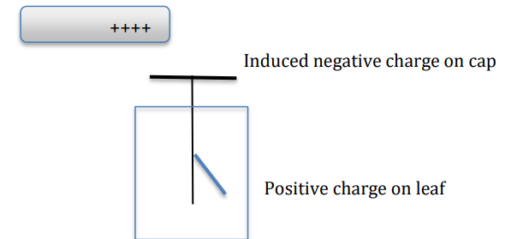

- Explain how point discharge occurs
The Point Effect is when charge tends to build up on the pointed ends of any irregular shape, as shown here
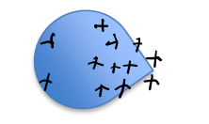
A large build up of charge in a small place tends to ionize the surrounding air.
If the point carries a negative charge, the free electrons created in the air will then tend to move to the centre of charge - the point.
The two charges will neutralize each other.
Any remaining charge on the object will then rearrange itself so that it moves towards the point, and the process will repeat until the object is discharged. The process is often accelerated by the ionization of the air itself.

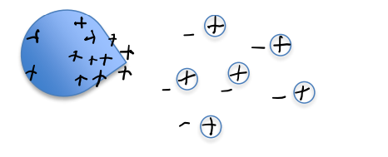

- Calculate the relative permittivity of the capacitor’s dielectric.
Relative permittivity follows this formula:
$$ε_{r}=\frac{ε}{ε_{0}}$$
To compete that calculation we must first find the actual permittivity, ε, Using $C=\frac{εA}{d},$we can say that:
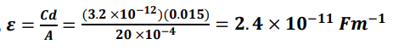
Subbing into the original equation:
$$ε_{r}=\frac{2.4×{10}^{-11}}{8⋅854{×{10}^{-12}}^{}}=2⋅71$$
- What would be the effect of on the capacitance if the distance between the plates was doubled
Using $C=\frac{εA}{d},$we can see that the capacitance is inversely proportional to the distance between the plates.
Therefore, doubling that distance would halve the value of the capacitance.

- Explain why the effective capacitance of this combination is 9.6 pF.
Capacitance follows this formula, C$=\frac{Q}{V}$

As the charge, Q, on each plate will be equal the total charge will be 3Q. the voltage across the arrangement will be constant, V.

This means that the total capacitance of the arrangement, C’ will be:
C$=\frac{3Q}{V}$= 3 C = 3(3.2) = 9.6 pF
- Draw the electric field pattern in a charged parallel plate capacitor.
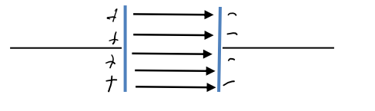
- Why is the cathode of an X‐ray tube hot?
The cathode is hot due to the presence of a low voltage heater beside it.
This is done to ensure that thermionic emission will occur – which is the emission of electrons from the surface of a hot metal. This is how the beam of electrons is created that ultimately leads to the release of the X-rays at the anode.
- Calculate the maximum speed of an electron as it moves between the cathode and the anode.
The max energy of the electrons is:
𝐸 = 𝑞𝑉 = (1.602 × 10 ⁻¹⁹)(20,000) = 3.204 × 10 ⁻¹⁵ J
𝐸_{𝑘} = ½ 𝑚𝑣²
𝑣² = 7.03 × 10 ⁻¹⁵
And the max velocity is: 𝑣 = 8.39 × 10 ⁷ 𝑚𝑠⁻¹

What happens to the energy of the electrons when they hit the anode?
Most of this energy is converted into heat in the anode, which is dissipated by a temperature control system. A small percentage is absorbed by the atoms in the anode and released as X-rays.

Question 13
- State the quark composition of the proton.
The proton consists of 2 up quarks and 1 down quark
- List the forces experienced by a proton in decreasing order of strength.
The proton experiences fundamental forces in this order
- Strong nuclear (because it consists of quarks)
- Electromagnetic (because it has an electric charge)
- Weak nuclear (which allows quarks to change flavor and is involved in the change between neutron and proton that leads to beta decay)
- Gravitational (because it has mass)

- The Planck constant relates energy and frequency. Its value is 6.6 × 10^{–34} J s. Express this unit in terms of metres, kilograms and seconds.
The units we use for measurements follow the same algebra as the formulae we use when calculating their value:
$E=hf$gives us $h=\frac{E}{f}$
We can also make use of : E$=\frac{1}{2}mv^{2}$and,$f=\frac{1}{T}$
Combining these: $h=\frac{1/2mv^{z}}{1/T}$
Which rearranges to: $h=1/2mv^{2}T$
Replacing each of these with their respective unit: $h=kg{\left(ms^{-1}\right)}^{2}s$
Rearranging: $h=\frac{kgm^{2}s}{s^{2}}$ which gives us:

Rearranging: $h=kgm^{2}s^{-1}$

- Write a nuclear equation for the pair annihilation of a proton and an antiproton.

$$p_{1}^{1}{+p}_{-1}^{1}→2hf$$

- A photon produces a muon anti‐muon pair. Calculate the minimum energy of the photon in electronvolts.

A muon is a lepton, whose is given in comparison to that of an electron on page 48 of the maths tables:
Mass: $m=2.07×{10}^{2}×9.109×{10}^{-31 }=1.886×{10}^{-28}kg$
For a muon anti-muon pair, this mass would be doubled:
$m=3.771×{10}^{-28}kg$This corresponds to energy according to $E=mc^{2}$
$$E=({3.771×{10}^{-28})(2.998×{10}^{8})}^{2}= 3.389×{10}^{-11}J$$

Converting this to electronvolts:
$$E=\frac{3.389×{10}^{-11}}{1⋅602×{10}^{-19}}=211,578,624 eV=211 MeV$$

- In the Large Hadron Collider, how are the particles
(a) accelerated:
Particles are accelerated using electric fields.
(b) maintained in circular motion?
They are maintained in circular motion using magnetic fields. Following the left hand rule, a charged particle will follow a curved path through a magnetic field.

- In 1932 Walton and Cockcroft manufactured one of the first useful particle accelerators. State two reasons why their experiments using this accelerator were of scientific significance.

The major contributions to science of the Cockroft-Walton experiment were:
- that it allowed for an experimental verification of Einstein’s equation: $E=mc^{2}$
- it showed that the nucleus of an atom could be altered using artificially accelerated particles in a controlled environment

Question 14a
An iron sphere of mass 40 g hangs from a spring and oscillates with simple harmonic motion. The period of oscillation is 0.74 s.
- What is simple harmonic motion?
Any motion where the acceleration (a) of a particle is proportional to its distance (s) from an equilibrium position is simple harmonic motion: a ∝ -s
Calculate the spring constant.

Rearranging Hooke’s Law:
$$F=\left(-\right)ks$$
$$ma=\left(-\right)ks$$
$$a=(-)k/ms$$

And comparing it to the equation for SHM $a=\left(-\right)ω^{2}s$
We can see that $ω^{2}=\frac{k}{m}$
This means that the spring constant, k, is given by: $k=ω^{2}m$
We also know that the period, T, is given by: $T=\frac{2π}{ω}$
This allows us to say: $ω=\frac{2π}{T}=\frac{2π}{0.74}=8.49 s^{-1}$
And we can now find k: $k={\left(8.49\right)}^{2}\left(.04\right)=2.88{ Nm}^{-1}$

- Calculate the acceleration of the sphere when its displacement is 18 mm from its equilibrium position.

$$a=\left(-\right)ω^{2}s$$
$$a=\left(-\right){(8.49)}^{2})\left(0.018\right)=-1.297 { ms}^{-2}$$
- Calculate the mass of the magnet.
From Hooke:
$$F=ks$$
$$mg=ks$$
The mass, m is given by:
$$m=k/gs={2.88}/{9.8}\left(0.015\right)=0.0044 kg$$

Question 14b
- What is the Doppler effect?
The apparent change in the frequency of a wave due to the relative motion of the source of the wave or an observer is known as the Doppler effect

- Describe how the Doppler effect can be demonstrated in the laboratory

To demonstrate the Doppler Effect

Attach a buzzer to a long string
Swing it in circles, as indicated in the diagram.
An observer standing to the front, as shown, will hear the frequency increasing as the buzzer approaches and decreasing as it recedes.
This is due to the Doppler Effect.




- Calculate the speed of the source.

From the tables:
$$f'=\frac{fc}{c-u}$$
$$806,000=\frac{800,000(1480)}{1480-u}$$
$$806\left(1480-u\right)=800\left(1480\right)=1184000$$
$$1192880 -806u=1184000$$
$$806u=8880$$

$$c=11.02 ms^{-1}$$

- Draw a ray diagram to show the refraction of a sound wave as it travels from water into air.
As the sound slows down in air, it will bend away from the normal as it enters the air

Air
Water

Question 14c
Describe what happens when
- f > fo , f is constant and I is increasing,

If f > fo, the incoming radiation has a frequency over the threshold frequency and therefore electrons will escape from the metal (i.e. a photocurrent will flow). The increasing value of I, means that the number of photons incident on the cathode is increasing, and therefore the current will also increase.
- f > fo , f is increasing and I is constant,
If f > fo, the incoming radiation has a frequency over the threshold frequency and therefore electrons will escape from the metal (i.e. a photocurrent will flow). As I is constant, that current will also be constant.
- f < fo , f is constant and I is increasing.
If f < fo, the incoming radiation has a frequency under the threshold frequency and thereforeno electrons will escape from the metal (i.e. a photocurrent will not flow). The increasing value of I will have no effect.

- Calculate the threshold frequency of the metal.

Work Function: $∅=2.6×1⋅602×{10}^{-19}= 4.165×{10}^{-19}J$
Threshold frequency: $f_{0}=\frac{∅}{h}=\frac{4.165×{10}^{-19}}{6.626×{10}^{-34}}=6.286 ×{10}^{14} Hz$
- Calculate the maximum speed of the emitted electrons.
From Einstein: $hf=∅+E_{k}$
Rearranging: $E_{k}=hf-∅$
The incoming radiation has wavelength 444 nm:
$$f=\frac{c}{λ}=\frac{2⋅998×{10}^{8}}{440×{10}^{-9}}=6.81×{10}^{14} Hz$$
Therefore: $E_{k}=\left(6.626 ×{10}^{-34}\right)\left(6.81×{10}^{14}\right)-4.165×{10}^{-19}$
$$E_{k}=3.47 ×{10}^{-20}$$
From: $E_{k}=1/2mv^{2}$

$$v=\sqrt{\frac{2E_{k}}{m}}=\sqrt{\frac{2(3.47 ×{10}^{-20})}{9.109 ×{10}^{-31}}}=276, 022.4 ms^{-1}$$
Question 14d
- The photograph shows the inverted image of a mountain formed in a ball lens.
Draw a ray diagram to show how an inverted image is formed in a lens. Is the image real or virtual?
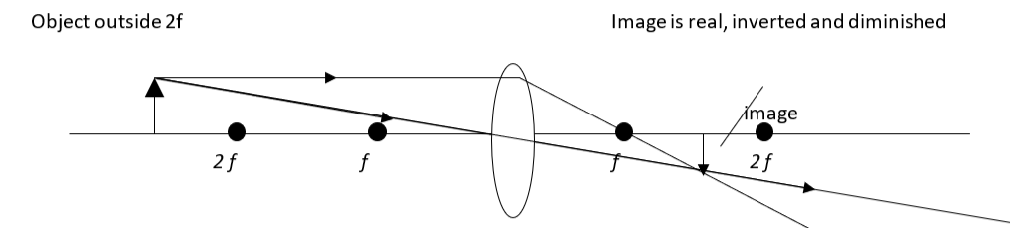

As shown in the diagram, the image would be real.
The critical angle of the glass in a ball lens is 41.4°.
- What is meant by critical angle?
As light oases from a dense to a less dense material, The critical angle is the angle of incidence for which the corresponding angle of refraction is 90º
- Calculate the speed of light in the ball lens.
Refractive index, n:
$$n=\frac{1}{sin C}=\frac{1}{sin 41.4}=1.51$$
$$n=\frac{c_{air}}{c_{glass}}$$
$$c_{glass}=\frac{c_{air}}{n}=\frac{2.9979×{10}^{8}}{1.51}=1.99×{10}^{8} {ms}^{-1}$$

- Explain why white light is dispersed as it passes through the ball lens.
On entering a dense medium such as glass, all light is refracted.
Refraction is caused by the light wave slowing down on entering the new medium, but not all colours slow down to the same extent and because of this they are not all refracted to the same extent. Blue light slows down the most, and therefore is the most deflected. Red light slows down to a lesser extent, and therefore is deflected to a lesser extent. In this way, white light is broken up into its different colours, and a spectrum is formed.
This happens with a glass ball in a way that is very similar to what happens with a prism
