Particle Zoo Guess Who
- Each player starts the game with a board that includes 24 particle cards and with all the images standing up.
- Each player selects a card of their choice from a separate pile of cards containing the same 24 images.
- The object of the game is to be the first to determine which card your opponent has selected.
- Players alternate asking various yes or no questions to eliminate particles. Well-crafted questions allow players to eliminate one or more possible cards.
- The player will then eliminate particles by flipping those cards down until all but one is left.
- Then the player has to shout the particle’s name.
(Based on the Hasbro Guess Who Game. Particle characters used from www.particlezoo.net )

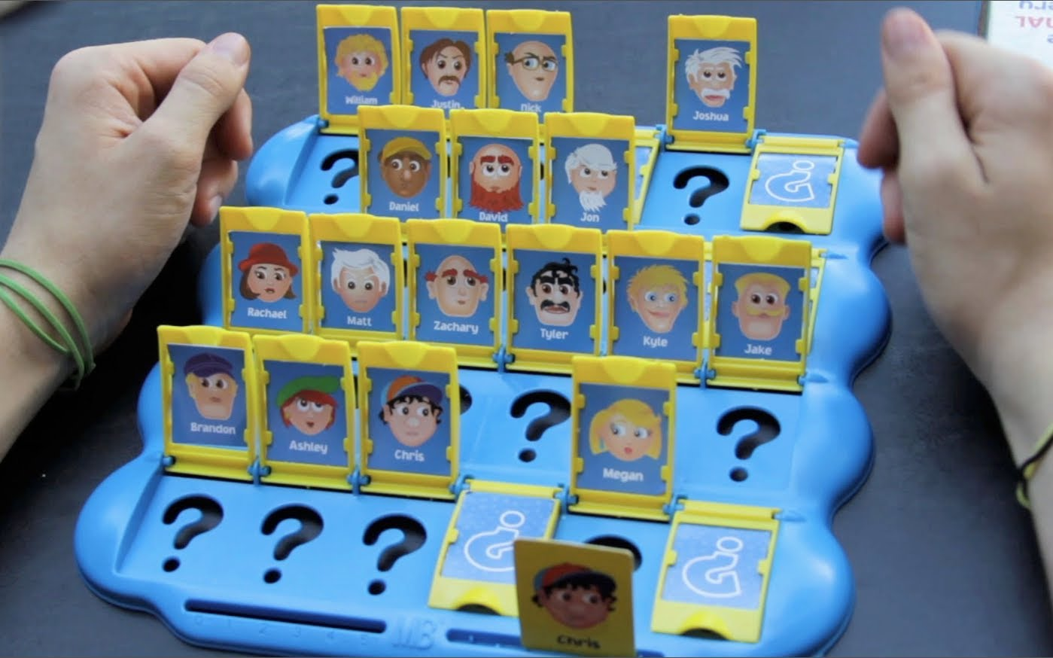
Notes:
- Students can place the cards face up in front of them and use a board to block the view of their opponent’s cards.
- If you don’t want to make a class set you could give each student in the class a card. As questions are asked each student would turn their card face down if they were eliminated until only one student remains. This student should have the correct card.
- Cards could be enlarged and laminated for posters in the class either.

Tachyon | T
Status:
Hypothetical

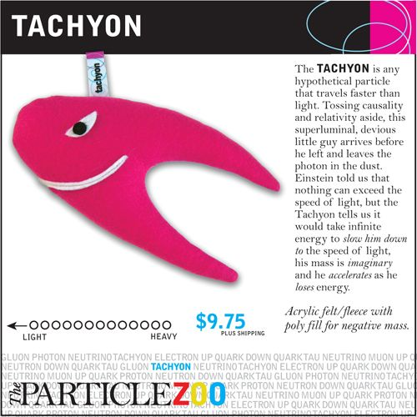
The Tachyon is any hypothetical particle that travels faster than the speed of light.

Graviton | G
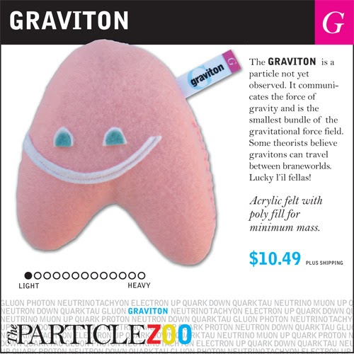
Classification:
Boson
Status:
Hypothetical

The graviton is the hypothetical particle of the weakest of all fundamental interactions, the gravitation.

Photon | $$γ$$
Classification:
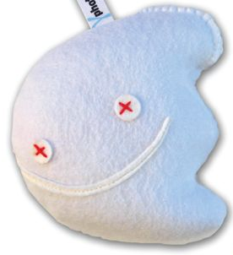
Boson
Status:
Photons were first postulated by Einstein in 1905

It is a massless particle with no charge and is stable. It is subject to the electromagnetic, gravitational and weak force. It communicates the electromagnetic force.

Gluon | g
Classification:
Boson
Status:
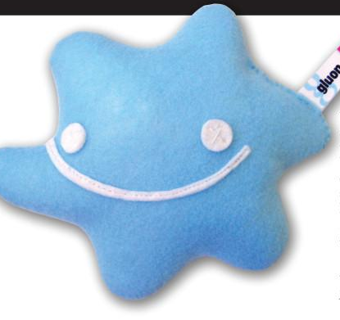
Discovered in 1978

It is subject to the strong force.
It is an elementary particle that acts as the exchange particle (or gauge boson) for the strong force between quarks. They "glue" quarks together, forming protons and neutrons.

Higgs Boson | $$H^{0}$$
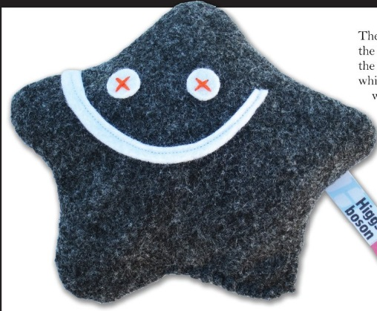
Classification:
Boson
Status:
Discovered in 2012

Scientists believe that the Higgs is responsible for giving mass to all other particles. It has a very short lifetime of one millionth of a billionth of a billionth of a second.

Up Quark | u
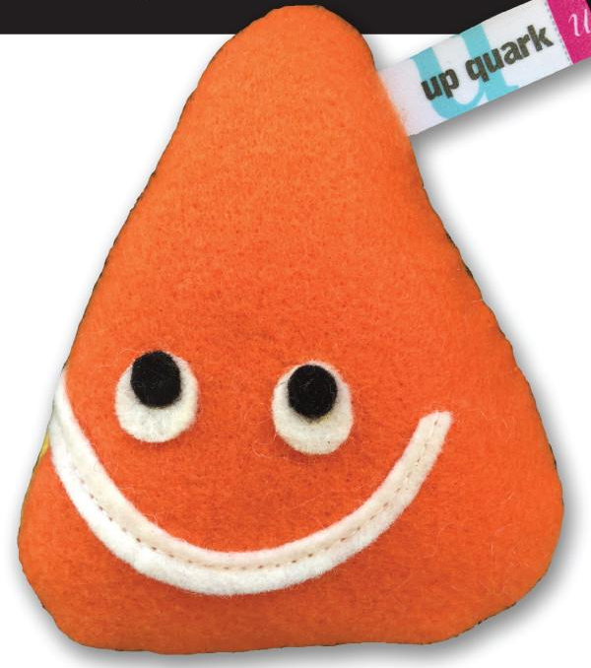
Classification:
Fermion
1st generation
Status:
Discovered in 1968

It has a charge of $+ \frac{2}{3}e$. It is subject to all the fundamental forces of nature. It is the smallest of the 6 quarks. Stable.

Down Quark | d
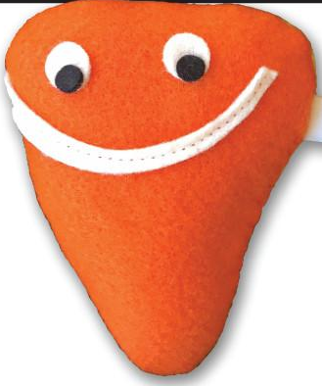
Classification:
Fermion
1st generation
Status:
Discovered in 1968

It has a charge of $- \frac{1}{3}e$. It is subject to all the fundamental forces of nature. It is slightly heavier than the up quark. Stable.

Top Quark | t
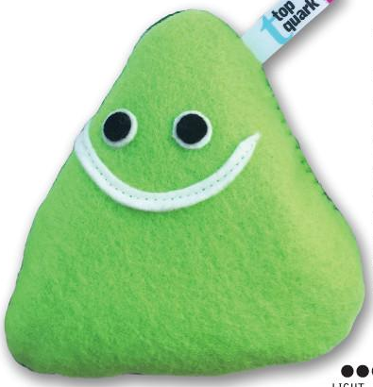
Classification:
Fermion
3rd generation
Status:
Discovered in 1995
It has a charge of $+ \frac{2}{3}e$. It is subject to all the fundamental forces of nature. It is slightly heavier than the up quark. Unstable due to its size with a lifetime of 5 x 10⁻²⁵ s.

Bottom Quark | b
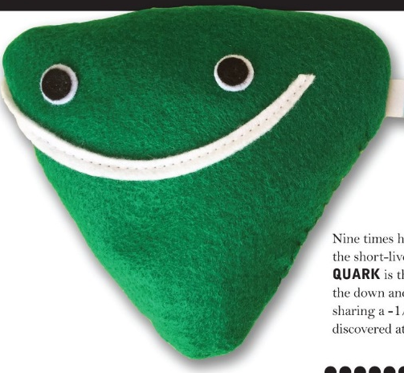
Classification:
Fermion
3rd generation
Status:
Discovered in 1977
It has a charge of $- \frac{1}{3}e$. It is subject to all the fundamental forces of nature. It is about 4 times the mass of the proton. Unstable with lifetime in the range of x10⁻¹² s.

Charm Quark | c
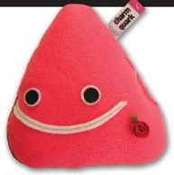
Classification:
Fermion
2nd generation
Status:
Discovered in 1974

It has a charge of $+ \frac{2}{3}e$. It is subject to all the fundamental forces of nature. It is slightly lighter than the tau. Unstable.

Strange Quark | s
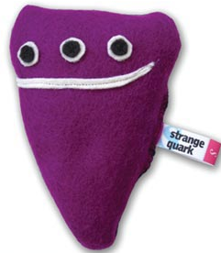
Classification:
Fermion
2nd generation
Status:
Discovered in 1968

It has a charge of $- \frac{1}{3}e$. It is subject to all the fundamental forces of nature. It is similar in mass to the muon. Unstable.

Positron | e⁺
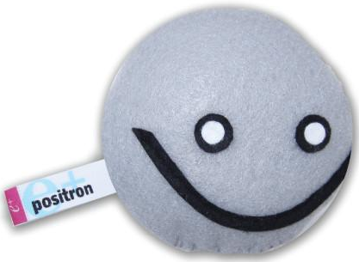
Classification:
Fermion, Lepton
Status:
Discovered in 1932

It has a positive charge. It is subject to the electromagnetic, gravitational and weak forces. This is the antiparticle to the electron. Produced naturally in $β^{+}$ decay.

Electron | e⁻
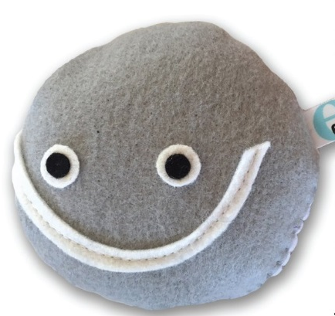
Classification:
Fermion, Lepton
Status:
Discovered in 1897

It has a negative charge. It is subject to the electromagnetic, gravitational and weak forces. Electrons are stable.

Muon | $$μ^{-}$$
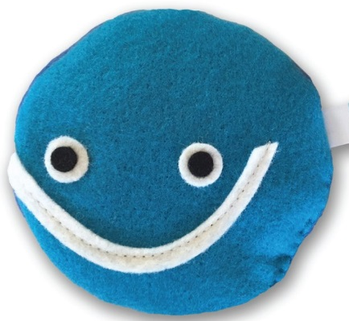
Classification:
Fermion, Lepton
Status:
Discovered in 1936

It has a negative charge. It is subject to the electromagnetic, gravitational and weak forces. The muon is much heavier than the electron. It has a lifetime of 2.2$μs$ before it decays into an electron. Comes from cosmic radiation.

Tau | $$τ^{-}$$
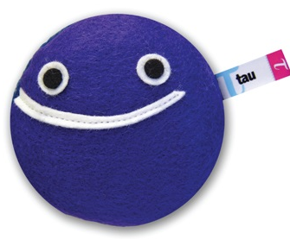
Classification:
Fermion, Lepton

Status:
Discovered in 1975

It has a negative charge. It is subject to the electromagnetic, gravitational and weak forces. The tau is the heaviest lepton. It has a lifetime of 3.3 x 10⁻¹³ s before it decays. Often produced in electron- positron annihilation.

Electron Neutrino | $$ν_{e}$$
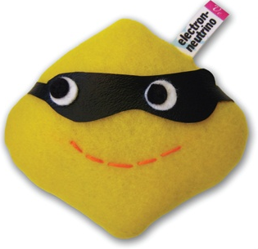
Classification:
Fermion, Lepton
Status:
Discovered in 1956
It has no charge. It is subject to the gravitational and weak forces. It is the result of radioactive decay. Travels close to the speed of light and rarely interacts with anything.

Muon Neutrino | $$ν_{μ}$$
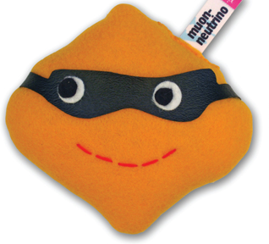
Classification:
Fermion, Lepton
Status:
Discovered in 1962
It has no charge. It is subject to the gravitational and weak forces. Travels close to the speed of light and rarely interacts with anything. Slightly heavier than the electron neutrino.

Tau Neutrino | $$ν_{τ}$$
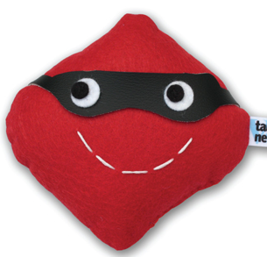
Classification:
Fermion, Lepton
Status:
Discovered in 2000

It has no charge. It is subject to the gravitational and weak forces. Travels close to the speed of light and rarely interacts with anything. It is the heaviest of the neutrinos.

Proton | p
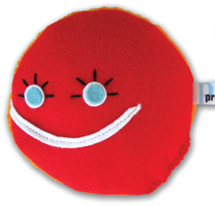
Classification:
Hadron, Baryon
Status:
Discovered in 1919

Composition:
uud

It has a postive charge. It is subject all the fundamental forces of nature.

neutron | n
Classification:
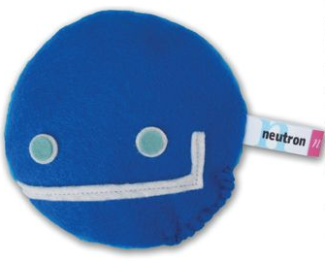
Hadron, Baryon
Status:
Discovered in 1932

Composition:
udd

It has no charge. It is subject all the fundamental forces of nature.

Lambda | $$Λ^{0}$$
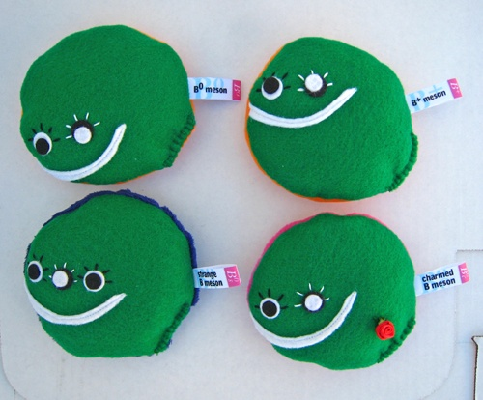
Classification:
Hadron, Baryon
Status:
Discovered in 1950

Composition:
uds

It has no charge. It is subject all the fundamental forces of nature.

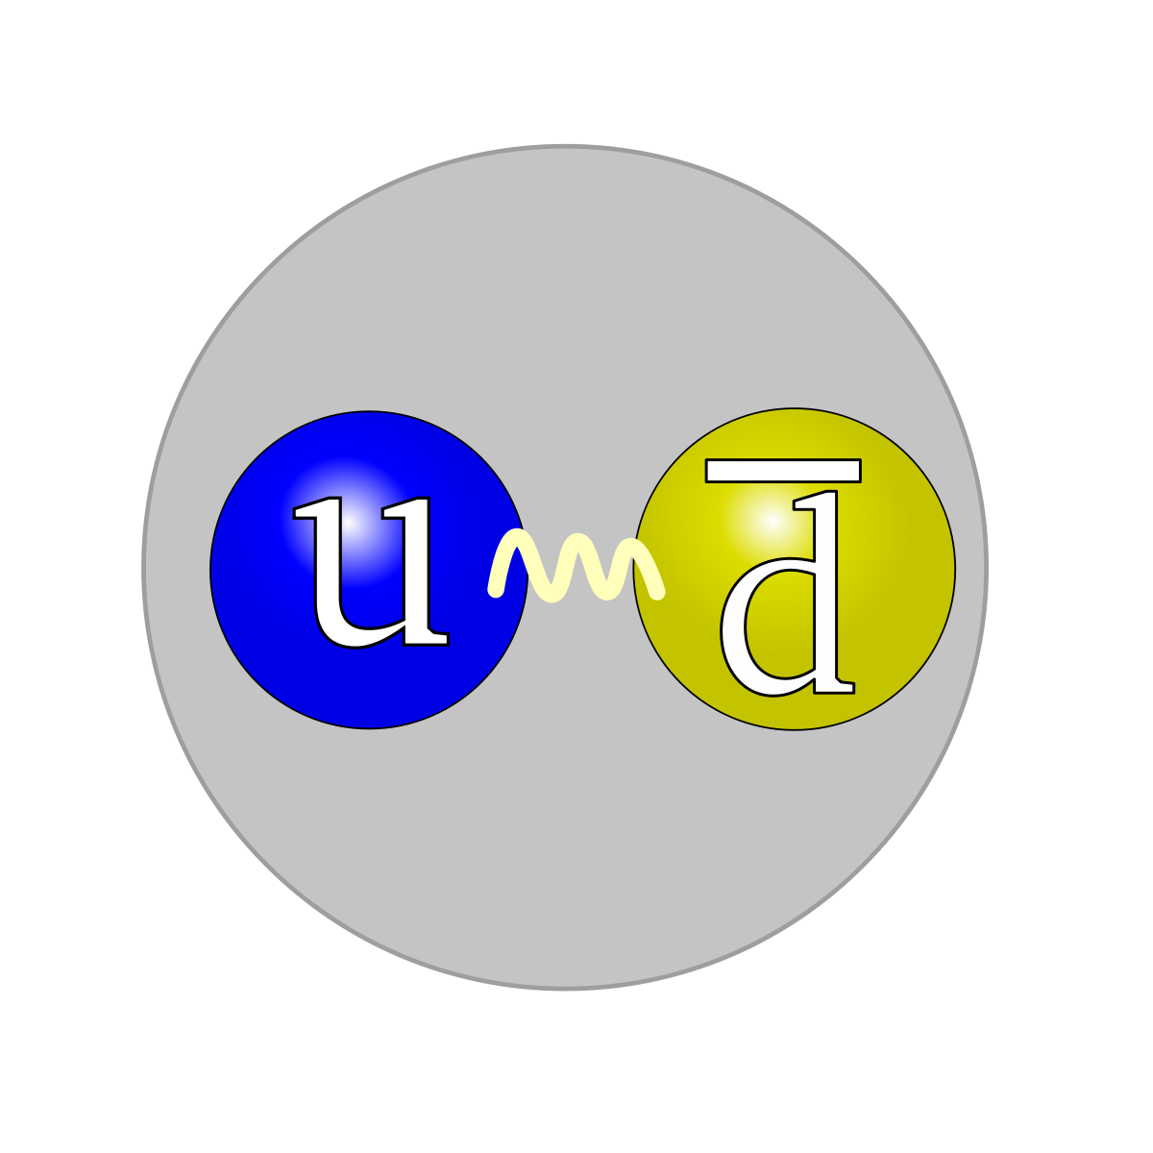

Sigma | $$Σ^{+}$$
Classification:
Hadron, Baryon
Status:
Discovered in 1953

Composition:
uus

It has positive charge. It is subject all the fundamental forces of nature.

Pion | $$π^{+}$$
Classification:
Hadron, Meson
Status:
Discovered in 1947

Composition:
$$u\overline{d}$$

It has positive charge. It is subject all the fundamental forces of nature.

Kaon | $$K^{+}$$
Classification:
Hadron, Meson
Status:
Discovered in 1947

Composition:
$$u\overline{s}$$

It has positive charge. It is subject all the fundamental forces of nature.

