2020 Leaving Cert Higher Level Physics
Section A
Question 1
(i)Draw a labelled diagram of how the apparatus was arranged in this experiment.
Ticker-tape
Timer

- Set up apparatus as in the diagram. With the second trolley stationary, give the first trolley a gentle push.
- After collision the two vehicles combine, using magnets, and move on together.
- The first trolley is attached to a ticker tape timer, as shown, allowing us to measure the time taken to travel a measured distance.
(ii) Describe how the time interval was measured.

As the trolley moves along the track the tape is pulled through the timer.
Every 0.02 seconds a mark is made on the paper by the hammer.
For an accelerating trolley, the paper looks like this:

. . . . . . . . . . . . …
x
y

The value of t, the time, is (the number of spaces between dots) x (0.02).

A value of 10 such spaced will yield a time of 0.2 s
To find the acceleration , we use the formula:

(iii) How were the effects of (a) friction and (b) gravity minimised?
(i)Friction creates an external force, which would invalidate the principle of conservation of momentum. To offset this effect, the air-track can be used. As the rider slides along on a bed of air, there is virtually no friction.
Alternatively, the track shown above could be placed on a very slight downward gradient, creating an acceleration due to gravity, which would offset the effect of friction.
(ii) If the latter method is used but the gradient is too great, this would mean that the acceleration caused by gravity would more than offset that created by friction. In that situation there is a risk that gravity would create an external force.
If the track is horizontal that would not be an issue.
As the effects of gravity and friction are interlinked (the weight of the riders pull them down onto and the track create friction), a balance should be struck between the two issues.

The following data were recorded.
Mass of body A = 125.6 g
Mass of body B = 111.1 g
Distance travelled by body A for 0.2 s before collision = 11.4 cm
Distance travelled by bodies A and B for 0.2 s after collision = 6.1 cm

Use the data to

(iv) calculate the initial and final velocities of body A,
Velocity before collision:
$$v=\frac{distance}{time}= \frac{.114}{.2}=0.57 ms^{-1}$$

Velocity after collision:
$$v=\frac{distance}{time}= \frac{.061}{.2}=0.305 ms^{-1}$$

(v) demonstrate how the experiment verifies the principle of conservation of momentum.
Momentum before collision: $p=\left(0.1256\right)\left(0.57\right)=0.072 ms^{-1}$
Momentum before collision: $p=\left(0.1256+.1111\right)\left(0.305\right)=0.072 ms^{-1}$

As these calculations show the total mentum before the collision is equal to the total momentum after, verifying the principle of conservation of momentum.

Question 2
- Explain how the refracted ray and the angle of refraction were determined. (A labelled diagram may help your answer.)

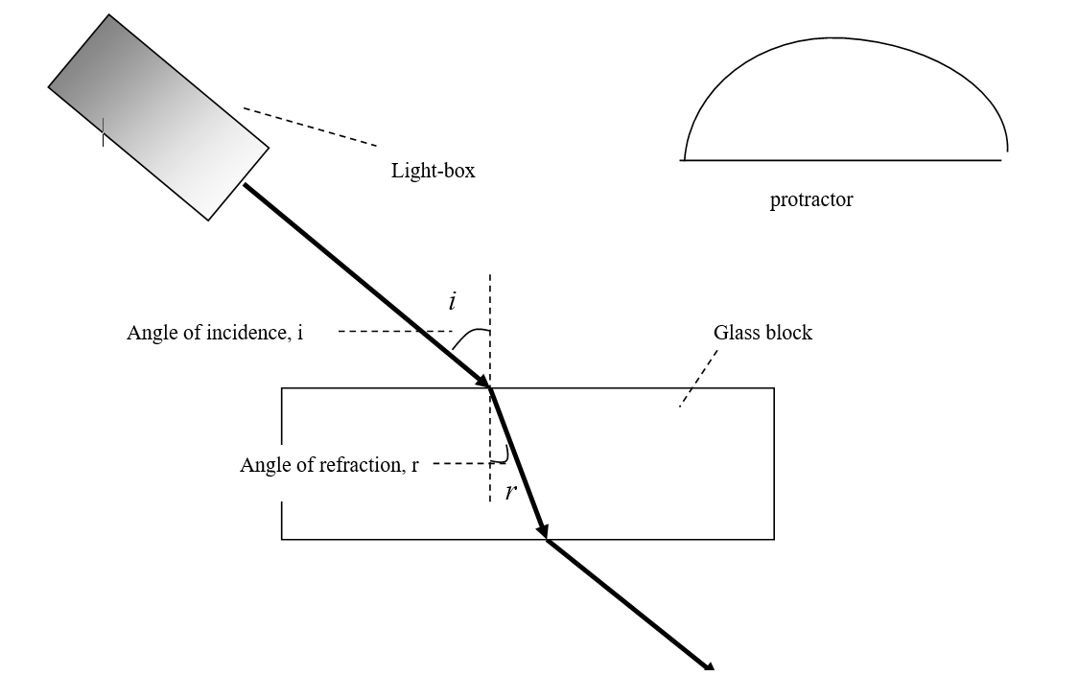

- Place a glass block as shown and mark its outline.
- Shine a ray of light from a light-box as shown.
- Mark the position of the light ray as it enters and leaves the block and remove the block
- Draw in the refracted ray, as shown above.
- Draw in the normal and measure i and r, as shown, with a protractor

(ii) Why would using a smaller angle of incidence have led to a less accurate measurement of the angle of refraction?
A smaller angle of incidence would create a smaller angle of refraction. This would increase the percentage error in the measurement of the angle of refraction.

(iii) Use the data to draw a suitable graph to verify Snell’s law.
Sin i | 0.5 | .64 | .77 | .87 | .94 | .98
Sin r | .33 | .42 | .52 | .57 | .63 | .66

(iv) Explain how your graph verifies Snell’s law.
The graph yields a straight line through the origin, confirming that sin I is proportional to sin r, in keeping with Snells Law.

(v) Use your graph to calculate the refractive index of the glass.
The slope of the line of best fit will be equal to the refractive index.

$slope=\frac{rise }{run}$ =$\frac{0.6-0.0 }{0.4-0.0}=1.5$

Therefore the refractive index is 1.5

Question 3
- Draw a labelled diagram of how the apparatus was arranged in this experiment.

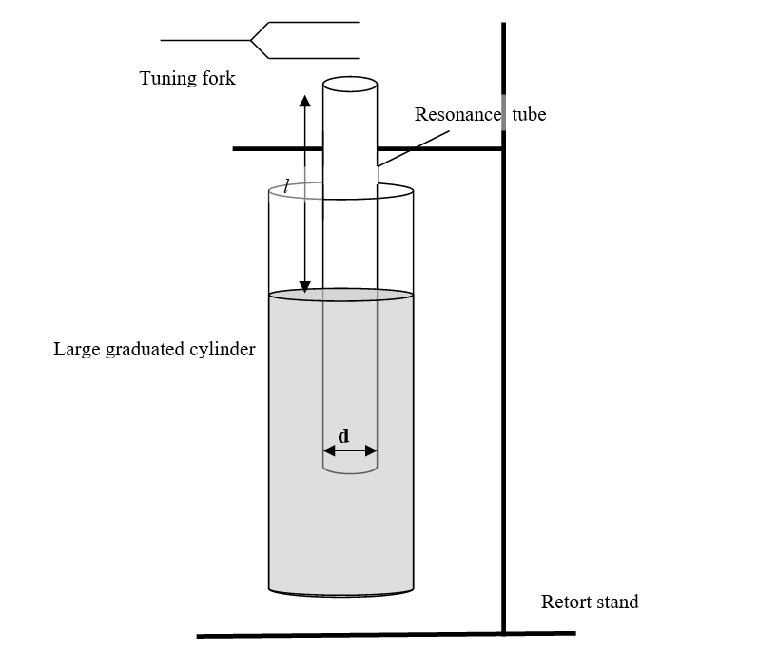

- How did the student determine the length of the air column for a particular frequency?
- Set up the tube as indicated in the diagram. One end of the tube will be sealed by the water, whereas the other is open to the air.. Using a Vernier, or digital, calipers, measure the diameter of the tube, d.
- Begin with the tube positioned so that only a few centimeters are above the level of the water
- Strike the highest frequency (f) tuning fork and hold it in a horizontal position just above the top of the tube.
- Slide the tube slowly up until you can hear a clear sound coming from the air inside the tube. Tighten the clamp in the position that yields the clearest sound, and measure the length of the air column (l) with a metre stick.
- Repeat this procedure to obtain the corresponding values of l for several tuning forks. Record the measurements in a table.

- How did the student ensure that the fundamental frequency, not an overtone, was observed?
If the student begins the process for each frequency with the value of l very small (close to zero) and slowly increases it, the fundamental frequency will be the first encountered. Also, if a frequency is noted at two lengths, the louder of the two will be the fundamental (and its sound will be the closest to the sound of the tuning fork)
- Use the data to draw a graph of f against ¹/l

- Calculate the slope of your graph. Hence or otherwise calculate the speed of sound in air
$slope=\frac{rise }{run}$ =$\frac{300- 0.0 }{3.6-0.0}=83.3$

We know that $c=fλ$ ,
and the wavelength in this case will be $λ=4l$, (where l = the measured length)

combining these two: $c=4fl$

rearranging this into the format that y$=mx+c$, we can say that the eqn of our line above is:
that $f=\frac{c}{4}.\frac{1}{l}$

from this we can say that:
$$\frac{c}{4}=slope$$

$$\frac{c}{4}=83.3$$

and,
$$c=4\left(83.3\right)=333.2 ms^{-1}$$

Question 4
- Name the pieces of apparatus that were used to measure (a) the diameter, (b) the length and (c) the resistance of the wire.

The diameter would have been measured with a micrometer screw, or digital calipers.
The length would have been measured with a metre stick
The resistance would have been measured with an ohmmeter

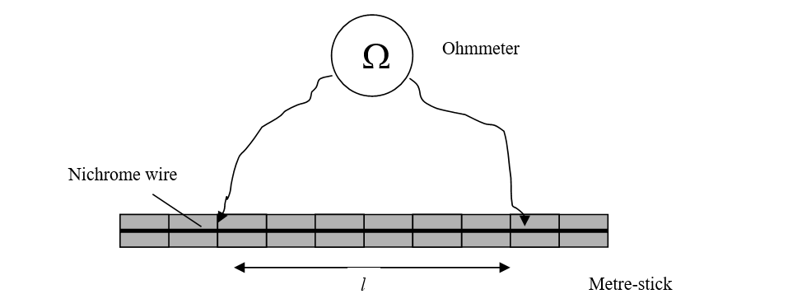

- How did the student ensure that the diameter of the wire was uniform?

The diameter would have been measured in a number locations to verify uniformity. It is quite likely that the wire would not be of uniform cross section, in which case, the average diameter is used.

- Use the data to draw a graph of R against l.

- Calculate the slope of your graph.
$slope=\frac{rise }{run}$ =$\frac{.151- 0.0 }{0.42-0.0}=0.36$

- Hence calculate the resistivity of the metal.
From the tables: $R=\frac{ρl}{A}$

Or, $R=\frac{ρ}{A}l$

By comparison with $y=mx+c$, we can see that:

$\frac{ρ}{A}=slope=0.36$

We know that $A=πr^{2}=π{\left(\frac{d}{2}\right)}^{2}=π{\left(\frac{2.05x10^{-3}}{2}\right)}^{2}$=$3.3x10^{-6}m^{2}$

Therefore the resistivity, $ρ=\left(0.36\right)\left(3.3x10^{-6}\right)=1.188x10^{-6}Ωm$

- How would the resistance of a fixed length of wire change if its diameter was doubled?

We know that doubling the diameter will increase A by a factor of 4 ($A=πr^{2}$)

Following $R=\frac{ρl}{A}$, we can see that this would decrease the resistance by a factor of 4.

Section B
Question 5
- State Boyle’s law.
Boyle’s Law states that for a fixed mass of gas at constant temperature, the pressure is inversely proportional to the volume ($i.e. Pα\frac{1}{V}$)
- A neutron star has a density of 3.7 × 10¹⁷ kg m⁻³.
What would the radius of the Earth be if it had the same density as the neutron star? (mass of Earth = 6.0 × 10²⁴ kg)
$$ρ=\frac{m}{V}$$
$$V=\frac{m}{ρ}=\frac{6.0 × {10}^{24} }{3.7 × {10}^{17} }=1.622x{10}^{7} m^{3}$$

We also know that $V=4/3πr^{3}$
Therefore: $r^{3}=\frac{3\left(V\right)}{4π}= \frac{3\left(1.622x{10}^{7}\right)}{4π}=3.87x{10}^{6}$
And the radius would be: $r=157 m$
- A spring has a length of 22 cm when a 2 N weight hangs from it. The spring constant is 50 N m^{–1}.
Calculate the natural length of the spring.
$$F=\left(-\right)ks$$

$$2=\left(-\right)50s$$

$$s= \frac{2}{50}=0.04 m$$

If the extension is 4 cm, and the actual length is 22 cm, then the natural length is 18 cm

- Draw a ray diagram to show the formation of an image in a convex mirror.
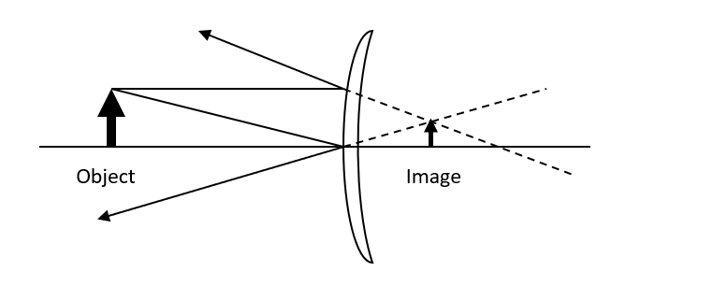
- What is meant by the amplitude of a wave?

The Amplitude of a wave is a measure of the maximum displacement moved by a point on or within a medium or object through which a wave is travelling. It is measured from the equilibrium position.

- Name one of the three primary colours of light. What is its complementary colour?
Red is a primary colour. Its complementary colour is cyan.

- Draw a labelled diagram to show how an electric field pattern can be demonstrated in the laboratory.

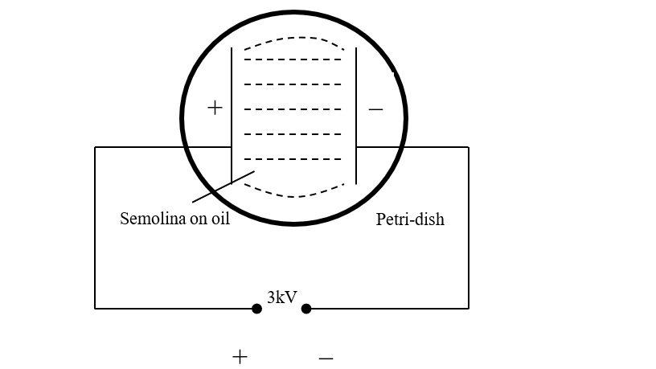

- Distinguish between intrinsic and extrinsic conduction in a semiconductor.
Intrinsic conduction refers to the conduction with a pure sample of a semiconducting material. There will be an equal number of free electrons and ‘positive’ holes.
Extrinsic conduction refers to the conduction within a sample of semiconducting material that has been doped with impurities, so that there will be either additional free electrons or ‘positive’ holes

- The diagram shows a sketch of a photocell.
What particles move between the electrodes of the photocell?
In what direction do the particles move?
Electrons move from the negative electrode of a photocell to the anode (once the cathode has been struck by electromagnetic radiation of a suitable frequency)

- a. Write a nuclear equation to show the pair annihilation of a positron and an electron.
$$e_{1}^{0}+e_{-1}^{0}→2hf$$
or b. Draw the truth table for an OR gate.
For a 2 input (A and B) gate:
input |  | output
A | B | output
0 | 0 | 0
1 | 0 | 1
0 | 1 | 1
1 | 1 | 1

Question 6
Motion and the effects of forces can be explained using Newton’s three laws of motion.
- State Newton’s laws of motion.
- A body will continue in a state of rest or of uniform velocity unless an unbalanced external force acts upon it
- The rate of change of a body’s momentum is proportional to the force which causes it and takes place in the direction of that force. (F = ma)
- If body A exerts a force on body B, then body B exerts an equal but opposite force on body A.
- Show that F = ma is a special case of Newton’s second law.

From the second law, we can see that force is proportional to the change in a body’s momentum:
i.e., for a body of mass m, changing from a velocity v to one of u:
(as $a=\frac{v-u}{t}$)
As this is the formula which is used to define the unit of force, the Newton, we can choose a value for k, and choose the value of 1.

- Describe an experiment to find the resultant of two co‐planar vectors.

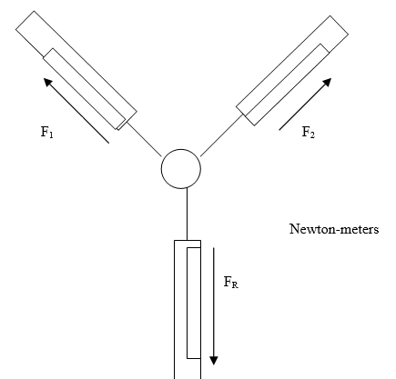

Method:
Set up apparatus as shown.
Note the readings on the first two Newton-meters
- F_{R}
And note the reading on the on the third meter,
Observation:
According to Newton’s third law, this should be equal in magnitude but opposite in direction to the resultant of the two upper meters.
(Note that you can also calculate the resultant of the vectors, F_{T} using vector addition. The two methods should give additional results.)

A cricket player moves her hands away from the motion of the ball as she catches it.
- Use Newton’s laws of motion to explain why she moves her hands away from the motion of the ball.

From Newton’s 2nd Law, we can say that the force created by the player on the ball, and subsequently by the ball on her hand is given by:

In catching the ball, she will obviously want to stop it moving, from velocity v to zero. This means that the top of the fraction has a fixed value. However, if she extends the time over which she does this as described in the question, the bottom of the fraction is increased in value, and the overall value of the force F (exerted by the ball on her hand) is reduced. This means it will hurt less.

She then throws a ball upwards with an initial velocity of 28 m s^{–1} at 45° to the horizontal. Her hand was 1.6 m above the ground. A short time later the ball was caught by another player. When it was caught the ball was again at a height of 1.6 m. Calculate:

- how long the ball was in the air,

We need to resolve the speed of the ball into horizontal and vertical components:
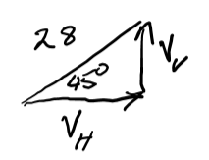
$V_{V}=28\sin{{45}^{0}}=19.80 ms^{-1}$

$$V_{H}=28\cos{{45}^{0}}=19.80 ms^{-1}$$

Considering vertical motion up to where it reaches its highest point:
$$u=19.80$$
$$v=0$$
$$a= -9.8$$
$$s=s$$
$$t=t$$

$$v=u+at$$
$$0=19.8-9.8t$$
$$t=\frac{19⋅8}{9.8}=2.02 s$$
It takes 2.02 s to reach its highest point, and will therefore take 4.04 seconds to return to its original height

- the horizontal distance travelled by the ball,
in horizontal motion, the acceleration is zero
$$s=ut+\frac{1}{2}at^{2}$$
$$=\left(19.8\right)\left(4.04\right)+\left(0\right)=79.99 m$$
The ball will have travelled approximately 80m

- the maximum height above the ground reached by the ball.

In vertical motion:
$$=\left(19.8\right)\left(2.02\right)+\frac{1}{2}\left(-9.8\right){\left(2.02\right)}^{2}=20 m$$

As the ball is already 1.6 m off the ground, the max height reached will be 21.6 m

- Draw a diagram to show the velocity v and acceleration a of the ball when it is at its maximum height. Also show the force(s) F on the ball. Use the letters v, a and F to label your vectors.
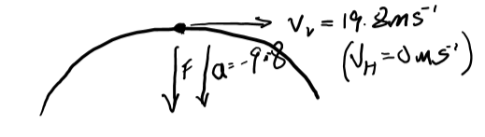
The force acting on the ball at its highest point is its own weight.

Question 7
Radioactivity was discovered in 1896 by Henri Becquerel.
Define (i) radioactivity, (ii) the becquerel.
Radioactivity is the emission of either particles or electromagnetic radiation from the nucleus of an atom

One Becquerel is defined as the disintegration of one nucleus per second

In the uranium decay series, U–238 decays to Pb–206 in a series of alpha and beta decays. The first decay in this series is an alpha decay and the final decay is a beta decay.
(iii) Write a nuclear equation for the first decay in this series.
$$U_{92}^{238}→Th_{90}^{234}+He_{2}^{4}$$

(iv) Write a nuclear equation for the final decay in this series.

${Tl}_{81}^{206}→{Pb}_{82}^{206}+e_{-1}^{0}$

- Calculate the total number of alpha particles and the total number of beta particles emitted in the series.

Mass number changes:$238-206=8(4)$
This means that 8 alpha-particle were emitted
What effect would 8 alpha-particles have on the atomic number?
$$8\left(-2\right)=-16$$
The atomic number would fall by 16 if only alpha particle were emitted
What did happen to the atomic number: $92-82=10$
The atomic number actually fell by 10.
Beta particles increase the atomic number by +1.
This tells us that 6 beta particles were emitted.

The half‐life of U–238 is 4.5 × 10⁹ years.
- How long will it take for the number of U–238 nuclei in a sample to decrease by a factor of 8?

Number of half-lives: $8= 2^{3}$: 3 half-lives have passed

$$3×(4.5×{10}^{9})=1⋅35×{10}^{10} years$$

- A sample of U–238 contains 3.2 × 10¹⁰ nuclei. Calculate its activity.

$$T_{1/2}=\frac{\ln{2}}{λ}$$

$$λ=\frac{\ln{2}}{(60x60x24x365x4.5×{10}^{9})}=4.88×{10}^{-18} s^{-1}$$

$$A= λN=4.88×{10}^{-18}x 3.2 x{10}^{10}$$
Activity: $A=1.56×{10}^{-7}Bq$

- U–238 is an isotope of uranium. What are isotopes?
Isotopes are atoms of the same element with differing mass numbers
Radon gas forms part of the uranium decay series.
- Why is radon considered to be dangerous?
Radon is an alpha emitter. Alpha particles are ionizing radiation and therefore pose a threat to us. At the same time they have low penetrating power, so alpha particles emitted by most rock pose little threat to us as they slow down quickly in the air.
Radon, however is a gas and mixes into the air. If it emits its alpha particle while inside our lungs, it can be damaging.

- How can the build‐up of radon in a building be reduced?
Radon build-up can be reduced by the inclusion of a Radon barrier in the foundations when a building is under construction. When an older building is shown to have a Radon build-up, the dangers can be mitigated by improving the ventilation and air-flow through the building.

Question 8
All insulated metal bodies can store charge.
- Describe how a pear‐shaped metal body can be charged by induction.

Allow a Van de Graaf generator to build up a charge.
Place a pear-shaped conductor close to the dome, as shown (using an insulating stand)
Touch the far side of the conductor, earthing it.
Remove your finger and remove the VdG generator.
There will be a charge on the pear-shaped conductor.

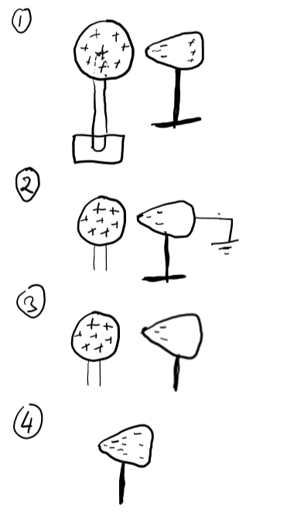

- Draw a diagram to show the distribution of charge on the body after charging.

The charge will be concentrated towards the ‘point’ of the pear shape, in keeping with the point effect.

A charged capacitor stores energy.
- Define capacitance.

The capacitance of an object is the ratio of the charge (Q) on the object to its voltage (V):

$$C=\frac{Q}{V}$$
- Draw the circuit symbol for a capacitor.
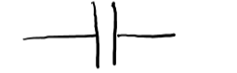

A 4000 μF capacitor is connected across 500 V. The stored energy is converted to heat when the capacitor is discharged through a heating element placed in 40 g of water in an insulated container.

- Calculate the maximum rise in temperature of the water

Energy stored: W$=1/2CV^{2}= 1/2(4000 x{10}^{-6})(50{0)}^{2}$= 500 J
When this energy is added to water:
$$E=mcΔθ$$
Maximum rise in temperature is given by:

$$Δθ=\frac{E}{mc}=\frac{500}{(0.04)(4180)}= {2.99}^{0}C$$

- Describe an experiment to demonstrate how the capacitance of a parallel‐plate capacitor changes with the distance between the plates.

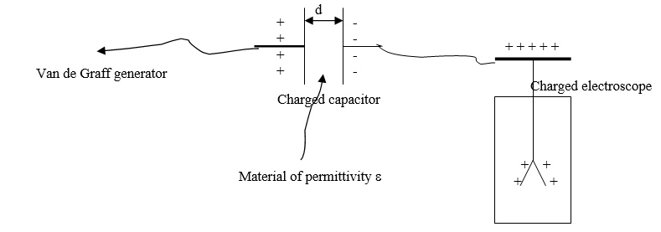

Set up the apparatus as shown
Observations / conclusion: When the plates are drawn apart, the leaves collapse, indicating that the stored charge, and therefore the capacitance, is inversely proportional to d.
Similarly we can show that reducing A, the common area, reduces the capacitance, and varying the material between the plates affects the capacitance according to the formula:

A student makes a Leyden jar in the laboratory. It consists of a cylindrical glass container of internal radius 6 cm. The glass in the jar is the capacitor’s dielectric and has a relative permittivity of 2.1 and a thickness of 5 mm. Aluminium foil of height 17 cm coats the inside and outside vertical walls of the jar.
- Calculate the surface area of the inner cylinder of aluminium foil.

Area of a cylinder: $A=2πRh= 2π\left(0.06\right)\left(0.17\right)=0.064{ m}^{2}$

- Calculate the capacitance of the Leyden jar.

$C=\frac{εA}{d}= \frac{(2.1×8.854×{10}^{-12})(0.064)}{(0.005)}=2.38×{10}^{-10}F$
- What property of glass allows it to be used as a dielectric?

It is an insulator

Question 9
- Define resonance.
Resonance is the transfer of energy between two bodies of the same natural frequency of vibration.

- Describe a laboratory experiment to demonstrate resonance
- Take two tuning forks of the same natural frequency. Hold one against a hollow wooden box, as shown.
- Strike the other so that it vibrates. Hold it against the box so that you can hear the sound. Then remove this fork.
- The other tuning fork will continue to audibly vibrate, demonstrating resonance

A guitar string has length 2 m and mass 0.88 g. It is stretched across two fixed points which are 65.1 cm apart on a guitar. It is then plucked and it vibrates at a fundamental frequency of 330 Hz.
- Draw a labelled diagram to show a guitar string vibrating at its fundamental frequency.

Calculate
- the tension in the string,
mass per unit length:
$$μ=\frac{mass}{lⅇngth}=\frac{0.00088}{2}=0.00044 k{gm}^{-1}$$

$$f=\frac{1}{2l}\sqrt{\frac{T}{μ}}$$

$$330=\frac{1}{2(0.651)}\sqrt{\frac{T}{(0.00044)}}$$

$$\sqrt{\frac{T}{(0.00044)}}=429.66$$

$$\frac{T}{0.00044}=184,607.716$$

$T=81.23 N$

- the speed of sound in the string.

Wavelength: $λ=2l=2\left(0.651\right)=1.302 m$

Speed: $C=fλ=\left(330\right)\left(1.302\right)=429.66 ms^{-1}$

- Draw the magnetic field around a bar magnet.

N S

- Explain how an emf is induced in the coil.

states that when there is a change in the magnetic flux linking a coil, an emf is induced in that coil. The strength of the emf is proportional to the rate of change of the flux linking the coil.
In an electric guitar, the string is magnetized by the presence of a magnet just beneath it, usually built into the structure of the guitar. When the string vibrates, it essentially becomes a vibrating magnet, inducing an emf, and a current, in the coil beneath.

- Sketch a graph to show how the output current varies with time.

I/A

t/s

Question 10
- What are the two fundamental forces that the neutrino experiences?
Neutrinos experience the weak nuclear force and the gravitational force.

- Pions and kaons are members of the meson family. What are mesons?
Mesons are subatomic particles that consist of one quark and one anti-quark. They are members of the Hadron family

- List the three types of neutrino in order of increasing mass.

The three types of neutrino are:
- The electron neutrino (the smallest often just referred to as a neutrino)
- The muon neutrino
- The tau neutrino (the largest)

- Why is no tunnel required to transport the neutrinos underground to South Dakota?

Neutrinos interact very weakly with matter, and most will pass through the earth as if it wasn’t there.

- Calculate the time taken for the neutrino to travel from Fermilab to South Dakota. (24)
$$time=\frac{distance}{speed}=\frac{1,300,000}{\left(0.99\right)\left(2.9979x{10}^{8}\right)}=4.38x10^{-3} s$$

- In another experiment in Fermilab two protons, each with a kinetic energy of 29 GeV, collide and new particles are created. After the collision, the total kinetic energy of the two protons and the new particles is 16 GeV. Calculate the total mass of the new particles created.

$$energy availble=\left(2x29\right)GeV-16 GeV=42 GeV$$

$$E=42x{10}^{9}×1⋅602×{10}^{-19}=6.7284x{10}^{-9}J$$

$$m=\frac{E}{c^{2}}=\frac{6.7284 x {10}^{-9}}{{\left(2.9979 x {10}^{8}\right)}^{2}}=7.5466 x{10}^{-26}kg$$

- Enrico Fermi proposed the existence of the neutrino. He also built the first self‐sustaining nuclear fission reactor.
What is nuclear fission?

Nuclear fission is the disintegration of a large atomic nucleus into two smaller nuclei, accompanied by the release of energy

- Why was Fermi’s nuclear reactor self‐sustaining?

The fission process is started when a neutron strikes a U -235 nucleus. The process results in the release of other neutrons, which can then strike further nuclei and create a self-sustaining chain reaction

- Graphite was used in his nuclear reactor. What was the purpose of the graphite?
Graphite was used as a moderator. This slowed the neutrons down so that they struck further nuclei at the speed most likely to result in nuclear fission.

- Is nuclear fission a spontaneous or a non‐spontaneous process? Explain your answer.

The nuclear fission of U-235 would not be considered a spontaneous process as it will only happen when the nucleus is struck by an external neutron (though that is likely to happen naturally due to the presence of neutrons in the atmosphere). It is possible that spontaneous fission of larger nuclei does occur, but it is very unlikely to lead to a sustained and uncontrolled chain reaction due to the low density of large nuclei in most natural situations.

Question 11
- J.J. Thomson used cathode ray tubes in his research. How are electrons (i) produced, (ii) deviated in a cathode ray tube?
Electrons are produced by thermionic emission at the cathode. They are deviated when they either pass between charged electric plates known as X- and y-plates, or when they pass through magnetic fields caused by electric magnets

- Cathode rays are accelerated through a potential difference of 4 kV in a cathode ray tube. Calculate the maximum speed of an electron in the tube.
Energy gained: $E=qV=\left(1.6×{10}^{-19}\right)\left(4000\right)=6.4×{10}^{-16} J$

this is kinetic energy: $\frac{1}{2}mv^{2}= 6.4×{10}^{-16 }J$
and $v=\sqrt{\frac{2x6.4×{10}^{-16}}{9⋅109×{10}^{-31}}}=$ 3.75 x 10 ⁷ ms⁻¹

- What pieces of apparatus can be used to demonstrate the diffraction of light in the laboratory?
A diffraction grating can be used with a laser to demonstrate diffraction. An interference pattern will be formed on a screen, demonstrating both diffraction and interference.

(d) Geiger also played an important role in the development of the Geiger counter, a detector of nuclear radiation.
Describe the principle of operation of any detector of nuclear radiation.
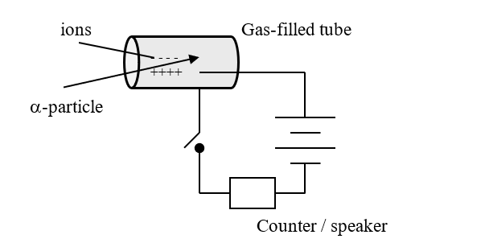

This a metal cylinder containing a mixture of argon and bromine at low pressure. An electric field exists in the tube as shown.
If ionizing radiation should enter the chamber, the ions it creates flow towards either the anode or cathode and for a few moments a current will flow. The counter can be used to register for how long the current flows, and therefore how much radiation is present.

- Describe the Geiger‐Marsden experiment that used thin sheets of gold. Include their setup, observations and conclusions.
This experiment is usually attributed to Rutherford, with whom Rutherford was studying.

They fired a beam of alpha-particles towards a thin sheet of gold.
Alpha particles are small, positively charged particles. He chose gold because it can be pressed very thin, so thin that it is only a few atoms from front to back.
Observations and conclusions: What they found was that most particles went through the foil, without damaging it. A small percentage was diverted as shown, while an even smaller percentage was repelled back towards the source.

This experiment gave rise to the idea of the Rutherford-Bohr model of the atom, with which we are already familiar. In this model,
- most of the atom is empty space
- there is a positively charged nucleus, which contains the protons and neutrons
- the nucleus is surrounded by several 'shells' of negatively-charged electrons.
- Describe with the aid of a labelled diagram the Bohr model of the atom. Use the model to explain emission line spectra.

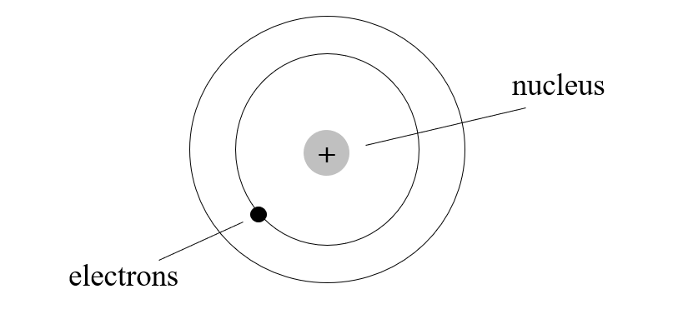
- In their low-energy (ground) state, electrons will occupy a shell as close to the centre of the atom as possible.
- When more energy is available – from heat, or light or any other source – an electron will use that energy to move further out from the centre, to a higher energy level, or shell.
- The electron will stay at the higher level for a period of time and then fall back towards the centre, to a lower level.
- The energy it absorbed when moving out, will be released in the form of electromagnetic radiation. The quantity of energy released determines the frequency of the radiation, or the colour of the light.
- Every element has a characteristic mix of electrons, and therefore electrons tend to move between the same levels within those elements. This means that each element has its own characteristic spectrum, which always consists of the same mix of colours.

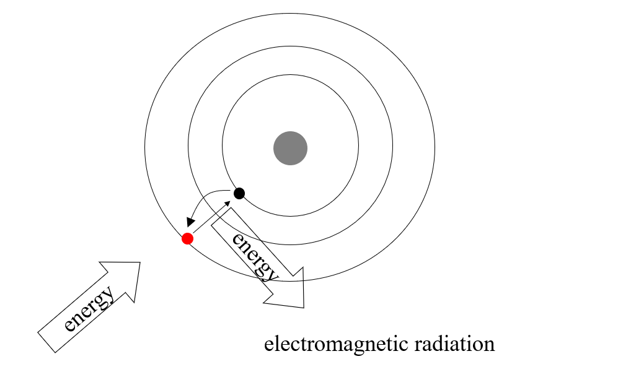

Question 12 a
- Derive an expression for the period of orbit T of the Moon when it has a radius of orbit R around the Earth (of mass M).

M
Satellite; mass = m
r

Period (T) of the moon (or any satellite)
For satellites in orbit about a planet of mass, M, the centripetal force is equal to the gravitational force: i.e.

But, in terms of the period, T of a motion:
$$T^{2}=\frac{4π^{2}r^{3}}{GM}$$

- Calculate the period of the Moon as it orbits the Earth.

$$T^{2}=\frac{4π^{2}r^{3}}{GM}$$

$$T^{2}=\frac{4π^{2}{(3.85 x10^{8})}^{3}}{\left(6.7×{10}^{-11}\right)\left(6×{10}^{24}\right)}=5.6×{10}^{12}$$

$$T=2,367.325.3 s$$
(which is approximately 27.4 days)

- Calculate the gravitational force exerted by the Moon on an astronaut of mass 80 kg when he is 250 km above the surface of the Moon.

$$F=\frac{GMm}{d^{2}}$$

$$F=\frac{\left(6.67×{10}^{-11}\right)\left(80\right)\left(7.3×{10}^{22}\right)}{{\left(1,740,000+250,000\right)}^{2}}=98.36N$$

- Astronauts appear to be weightless when they orbit the Moon. Explain why.

When in orbit around the moon, the astronauts and their orbiter are in what is known as perpetual freefall. They are by no means weightless – their weight is what is keeping them in orbit, but the force pulling them down to the moon creates a trajectory that exactly matches the curvature of the moon’s surface beneath them.

They are in a situation analogous to being inside a falling lift: they are constantly falling and their spacecraft (or lift) is falling at the same rate. The lack of a normal reaction means that they can float around inside as if weightless.

The same thing happens in the ISS.

Question 12b
On a particular day, solar radiation falls on the surface of Antarctica at a rate of 850 W m^{–2}. 52% of the incoming radiation is infra‐red radiation. The average frequency of the infra‐red radiation is 15 THz.
- Radiation is one of three methods of heat transfer. What are the other two methods?
The other methods are conduction and convection

- Calculate the infra‐red energy that falls on 0.25 m² of Antarctica in 3 minutes.

$$E=\left(850\right)\left(0.25\right)\left(3×60\right)=38, 250 J$$

- Calculate the number of infra‐red photons that fall on this area in this time.

The energy on 1 photon:

$E=hf=\left(6.626x 10^{-34}\right)\left(15×{10}^{12}\right)=9.94 x{10}^{-21}J$

The number of photons, N:

$N=\frac{38250}{9.94×{10}^{-21}}=3.85x {10}^{24}$

At present the total volume of ice in glaciers on Earth is 170,000 km³.

Calculate the energy required to melt 0.5% of the Earth’s glaciers if their average temperature is –6 °C and the melting point of glacier ice is –2 °C.

$m=ρV=\left(920\right)\left(85,000x {10}^{9}\right)=7.82x {10}^{16 }kg$

$$E=\left(mcΔθ\right)+\left(ml\right)$$
$E=\left(7.82x {10}^{16 })(2900)(4)\right)+\left(7.82x {10}^{16 }\right)\left(3.3x {10}^{5 }\right)= 2.67x {10}^{22 }$ J

Question 12c
- What is the Doppler effect?

The apparent change in the frequency of a wave due to the relative motion of the source of the wave or an observer is known as the Doppler effect

- Explain, with the aid of labelled diagrams, how the Doppler effect occurs.

The following diagram shows the source of a wave moving from left to right. Each wave will still spread out in a circle, and the centre of that circle will be the point the source was when it emitted the wave. But as the source is moving, each circle has a different centre.
It shows how the waves become bunched up together in front of the source, and become spread out behind it. Where the waves are bunched up, they will pass by more quickly - that is, they will have a higher frequency (or a higher pitch). Behind the source, they will pass more slowly, so the sound will be of lower frequency.
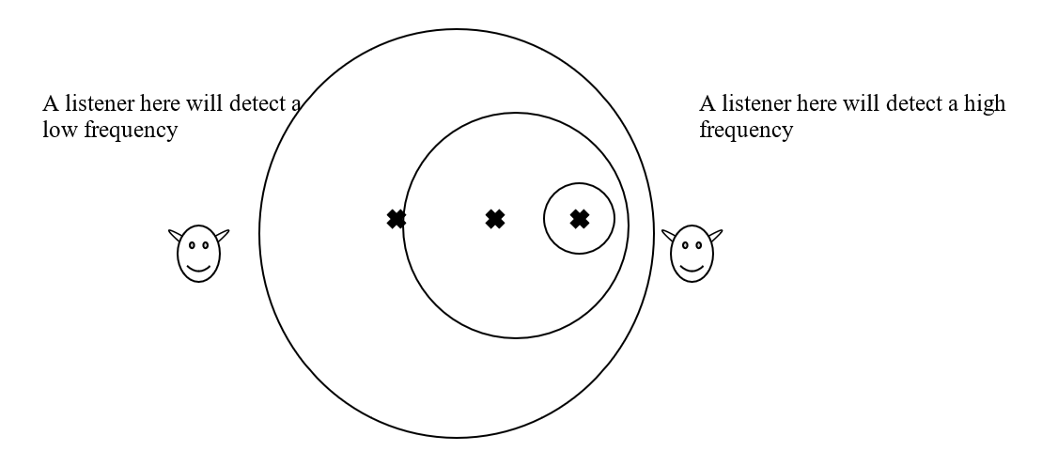

A source of sound approaches a stationary observer. The source appears to have a frequency that is 20% greater than its frequency at rest.
- Calculate the speed of the source.

$$f^{'}=\frac{cf}{c-u}$$

$$1.2 f=\frac{(340)f}{340-u}$$

$$1.2\left(340-u\right)=340$$

$$408-1.2u=340$$

$$1.2 u =68$$

$$u=56.67 ms^{-1}$$

- The Doppler effect is also used to detect the red‐shift of galaxies. What does the red‐shift tell us about the universe?

The red shift is a phenomenon whereby the frequencies of light coming from distant stars is usually a little lower than we would expect (shifted towards the red end of the spectrum) This indicates that that star is moving away from is, according to the Doppler Effect.

As the light from a large majority of stars is red shifted it would indicate that almost all stars are moving away from us. This indicates that universe is expanding – and also implies that it was once much smaller.

The discovery of the effect by Hubble, lead to the idea of the Big Bang theory.

Question 12d
- What is current?
Electric current is the flow of electric charge through an object.
- Calculate the current flowing when a mole (6.0 × 10²³) of electrons passes a point in 30 minutes.

$$1 Amp=1 Coulomb per second$$

Current, I:

$$I=\frac{\left(6×{10}^{23}\right)\left(1602×{10}^{19}\right)}{\left(30x60\right)}=53.4 A$$

The previous definition of the ampere was based on the phenomenon of two parallel current carrying conductors exerting a force on each other.
- Explain why this phenomenon occurs.

Electricity and magnetism are intertwined. Every electric current creates a magnetic field. Therefore, if two parallel wires each carry a current, they are each creating a magnetic field, and these fields have an effect on each other, creating magnetic forces on the wires.

- Describe a laboratory experiment to demonstrate this phenomenon.

Method: Set up a circuit as shown, supporting the foil with a retort stand. Switch on the current and observe what happens
Observation / conclusion: The wires move apart, indicating that parallel wires conducting a current will experience a force, the principal on which the definition of the ampere is based.
