2023 LC Physics Paper
Question 7
State Newton’s third law of motion.
If body A exerts a force on body B, then body B exerts an equal but opposite force on body A.
Show that F = ma is a special case of Newton’s second law of motion.
Newton’s second law states that when a force acts on a body, the rate of change of the body’s momentum is proportional to the force (and takes place in the direction of the force). This can be written mathematically as:
$$F∝\frac{Change in momentum }{time}$$
Using standard notations: $F∝\frac{mv-mu }{t}$
Factorising: $F∝m\frac{v-u }{t}$
Which implies that $F∝ma$
If two measurements are proportional, we can introduce a constant:
$$F=kma$$
We can then let k =1 (i.e. we can then use this equation to define the unit of force, such that a force of 1 Newton, acting on a body of mass 1 N will create an acceleration of a 1 ms⁻²). This gives us:
$$F=ma$$

A force of 6.8 kN is applied to a golf ball at rest by the head of a golf club. The ball has a mass of 45.6 g and the club and ball are in contact for a time of 0.51 ms. Calculate the velocity of the ball immediately after impact.
$$F=ma$$
$$a=\frac{F}{m}=\frac{6,800}{0.0456}=149122.81 {ms}^{-2}$$
$$v=u+at=0+\left(149122.81\right)\left(0.51×{10}^{-3}\right)=76.05 ms^{-1}$$

The velocity of the ball immediately after impact is at an angle of 15° to the horizontal.
Draw separate diagrams to show the forces acting on the ball.
(a) during impact,
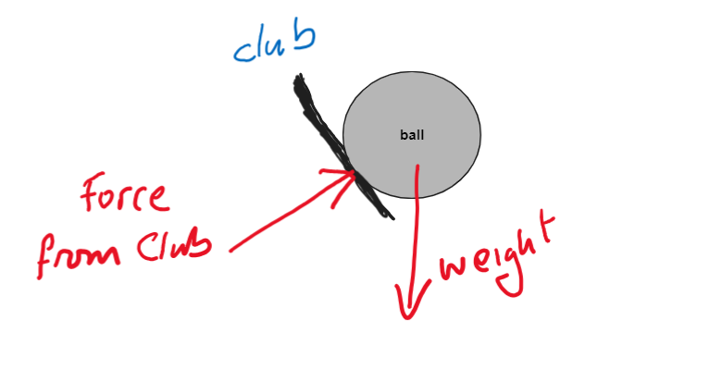
(b) immediately after impact.
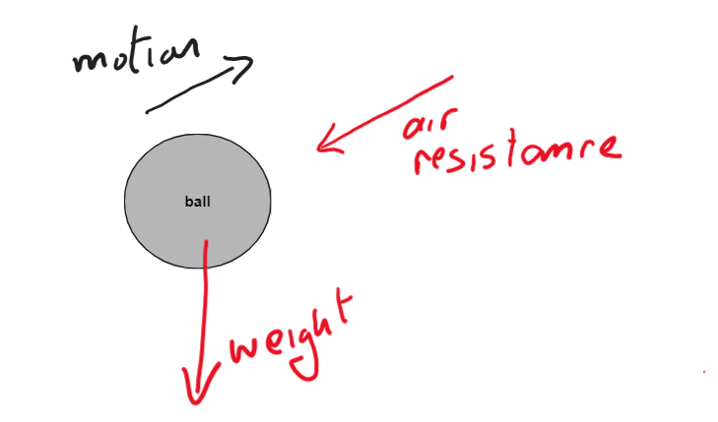
The only forces acting on the ball in motion is created by gravity and air resistance (which is often neglible)
Calculate the maximum height reached by the ball.
Resolving the velocity into horizontal and vertical components:
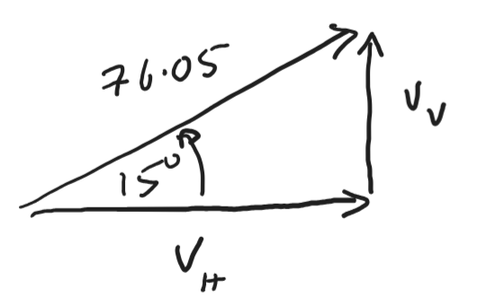
$$V_{V}=76.05\sin{15}=19.68 ms^{-1}$$
$$V_{H}=76.05\cos{15}=73.46 ms^{-1}$$
In terms of vertical motion, the ball is rising with an initial velocity of 19.68 ms⁻¹, and will reach a velocity of zero at its greatest height:
$$v^{2}=u^{2}+2as$$
$$s=\frac{v^{2}-u^{2}}{2a}=\frac{{19.68}^{2}-0}{2(9.8)}=19.76 m$$
The greatest height reached will be 19.76 m
Calculate the time it takes for the ball to travel a horizontal distance of 280 m.
In horizontal motion, the ball is travelling at a constant velocity of 7.46 ms⁻¹ (assuming air resistance to be negligible)
$$t=\frac{d}{s}=\frac{280}{73.46}=3.81 s$$
A wind blows as the ball travels through the air. The wind has a velocity of 8.2 ms^{–1} east and 3.7 ms^{–1} north. Calculate the magnitude and direction of the velocity of the wind.
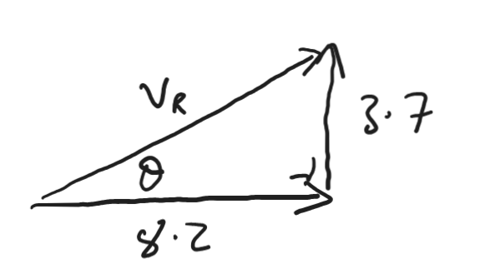
$$θ=tan^{-1}\frac{3.7}{8.2}=24.29^{o}$$
$${V_{R}}^{2}={3.7}^{2}+{8.2}^{2}=80.93$$
$$V_{R}=8.996$$
The wind-speed will be approximately 9 ms⁻¹, at an angle of 24.29º to the horizontal

Question 8
The strings of a guitar can be plucked so that they vibrate at certain frequencies. The guitar and the air inside it also vibrate due to resonance.
What is resonance?
Resonance is the transfer of energy between two bodies of the same natural frequency of vibration.
Describe a laboratory experiment to demonstrate resonance.
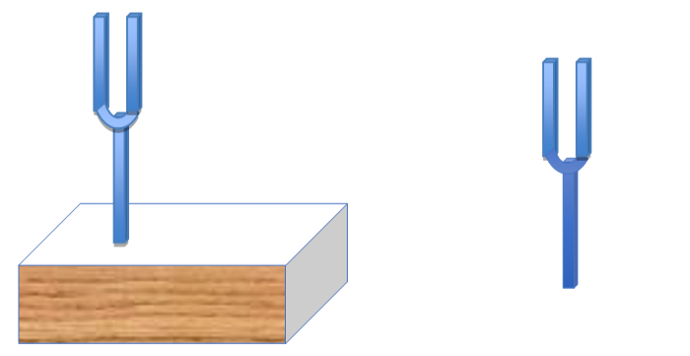
Take two tuning forks of the same natural frequency. Hold one against a hollow wooden box, as shown.
Strike the other so that it vibrates. Hold it against the box so that you can hear the sound. Then remove this fork.
The other tuning fork will continue to audibly vibrate, demonstrating resonance
For each of the following pairs of variables, sketch a suitable graph to show the relationship between them.
Following the relationship: $f=\frac{1}{2l}\sqrt{\frac{T}{μ}}$
(a) f and T
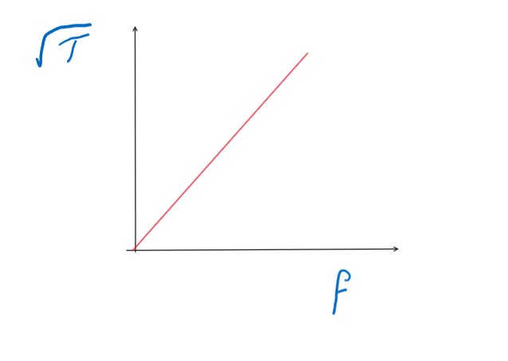
The straight line through the origin verifies that $f∝\sqrt{T}$
(b) f and l
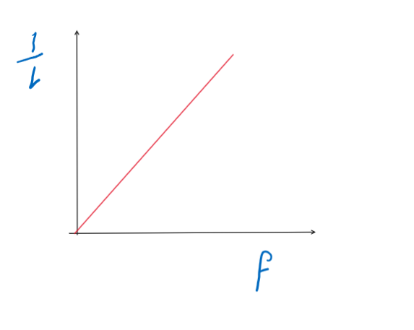
The straight line through the origin verifies that $f∝\frac{1}{l}$
(c ) f and µ
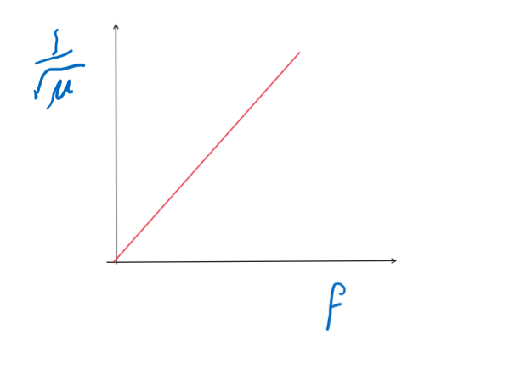
The straight line through the origin verifies that $f∝\frac{1}{\sqrt{μ}}$
For each of the following variables, state the effect on the frequency f if the variable is increased by a factor of four.
- T
as $f∝\sqrt{T}$, we can say that increasing T by a factor of 4 will double the frequency

- l
As $f∝\frac{1}{l}$ we can say that multiplying l by 4 will divide the frequency by 4
(c ) µ
As $f∝\frac{1}{\sqrt{μ}}$, we can say that multiplying $μ$ by 4 will divide the frequency by 2. (as 2 is $\sqrt{4}$)
A string is stretched between two fixed points which are 62 cm apart. The string vibrates with a number of different harmonics. The speed of sound in the string is 380 ms^{–1}. What are harmonics?
Harmonics are multiples of the fundamental frequency of a body
Draw a diagram to show the string vibrating at its third harmonic.
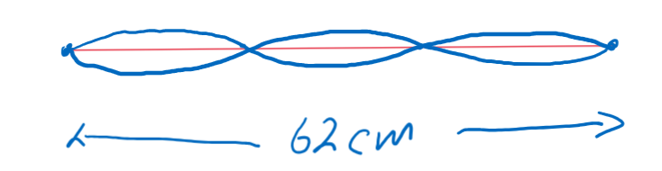
Calculate the frequency of the string when it is vibrating at its third harmonic.
We can use $c=fλ$ to find the frequency
The wavelength will be $2/3$ of the length of the string (i.e. λ$=0.41 m$)
And the frequency: $f=\frac{c}{λ}=\frac{380}{0.41}=926.83 Hz$

Question 9
The spacecraft are powered with radioisotope thermoelectric generators. When the spacecraft were launched, each generator contained 4 kg of plutonium–238. Each atom of plutonium–238 has a mass of 3.9529085 × 10^{–25} kg.
Write a nuclear equation for the alpha decay of plutonium–238.
$${}_{94}^{238}{Pu→{}_{92}^{234}U}+{}_{2}^{4}{He}$$
Calculate the energy released during each decay of plutonium–238, in MeV.
Mass Before: 3.9529085 × 10^{–25} kg
Mass After:
($234.040952+ 4.002603)×1.6605402×{10}^{27})=3.9528089× {10}^{-25}kg$
Change in mass: $m=9.957572×{10}^{-30}$
Energy released:
$E=mc^{2}=\left(9.957572×{10}^{-30}\right){\left(3×10^{8}\right)}^{2}=8.9618×{10}^{-13 }J$

In MeV: $E=\frac{8.9618×{10}^{-13 }}{(1.6021×{10}^{-19})×{10}^{6}}=5.59 MeV$

The energy released by the decay is converted into electrical energy in thermocouples. State the thermometric property of a thermocouple.
The thermometric property of a thermocouple is the voltage created between two metals when one of the metal-metal junctions is cold and the other is hot.

Draw a labelled diagram of the arrangement of a thermocouple.
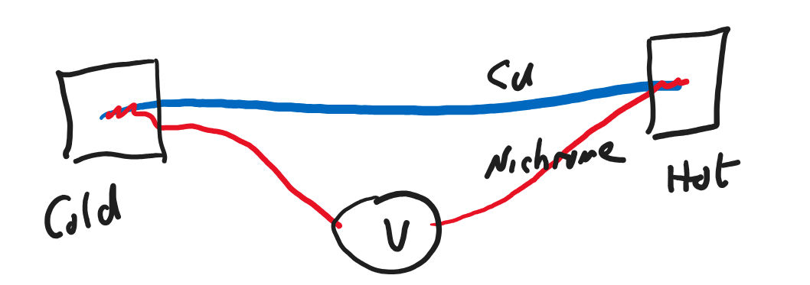

Plutonium–238 has a half‐life of 87.8 years. Calculate the rate of decay of the plutonium in each generator in 1977.
$$T_{\frac{1}{2}}=\frac{ln2}{λ}$$
$$λ=\frac{ln2}{T_{1/2}}=\frac{0.693}{(87.8×60×60×24×365)}=2.503×{10}^{-10} s^{-1}$$
Number of atoms: $N=\frac{4}{3.9529085 × 10^{-25}}=1.0119×{10}^{25}$
Activity:
$A=λN=\left(6.0068×{10}^{-9}\right)\left(1.0119×{10}^{25}\right)=2..53×{10}^{15} Bq$

Calculate the year when only 1 kg of the plutonium will remain in each generator.
1 kg would be ¼ of the original mass: this would mean two half-lives had passed. This would be a total of 175.6 years.
This means it will happen in either the year 2152 or 2153, depending on the launch date in 1977

The Voyager spacecraft are now beyond our solar system and they are maintaining constant velocities. Use one of Newton’s laws to explain why the spacecraft maintain constant velocities.
Newton’s first law of motion states that an object at rest will remain at rest and that an object in motion will continue to travel at constant velocity unless an unbalanced external force acts on it.
As there is no force now acting on the spacecraft, it will continue at constant velocity.

Question 10
In a Van de Graaff generator, point discharge is used to move charge on to a belt at the lower comb in the generator.
Describe how point discharge occurs.
Electric charge tends to build up at any sharp point on a charged object. This is the Point Effect.
After the point effect has occurred, the charged object will tend to lost its charge to the surroundings.
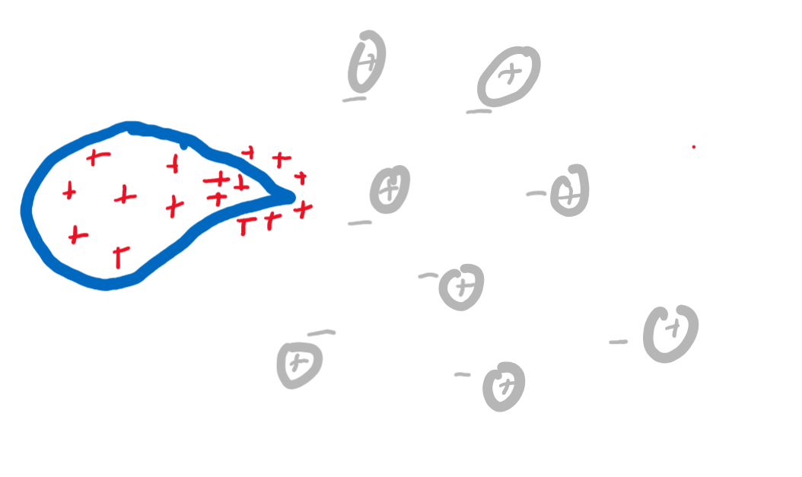
Imagine a positive charge has built up at a point as shown.
The very concentrated positive charge at that point will ionize surrounding air molecules – separating them into positive and negatives.
The negative charges (individual electrons) will be attracted to the point and will neutralize the charge there.
The charge might then redistribute itself on the object so that a charge will build up again at the point – and is again removed.
In this way, the charge will disappear.

Describe a laboratory experiment to demonstrate point discharge.
Build up a large positive charge on a Van de Graaff generator
Attach a sharp point to the top of the dome, as indicated.
Hold a lighter flame near to the point.

The flame will change shape as indicated, indicating the movement of the positive ions away from the point, demonstrating the point discharge
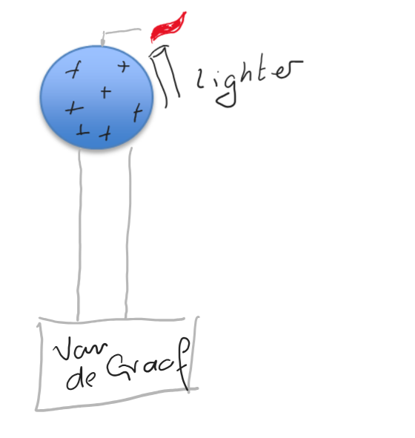
The dome of a Van de Graaff generator has a diameter of 32 cm.
A large electric field exists around the dome when it is given a charge of +200 nC.
Draw the electric field around the dome.
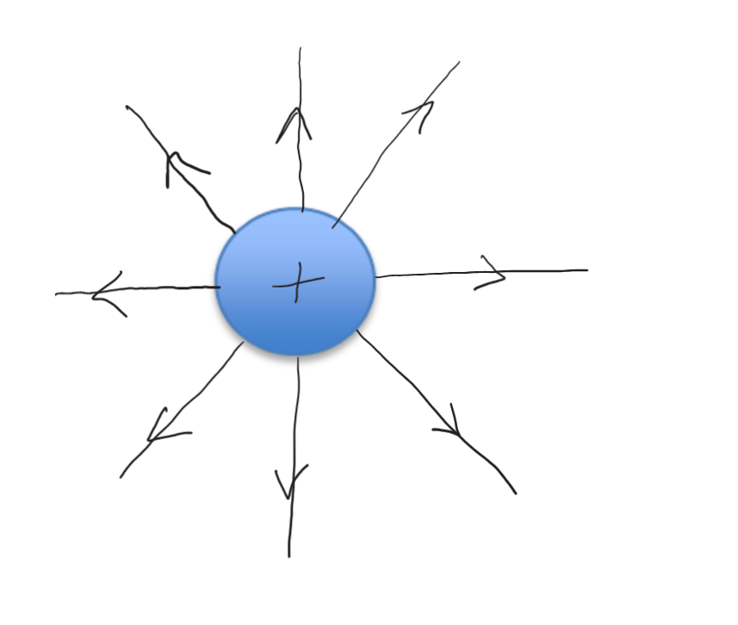
Calculate the electric field strength at the surface of the dome.
The field will behave as if the charge sits at its centre.
This means a point on the dome is 0.16 m from the centre of charge.
$$E=\frac{1}{4πε}\frac{Q}{r^{2}}=\frac{1}{4π(8.854×{10}^{-12})}\frac{200×{10}^{-9}}{{0.16}^{2}}=70216.74 NC^{-1}$$

Calculate the force experienced by an electron placed at the surface of the dome.
$$E=\frac{F}{Q}$$
$$F=EQ=\left(70216.74\right)\left(1.602×{10}^{-19}\right)=1.12×{10}^{-14}N$$

A voltage of 70 kV is applied across an X‐ray tube.
Calculate the maximum speed of the electrons produced in the tube.
The electrons will gain kinetic energy according to the equation:
$$E_{k}=QV=\left(1.602×{10}^{-19}\right)\left(70,000\right)=1.12×{10}^{-14} J$$
Comparing this to $E_{k}=\frac{1}{2}mv^{2}$, we can say that
$$v=\sqrt{\frac{2E_{k}}{m}}=\sqrt{\frac{2(1.12×{10}^{-14})}{9.109×{10}^{-31}}}=1.57×{10}^{8 }{ms}^{-1}$$
Draw a labelled diagram of an X‐ray tube. 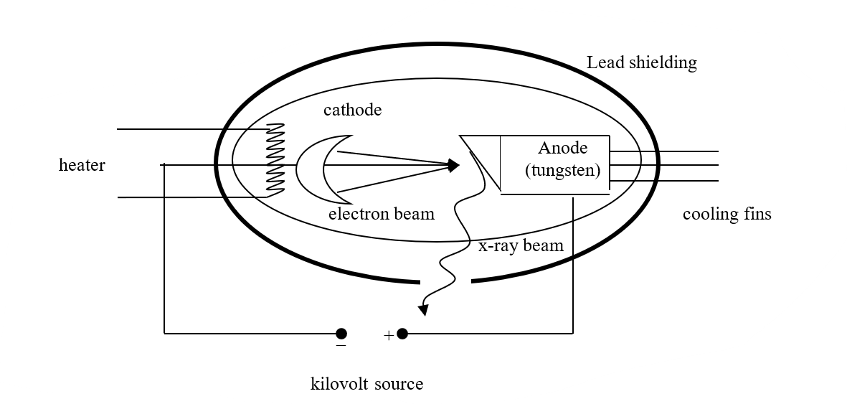

Question 12a
Anti‐matter is the most expensive substance on Earth, costing about €65 trillion per gram.
What is anti‐matter?
Anti-matter is made from anti-particles:
For every category of particle, there also exists the equivalent anti-particle. When particle and antiparticle meet, they are annihilated and their mass converted into other forms of energy.
Who made a mathematical prediction of the existence of anti‐matter?
Dirac
A positron is an example of anti‐matter. Write an equation to show the pair production of an electron‐positron pair.
$$hf→{}_{0}^{-1}{e+{}_{0}^{-1}e}$$
Explain how:
- charge is conserved in this interaction
The total charge before this reaction occurs is zero. The total charge after is also zero (+1-1 = 0) . In this way, the total charge has been conserved.
- momentum is conserved in this interaction.
The total momentum before the interaction is the momentum of the photon (a gamma ray, represented by ‘hf’).
The vector sum of the momentum of the two particles created immediately after they are created, will equal that of the photon.
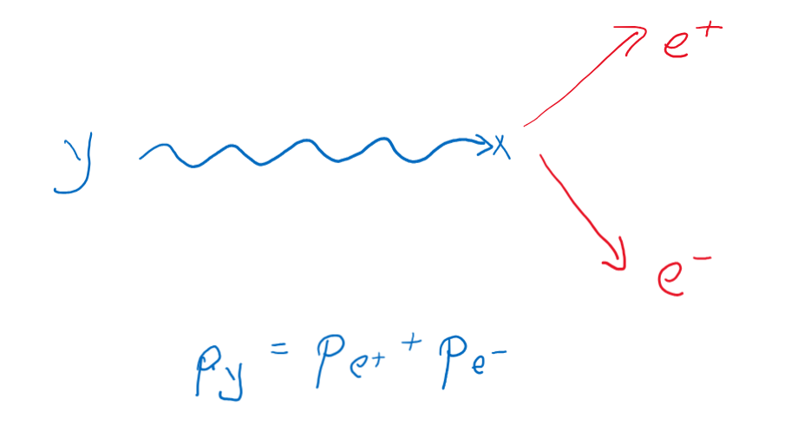
List the fundamental forces, in order of increasing strength, that a positron experiences.
Gravitational
Electromagnetic
Strong nuclear

Name the fundamental force that a positron does not experience.
Weak Nuclear
(In general, positrons do not experience the weak nuclear force)

Calculate the wavelength of the electromagnetic radiation produced when a proton and an anti‐proton annihilate.
When proton and anti-proton collide, they create two gamma rays:
$${}_{0}^{-1}{p+p→2hf}$$
Total mass converted: $m=2×1.672 6×{10}^{-27 }=3.345 ×{10}^{-27} kg$
Energy converted:
$E=mc^{2}=\left(3.345×{10}^{-27}\right){\left(3×{10}^{8}\right)}^{2}=3.011×{10}^{-10} J$
Frequency of gamma ray: $f=\frac{E}{h}=\frac{3.011×{10}^{-10}}{6.626×{10}^{-34}}=4.54 ×{10}^{23} Hz$
Wavelength: $λ=\frac{c}{f}=\frac{{3×10}^{8}}{4.54×{10}^{23}}=6.60×{10}^{-16 }m$

Distinguish between baryons and mesons.
Baryons contain 3 quarks or anti-quarks
Mesons contain one quark and one anti-quark

State the quark composition of
a proton: up, up, down
an anti‐proton: anti-up, anti-up, anti-down
The Large Hadron Collider is an example of a modern particle accelerator. Explain how it differs from the particle accelerator used by Cockroft and Walton.
The LHC is a circular particle accelerator, consisting of a circular tube many kilometres long. Particles (often protons) move around this circular path many times before being involved in a collision. This allows them to build up enormous speeds and energy.
The Cockroft Walton equipment was linear. The protons moved through a path that was only a few metres long. In comparison to the LHC, the energy involved is much smaller.

Question 13
Assume that the upper reservoir in Turlough Hill is full.
Calculate the mass (in kg) of water in this reservoir:
We can find mass using the measurements for volume and density:
The density is given as 0.997 g cm⁻³
There are 1,000.000 cm³ in 1 m³, so this equates to 997,000 gm⁻³
And in kg, this would be 997 kg m⁻³
$$m=ρV=\left(997\right)\left(2.3 ×{10}^{6}\right)=2,293, 100, 000 kg$$
Calculate the potential energy stored in this reservoir,
$$E_{p}=mgh=2, 293, 200, 000×9.8×321=7.21×{10}^{12 }J$$
Calculate the maximum power that could be generated if the reservoir was fully emptied in 24 hours.
Power is given by: $P=\frac{E}{t}=\frac{7.21×{10}^{12}}{24×60×60}=83,491,134.03 W$

State the main energy conversion that takes place:
- as the water flows down through the pipe at position A and
at A, potential energy is being converted into kinetic energy
- as the water flows through the generator at position B.
at B, kinetic energy is being converted into electrical energy
A motor operates on the principle that a current carrying conductor in a magnetic field experiences a force. Describe a laboratory experiment to demonstrate this principle.
Method: Set up a circuit as shown, supporting the foil with a retort stand
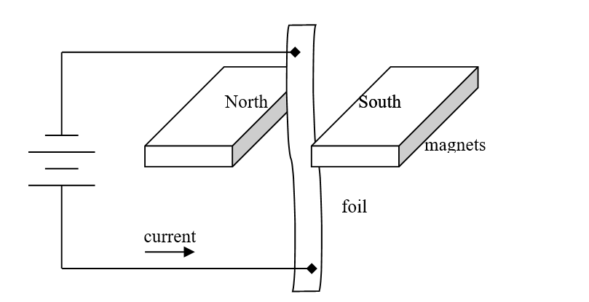
Observations / Conclusion: When the current flows, the strip of foil moves, indicating that a current carrying conductor in a magnetic field experiences a force.
The direction of the force can be determined by the left hand rule, and its magnitude is given by the formula, F = IlB
A flywheel of diameter 1.4 m rotates with 5000 revolutions per minute.
Calculate
- the period (in s) of the flywheel’s motion,
The period: $T=\frac{1}{f}=\frac{1}{(5000÷60)}=0.012 s$

- the angular velocity of the flywheel,
$$ω=\frac{2π}{T}=\frac{2π}{0.012}=523.60 s^{-1}$$
- the centripetal acceleration at the circumference of the flywheel.
$$a=rω^{2}=(0.7)({523.60)}^{2}=191,908.97 ms^{-2}$$
A battery is a source of emf. Name two other sources of emf.
An electical generator, where a coil of wire rotates inside a magnetic field, is a source of emf.
A thermocouple can also be a source of emf
As we move away from generating electricity using non‐renewable sources (e.g. fossil fuels) towards generating electricity using renewable sources (e.g. wind, solar) it is more essential than ever to have energy storage systems such as the ones described in the text. Explain why.
Wind and solar power both tend to be very good at producing electrical energy when the wind is blowing or the sun is shining – but obviously that is not going to be all the time. To avoid a situation where we fall back on the use of fossil fuels when renewable systems are less productive, it is important that we can store excess energy produced when they are working well

