His mother was tried for witchcraft. He defended her in court.She was declared innocent of all charges.
She had an affair with a married man after her husband was tragically killed

Was it a true meeting of minds when he married the cabaret dancer?
No, it ended in divorce.
A man got the credit for her theory on fission because she was hiding during WW2.
Matilda Effect

Who is she? She rejected his romantic advances. Did he steal her X-Rays of DNA and give them to Crick and Watson?
Matilda Effect
Womaniser? Communist? Traitor? Should he have been In charge of the Manhattan Project?

Did he destroy all of the portraits of Hooke after his death because he claimed to have discovered the inverse square relationship first?
AC won the Battle of the Currents, but did he really fall in love with a pigeon?

The spy Karl Fuchs accused him of being a spy during the Manhattan Project because of his safe-cracking abilities breaking the PINs of his colleagues’ lockers.
He investigated the O rings of the doomed Challenger and proved that they were too cold on that frosty morning in Florida for safety.
He wore a fake gold nose because his nose was cut off during a duel about who was the better mathematician

The odd one out! Why?
He married his first cousin, but did she help him with his discoveries?

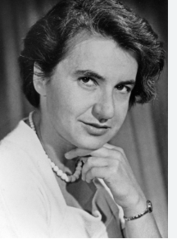

Rosalind Franklin

Rosalind Franklin

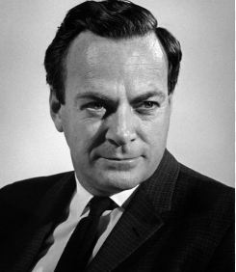Richard Feynman

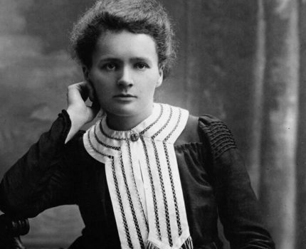

Marie Curie

Marie Curie

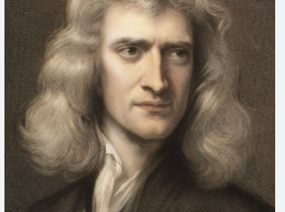

Isaac Newton

Isaac Newton

Johannas Kepler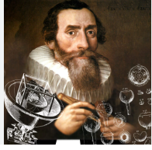
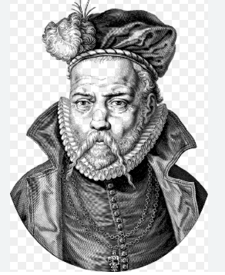
Tycho Brahe

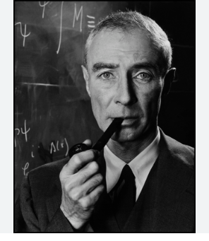Robert Oppenheimer
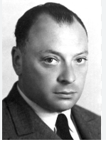Wolfgang Pauli

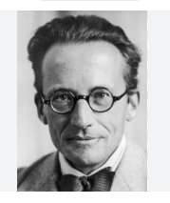Erwin Schrodinger
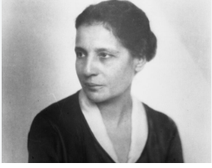Lise Meitner

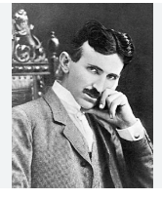
Nikola Tesla
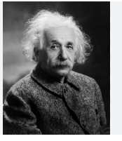Albert Einstein

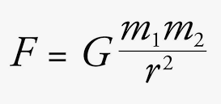
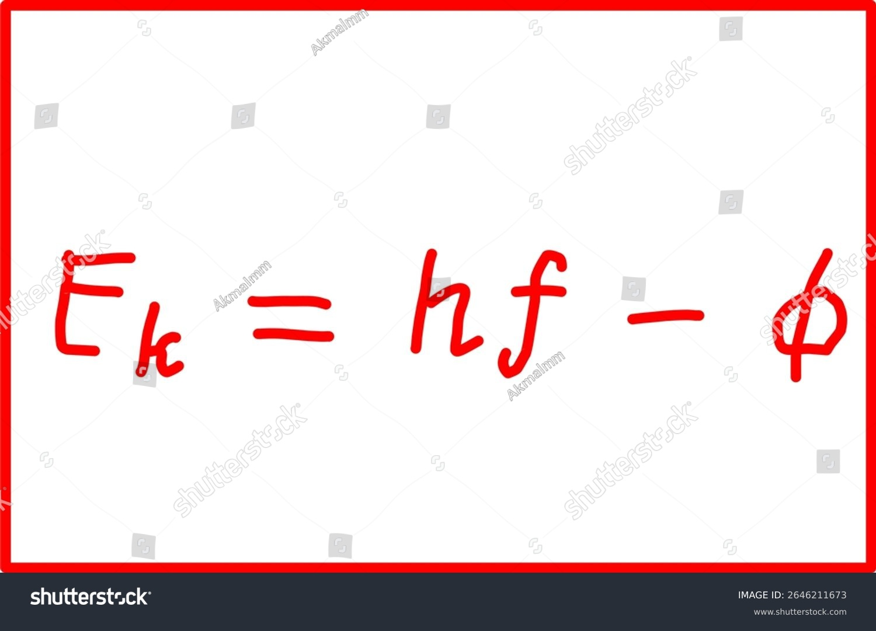
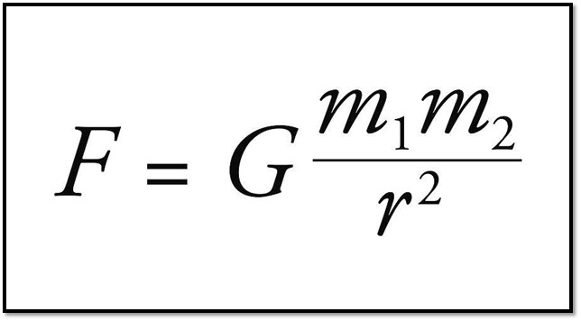

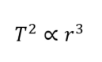
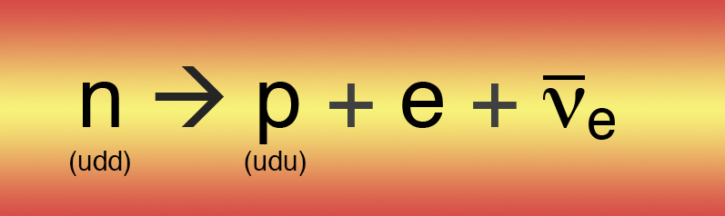
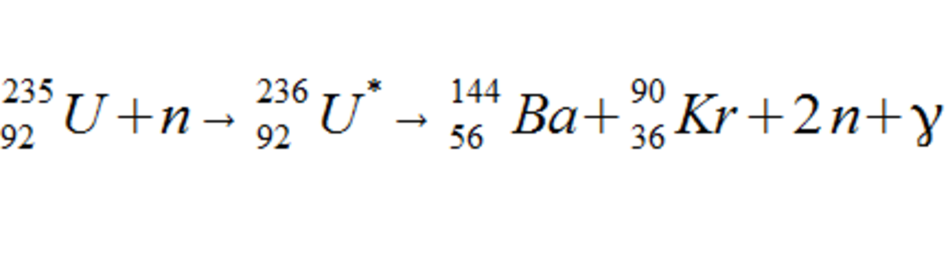

I_{RMS} = I_{o}/$\sqrt{2}$

T² is proportional to r³



Her boss got the Nobel Prize for her discovery of pulsars.
Matilda Effect

