Physics Resource Bank: Survey Results
The survey was carried out between November 23 and Dec 1
Participants were found using PhysicsResourceBank.com, an email circular and twitter
91 teachers responded, which is somewhere between 13% and 20% of the numbers teaching physics in the country


Are you teaching Leaving Cert Physics to a 5th or 6th year group this school year?

How many years teaching experience do you have (in any subject)?
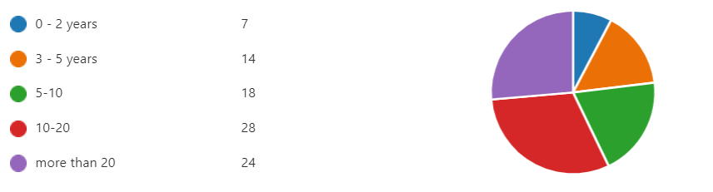

How many years’ experience do you have of teaching Physics to Leaving Cert Level?
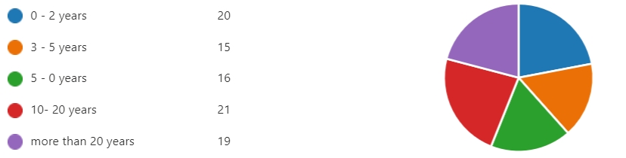

To what age bracket do you belong?
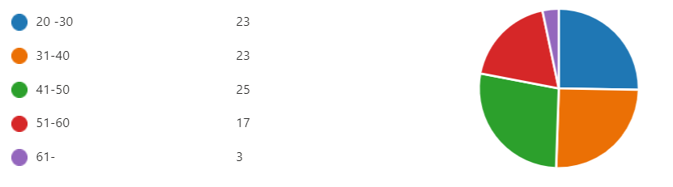

Do you teach at least one Junior Cycle Science class at the moment?


Do you teach Maths at the moment, at any level



In recent years, would you say that the uptake of physics at leaving cert level in your school is …
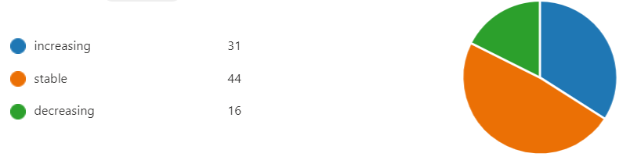
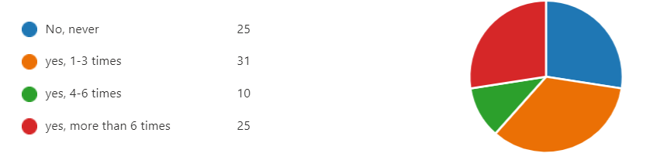
In the past, have you attended any PDST evening workshops or Lab-days?

How many physics teachers are there in your school (including yourself)
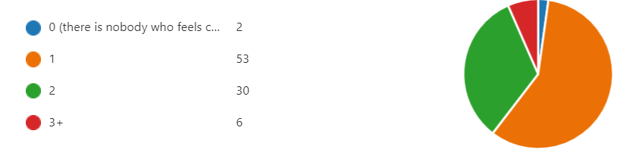

Is your school....
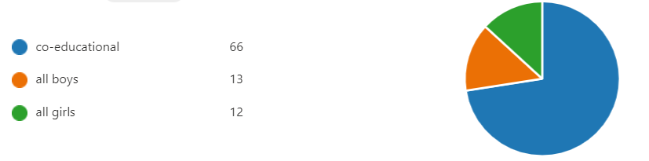

Is your school best described as.....


What resources (if any) have you used most on physicsresourcebank.com?


What resources would you like to see made available on physicsresourcebank.com?

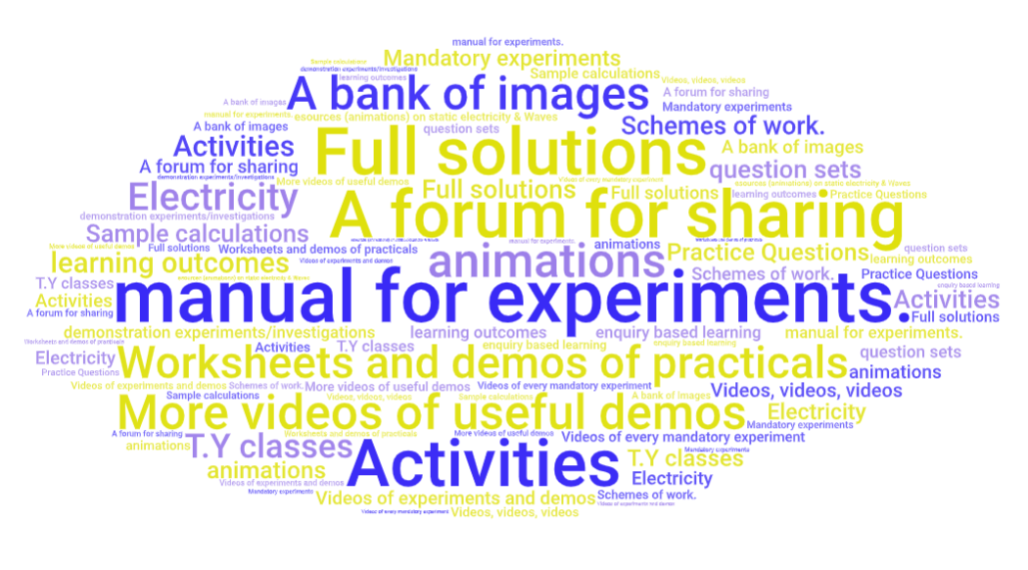

If the uptake of physics in your school is either increasing or decreasing, to what would you attribute the change?

Positive:



Negative:

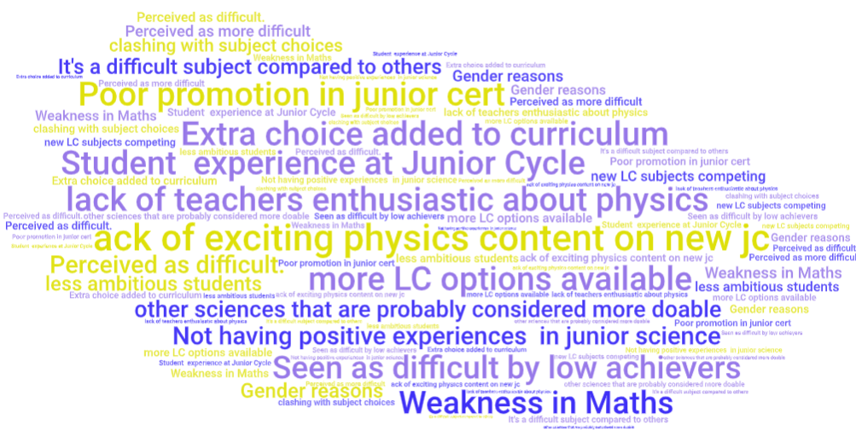

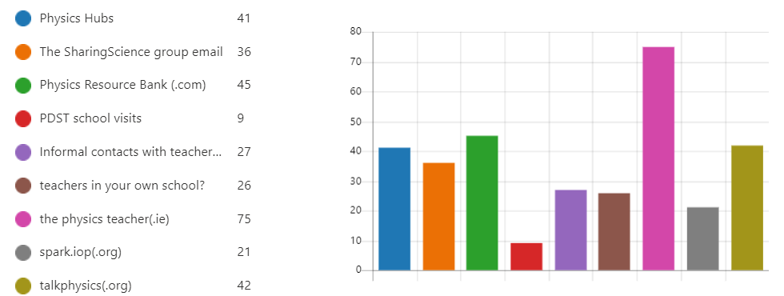
When looking for resources relevant to teaching physics, which (if any) of these have you used in the last year?

If workshops were available on any of these topics, which would you be most likely to attend?
 | 1st choice | 2nd choice | 3rd choice | total
weighting | 3 | 2 | 1
Modern physics | 13 | 10 | 13 | 72
Heat | 1 | 7 | 6 | 23
Waves | 7 | 6 | 10 | 43
Sound | 1 | 8 | 4 | 23
Optics | 2 | 3 | 5 | 17
General mechanics | 9 | 10 | 10 | 57
Circular + SHM | 10 | 10 | 13 | 63
General Electricity | 15 | 21 | 13 | 100
Electricity + Magnetism | 31 | 14 | 17 | 138

