2019 LCHL Physics
Section A

Question 1
Draw a labelled diagram of the apparatus used in the experiment.
Between which points was the distance s measured?
Describe how the time t was measured.
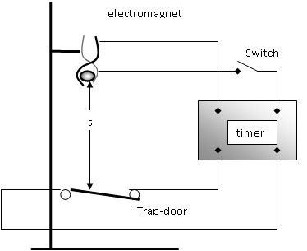

The distance ‘s’ is measured as shown: from the bottom of the ball bearing to top of the trap-door or sensor.
To measure ‘s’, the clamp is opened which simultaneously releases the ball bearing and triggers the milli-second timer. When the ball bearing hits the sensor underneath, the timer stops – thus yielding a value for ‘t’ – the time to fall a distance ‘s’.

Draw a suitable graph that can be used to determine the acceleration due to gravity g. Hence determine g.
s/m | .3 | .4 | .5 | .6 | .7 | .8 | .9
t²/s² | .06 | .08 | .1 | .12 | .14 | .16 | .19

To find g, we first find the slope:
$$slope= \frac{rise}{run}=\frac{.5}{.1}=5$$

From the equations of motion we know that:
$s=\frac{1}{2}g$t²
We can compare this to the equation of a line from co-ordinate geometry:
$$y=mx+c$$
Comparing the two, we can say that the slope and the value of g are related by:
$$slope=\frac{1}{2}g$$

Therefore we can say that:
$$g=2\left(slope\right)=2\left(5\right)=10ms^{-2}$$

A small, dense ball was used as the object in this experiment.
State an advantage of using this type of ball.

A small, dense ball will minimize the effect of air resistance, thus ensuring the accuracy and validity of our calculations.

Question 2
How did the student find the approximate focal length?
Why did the student find the approximate focal length at the start of the experiment?

To find the approximate focal length, the student would have used the mirror to find the image of a brightly lit distant object. Such an image will form at the focal point. The student would then have measured the distance from the mirror to the object to give a good approximation of f.

The student would have done this both to add confidence to his later conclusions, and to have a working value in mind during the experiment: if the object is placed inside the focal length, no real image will be formed. It is good to know in advance roughly where this is to save time and avoid frustration.

Describe, with the aid of a labelled diagram, how the position of the image was found.
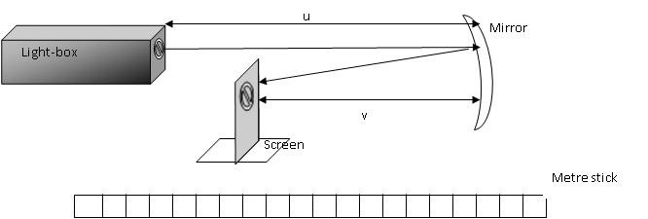

A light box creates a brightly lit object.
The light reflects from the mirror.
The position of the mirror and screen are adjusted until a clearly focused image is found. The object and image distances are measured as shown.

State two precautions that should be taken when measuring v.
In measuring v, one should be careful
- to avoid an error of parallax with the metre stick
- to ensure the measurement is taken from the back of the mirror
- to ensure the image is clearly in focus

Use all of the data to calculate the focal length of the mirror.
$$\frac{1}{f}=\frac{1}{u}+\frac{1}{v}$$

Rearranging gives:
$$f=\frac{uv}{u+v}$$
Subbing in yields:
$$f=\frac{\left(20\right)\left(61\right)}{20+61}=15.06$$

$$f=\frac{\left(30\right)\left(29.5\right)}{30+29.5}=14.87$$

$$f=\frac{\left(40\right)(24)}{40+24}=15.75$$

$$f=\frac{\left(50\right)\left(20.5\right)}{50+20.5}=14.54$$

This yield an average value for f of:

$$f=15.06 cm$$

Question 3
The following data were recorded.
Mass of copper calorimeter = 56.3 g
Mass of calorimeter and water before adding ice = 108.5 g
Initial temperature of water = 29.5 °C
Final temperature of water = 8.0 °C
Mass of calorimeter and water after adding ice = 122.9 g

Why did the student
- crush the ice,
- dry the ice?

The student crushed the ice because ice when it has been left to melt for a while is not all at the same temperature. The centre could be at -40 ºC when the edge is at 0 ºC. The maths we use assumes uniformity of temperature, so to achieve that, we crush the ice

Similarly, the maths we use assumes that only ice at 0ºC is added to the water. But melting ice is likely to include some water. To avoid this problem, the ice is dried before adding it.

How was the ice
- crushed,
- dried?
The ice was crushed by wrapping it in a dry cloth and striking it with a heavy weight
It was dried by leaving it some filter paper which would absorb the run off.

Why did she
- use warm water,
- use melting ice?

Insulation is used to retain heat in the system, but is inevitably compromised and heat will be either absorbed or released from the system. By beginning with warm water it ensures some heat will be lost early in the experiment, and this will be offset by the heat gained at the end when the temperature has fallen below low temperature.

The maths on which we base our calculations assumes that the ice is at 0ºC. To ensure this is the case, we use crushed, dried and melting ice.

Use the data to calculate the specific latent heat of fusion of ice.
$$heat lost=heat gained$$
$$ml+mcΔθ=mcΔθ+mcΔθ$$
$$\left(.0144\right)l+\left(.0144\right)\left(4180\right)\left(8\right)=(.0522)(4180\left(21.5\right)+(.0563)(390)(8)$$

Rearranging:
$$l=3.25×10^{5} J kg^{-1}$$

Question 4
Draw a circuit diagram for this experiment.
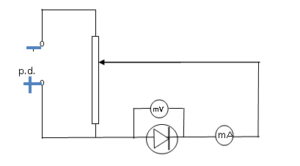
Use the data to draw a graph of current against potential difference.
V (mV) | 0 | 50 | 100 | 150 | 200 | 250 | 300
I (mA) | 0 | 0 | 0 | 2 | 5 | 40 | 11

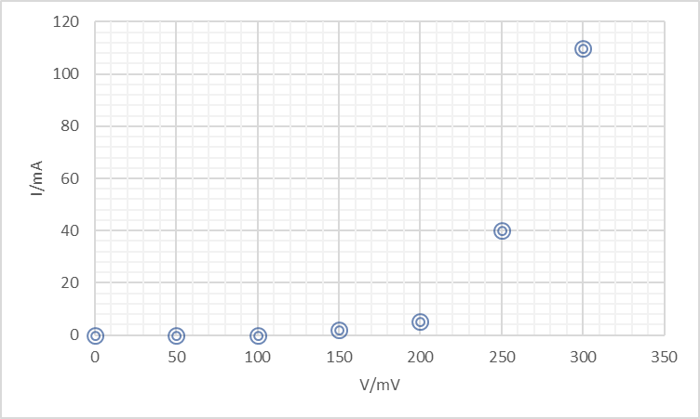
Junction Voltage

Use your graph to determine the junction voltage.
The current increases dramatically between 150 mv and 200 mV. A good approximation for the junction voltage would be 180 mV

What happened in the diode when the junction voltage was exceeded?

The junction voltage is created with the depletion layer in the centre of the diode. The p-type material in the depletion layer has a small majority of electrons and is therefore negative. Conversely, the n-type material has a small positive charge. These charges create the (small) junction voltage, which is in the opposite direction to the applied voltage when the diode is in forward bias. It therefore limits the current flowing. When the applied voltage exceeds the junction voltage, though, this effect is no longer relevant and the current increases by a large amount.

Is Ohm’s law obeyed for the diode? Justify you’re answer.
Ohm’s Law states the voltage and current should be in direct proportion to each other. Such a relationship would create a straight line through the origin for a V- I graph. As this graph is not a straight line, we can see that Ohm’s Law is not obeyed.

The diode is now reversed and data is recorded.
State two other changes that are made to the circuit before recording data for a diode in reverse bias.

- The diode would be reconnected, with its poles reversed.
- As any current that flows would be extremely small, the milliammeter would have to be replaced with a microammeter.
- Furthermore, as the small current taken by the voltmeter would now be large enough to be relevant, the ammeter should be moved to measure only the current flowing directly through the diode.

Section B
Question 5
- A light-year is the distance travelled by light in a vacuum in one year. Calculate this distance in metres.
$$distance=\left(speed\right)\left(time\right)=\left(3×10^{8}\right)\left(60×60×24×365\right)$$
$$1 light-year=9.46×{10}^{15 }m$$

- An apple has a weight of 1 N and its volume is 121 cm3. Calculate the density of the apple. (acceleration due to gravity = 9.8 m s–²)

$$density= \frac{mass}{volume}=\frac{\frac{1}{9.8}}{121×10^{-6}}=842 kgm^{-3}$$

- A book is decelerating as it moves to the right on a horizontal table. Draw a labelled diagram to show the forces acting on the book as it moves on the table.

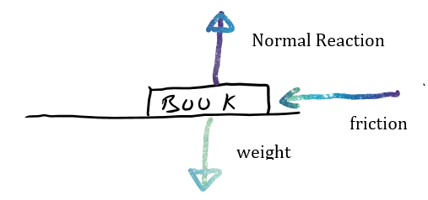
- What is meant by polarization of light?
Polarisation of light is the restriction of vibration within a light wave to a single plain.

- What is the thermometric property of (i) a mercury thermometer, (ii) a thermocouple?
For a mercury thermometer, the thermometric property is the length of the column of mercury inside a narrow glass tube.
For the thermocouple, it is the emf created between the hot and cold junctions

- Sketch a graph to show the relationship between resistance R and temperature T (in °C) for a metallic conductor.

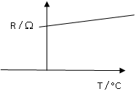
This graph covers a large range of temperatures, but at very low values of T the resistance often falls to zero, exhibiting superconductivity

- Power P is generated in a resistor of resistance R when a potential difference V is applied across it. Write P in terms of R and V.

Taking: $P=VI$ and $I=\frac{V}{R}$
gives: $P=V\frac{V}{R}=\frac{V^{2}}{R}$

- Polonium was discovered by Marie and Pierre Curie in 1898. Polonium–218 has a half‐life of 3 minutes. Calculate the activity of a sample of polonium-218 that contains 75000 nuclei.

$$T_{1/2}=\frac{ln2}{λ}$$

gives: $λ=\frac{ln2}{T}=\frac{.693}{3×60}=3.85×{10}^{-3}{ s}^{-1}$

and: $Activity= λN=3.85 ×10^{-3}×75,000=288.82 Bq$

- Polonium–218 is produced as the daughter nucleus in the alpha-decay of radon-222. Write a nuclear equation for this reaction.

$${}_{86}^{222}{Rn=}{}_{84}^{218}{Po}+{}_{2}^{4}{He}$$

- Neutrinos are sometimes called ghost particles. Why are they very hard to detect?
Particle are made easier to find through their mass or their electric charge. Neutrinos have no charge, and almost zero mass. This limits their interaction with other particles to the point where they are very difficult to find.

Or

Describe how a galvanometer can be converted into an ammeter.
In the diagram, an ammeter designed to measure current up to a few amps is represented.
The low resistance resistor takes a large proportion of the current, but the galvanometer still has a small current. The value of the galvanometer current is proportional to the total current and will therefore be a measure of the full current.

Question 6
State Newton’s law of universal gravitation. What is the relationship between the period T and radius of orbit r of a satellite?
Newton’s Law of Gravitation states that the force (F) of attraction between any two point masses is directly proportional to the product of the masses (m), and inversely proportional to the square of the distance (d) between them.
i.e. $F=\frac{Gm_{1}m_{2}}{d^{2}}$
The relationship between the period and radius of a satellite is given by Kepler’s Law, $T^{2}∝R^{3}$, or more completely by the formula:

$$T^{2}=\frac{4π^{2}R^{3}}{GM}$$

Which has a longer wavelength, visible or infrared radiation?
Infra-red has the longer wavelength

Describe how infrared radiation can be detected in the school laboratory.
To detect the presence of Infra-red
Set up a prism, light source and screen as shown.
Just beyond the red end of the spectrum, hold a thermometer for a few minutes.
As it is exposed to the heating effect of Infra-red radiation, you would expect the temperature to rise beyond room temperature.
This demonstrates the presence of the Infra Red radiation

thermometer

What is the period of METEOSAT 11?
As the satellite is in geostationary orbit, it would have the same period as the spin of the earth: 24 hours

Calculate its height above the surface of the Earth.
Using: $T^{2}=\frac{4π^{2}R^{3}}{GM}$
We can say that: $$R^{3}=\frac{GMT^{2}}{4π^{2}}$$
Therefore: $$R^{3}=\frac{(6.67×{10}^{-11})(6×{10}^{24})({60×60×24)}^{2}}{4π^{2}}=7.567×{10}^{22}$$

The radius of the motion is therefore:
$R=4.2298×{10}^{7} m$, or $42, 298 km$

And the height above the earth surface is:
$$h=42,298-6400=35,898km$$

A global positioning satellite is not in geostationary orbit.
It orbits the Earth with a speed of 14000 km hr^{-1.}
Calculate (i) its radius of orbit, (ii) its angular velocity.
$$v=\frac{14,000,000}{60×60}=3888.9 ms^{-1}$$
Using, $v^{2}=\frac{GM}{R}$ we can say that:

$$R=\frac{GM}{v^{2}}=\frac{(6.67×{10}^{-11})(6×{10}^{24})}{({3888.9)}^{2}}=26464053 m$$

Or,

$r=2.65×{10}^{7}m$

Using $v=rω$, we can say that the angular velocity is given by:
$$ω=\frac{v}{r}=\frac{3888.9}{2.65×{10}^{7}}=1.47×{10}^{-4} rad s^{-1}$$

Calculate the minimum time it takes a signal to travel from the global positioning satellite to the Earth.
Assuming the satellite is overhead, this is a simple time-distance-speed calculation:

$$t=\frac{distance}{speed}=\frac{2.65×{10}^{7}-6.4×{10}^{6}}{3×{10}^{8}}=0.067 s$$

Explain why satellites remain in orbit and do not fall to Earth.
Satellites are sometimes described as being in perpetual freefall. They are usually found at heights above the earth’s surface that might cause a reduction in weight, but they are not at all far enough away for us to say that they are even approximately weightless.
In fact their weight is always pulling them towards the earth – just as it would for a stone thrown through the air. But unlike a stone that is very close to the earth’s surface, they are high enough that the curved path they follow is matched by that of the earth’s curve. They are falling towards the earth, but the earth is curving away underneath them, so they never fall to the surface.

Question 7
What is meant by potential difference? State its unit.
The Potential Difference between two points is the work done in moving a unit positive charge from one point to the other. It is measured in Volts.

Define electric field strength.
Electric field strength is the force, F, per unit positive charge, Q, at a point in an electric field.
i.e.

Describe how an insulated spherical conductor can be charged positively by induction.
- We negatively charge a plastic rod through friction
- We bring the rod close to the metal sphere. This induces a positive charge on the near-side of the sphere – which is matched by a negative charge on the far side.
- We earth the far side of the sphere (by touching it with a finger, for example). This removes the negative charge
- We remove the connection to earth
- We remove the plastic rod. The positive charge is now trapped on the sphere

A spherical conductor has a diameter of 12 cm.
It is charged positively by induction.
Draw the electric field around the charged conductor.

There is an electric field strength of 2.3 N C⁻¹ at a distance of 5 cm from the surface of this spherical conductor. Calculate the charge on the conductor.

$$E=\frac{1}{4πε}\frac{Q}{d^{2}}$$

$$Q=4πεd^{2}E=4π(8.85×{10}^{-12}){(0.11}^{2})(2.3)=3.095×{10}^{-12} C$$

Explain how point discharge occurs.
The point effect describes how, at sharp points on a charged object, there will be a build-up of charge.
The point effect can actually lead to the object becoming discharged. This is point discharge.
Remember that air is made up of molecules and that these molecules consists of protons and electrons in the same way as with every other material. If there is, say, a very large positive charge at a point on a conductor, this will attract the negatively charged electrons within the molecules in the air towards it and push away the positively charged protons. If the charge is sufficient, the negatively charged electrons can actually be removed from the atoms. This leaves what we call positively charged ions. The electrons are then attracted to the metal surface and neutralise the positive charge that was there, while the positively charged protons are repelled from the surface. The result of this is that the charge is taken from the conductor. The accelerating movement of the ions in the air can then lead to the creation of further ions, speeding up the process still further.
Describe how point discharge can be demonstrated in the laboratory
Attach a Van de Graaff generator to an electroscope, as shown.
Charge the generator and note how the presence of the charge causes the leaves on the electroscope to diverge.

Bring a sharply pointed object, such as a needle, close to the generator.

Note how the leaves collapse, indicating the charge has been removed from the system.

This is a demonstration of point discharge.
Alternatively the pointed needle can be attached directly to the metal sphere, with the same effect.

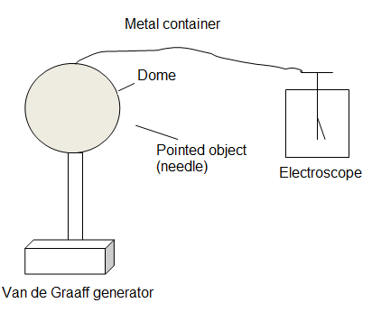

Question 8
Distinguish between photoelectric and thermionic emission.
Thermionic emission is the emission of electrons from the surface of a hot metal
The Photoelectric Effect is the emission of electrons from a metal, caused by the incidence of electromagnetic radiation of suitable frequency

What name is given to electrons emitted during radioactive decay?
They are known as beta-particles.

When current is passed through the vapour in a sodium lamp, light is emitted as a line spectrum.
What is a line emission spectrum?
A line emission spectrum is the name we give to the electromagnetic radiation in a mix of frequencies emitted from certain materials in situations similar to that described.

Explain, in terms of the structure of the atom, how this spectrum is produced.
Energy in, electron leaps to higher level
Electron falls to lower level, energy out as em wave

Energy levels are the fixed values of energy that an electron can hold within an atom. The energy levels close to the nucleus contain electrons with less energy than those further out, and the quantity of energy held by electrons in each level is very precise and fixed by nature.
Lower energy levels are close to the nucleus, higher energy levels are further away from the nucleus.
If an electron in a low energy level should gain energy, it will instantly move to the appropriate outer level. This movement is known as a quantum leap.
When an electron moves to an outer level, it will leave a gap in a lower level. After some time – usually a very short period of time – it will fall back down to the lower level. When it does so, it has to shed the extra energy it had briefly contained. This energy is emitted as electromagnetic radiation.
When an electron moves between two energy levels which are close together, the gap between the energy levels is small and the energy emitted is low. This creates an electromagnetic wave of relatively low frequency (maybe the colour red, for example or even a radio wave.)
When an electron jumps from a very high level to a much lower one, the amount of energy released is obviously quite large and in that instance a high energy, high frequency wave is created, such as the colour blue, or an X-ray.
The graph shows the relationship between the kinetic energy E_{k} of the electrons emitted during photoemission and the frequency f of the incident radiation.
Write down Einstein’s photoelectric equation.
From the tables:
$hf=Φ+\frac{1}{2}mv^{2}$,
where $Φ=hf_{o} (the work function)$
$$E=hf (the incident energy)$$
$$E_{k}=\frac{1}{2}mv^{2}$$
What physical quantity is represented by (i) point A, (ii) the slope of the graph?
E_{k}
A f

The equation above can be rearranged as: $E_{k}=hf-Φ$
This is then the equation of the given line in the form, $y=mx+c$
Comparing these two equations, we can see:
- Point A is where the emitted electrons have no initial kinetic energy. This means that the incident radiation must contain exactly the minimum energy for photemission. This occurs at the threshold frequency and that is therefore what A represents.
- The slope of line will be equal to Planck’s Constant

The work function of magnesium is 3.68 eV. Calculate the maximum velocity of the emitted electrons when photons of energy 4.15 eV are incident on magnesium.
$$E_{in}=4.15×1.602×10^{-19}=6.648×{10}^{-19}J$$
$$Φ=3.69×1.602×10^{-19}=5.895×{10}^{-19}$$

$$E_{k}=6.648×{10}^{-19}-5.895×{10}^{-19}=7.53×{10}^{-20}J$$

$$E_{k}=\frac{1}{2}mv^{2}=7.53×{10}^{-20}$$
Max velocity:
$$v^{2}=2×\frac{7.53×{10}^{-20}}{9.109×{10}^{-31}}=1.653×{10}^{11}$$
$$v=406609 ms^{-1}$$
Or
$v=4.1×10^{5} ms^{-1}$

Electrons are produced in an X‐ray tube by thermionic emission.
Where in the tube are the electrons produced?
They are produced at the cathode.

The electrons are then accelerated to high velocities.
Some of the electrons have their energy converted into X rays
What is the minimum wavelength of an X‐ray produced in a 50 kV tube
The max velocity of the electrons corresponds to the max frequency, minimum wavelength:
$$qV=hf$$
$$f=\frac{qV}{h}=\frac{1.602×10^{-19}}{6.626×{10}^{-34}}=1.209×{10}^{19}$$
$$λ=\frac{c}{f}=\frac{2.998×{10}^{8}}{1.209×10^{19}}=2.48×{10}^{-11} m$$

The kinetic energy of each of the other electrons is converted into heat energy.
State two design features of an X‐ray tube that take account of this.
The anode is usually made of a material like tungsten, which has a very high melting point
A cooling system has to be built into the system to stop it overheating

Question 9
Both a moving charge and a conductor carrying an electric current experience a force in a magnetic field.
Explain the underlined terms.
A force is anything causes, or tends to cause, and acceleration.
A magnetic field is that 3D area surrounding a magnet where it creates a force.

Describe an experiment to demonstrate that a current‐carrying conductor experiences a force in a magnetic field.
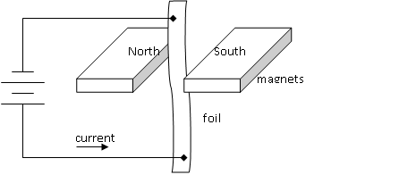

Method: Set up a circuit as shown, supporting the foil with a retort stand
Observations / Conclusion: When the current flows, the strip of foil moves, indicating that a current carrying conductor in a magnetic filed experiences a force.

When would a current‐carrying conductor in a magnetic field not experience a force?
The conductor would not experience a force in a situation where the current was flowing parallel to the direction of the magnetic field lines.

(b) A straight wire of length 3 cm was placed perpendicular to a magnetic field of uniform magnetic flux density B.
The force F on the wire was measured for a series of values of current I flowing in the wire.
Write down an expression for the force F on the current‐carrying wire in terms of I, B and the length l of the wire.
Where the current, I, is perpendicular to the magnetic flux density, B, this formula applies:
$$F=IlB$$

Plot a graph on graph paper of force against current.
I (A) | 0.5 | 1.0 | 1.5 | 2.0 | 2.5 | 3.0 | 3.5
F (mN) | 10 | 18 | 31 | 39 | 50 | 59 | 68

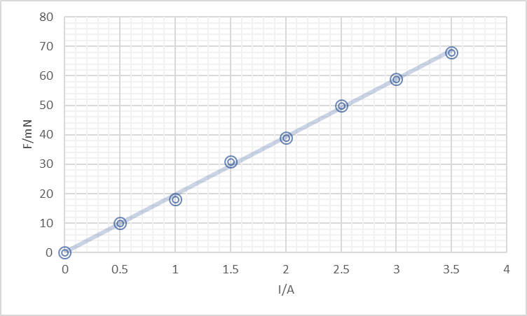

Calculate the slope of the graph and use it to calculate the magnetic flux density of the field.

Slope: $slope=\frac{rise}{run}=\frac{50}{2.5}=20$
Factoring in the importance of units and working in newtons, we can say this is: $slope=20×{10}^{-3}NA^{-1}$
We can compare: $F=IlB$, or (rearranging): $F=BlI$
to: $y=mc+c$
from this we see that
$$slope=Bl$$
From this: $B=\frac{slope}{l}=\frac{20×{10}^{-3}}{.03}=0.67 T$

(c) Starting with the expression for the force that you wrote in part (b), derive the expression F = qvB for the force F acting on a charge q travelling at a velocity v perpendicular to a magnetic field of flux density B.
A force exists on a current-carrying conductor in a magnetic field. It is described by the formula:
,
A similar force exists on a charge, q, moving through a magnetic field at velocity v. We can say that the current in this case is the quantity of charge passing any point per second,
i.e. () ,
and the effective length of the charge in the magnetic field is given by

Subbing into

Gives

In a nuclear detector a proton enters a magnetic field of flux density 0.5 T at right angles to the field.
The proton initially follows a circular path of radius 2.3 mm.
Calculate the speed of the proton as it enters the field.
$$F=qvB=1.602×{10}^{-19}×0.5v$$
The centripetal force tells us:
$$F=\frac{mv^{2}}{r}=\frac{1.67×{10}^{-27}v^{2}}{2.3×{10}^{-3}}$$

Equating these:
$$v=1.01 ×10^{5} ms^{-1}$$

Question 10
Explain the terms diffraction and interference.
Diffraction is the ability of a wave to recover after meeting an obstacle.

Interference occurs when two waves meet: When this happens, the total displacement will be equal to the algebraic sum of the individual displacements

Explain, with the aid of a labelled diagram, how a series of bright and dark fringes were produced. How does this experiment demonstrate that light is a wave?

To demonstrate the Wave Nature of Light

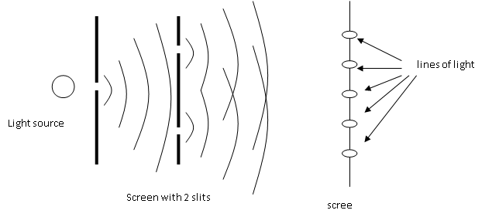

A single light source is placed behind a screen. The light passes through this screen and encounters another, with two slits. A third and final screen is found beyond this one. A pattern is found on it as shown.

The second screen creates two coherent light waves.
These waves then diffract having passed through a narrow gap.
The spreading waves meet and interference is created.

The bright lines correspond to constructive interference. Darkness corresponds to destructive interference.

The presence of diffraction and interference demonstrate the wave mature of light as these are exclusively wave properties.

The experiment was repeated in the school laboratory.
The slits were 0.5 mm apart and were placed at a distance of 1.25 m from the screen.
The distance across 13 bright fringes on the screen was found to be 1.65 cm.
Calculate the wavelength of the monochromatic light.

Using $nλ=dsinθ$
$n=6$: 13 bright fringes indicate that we are looking at the 6 orders of image (6 to the right, 6 to the left and one in the middle)
$$d=0.5×{10}^{-3}$$
To find θ, we use trigonometry:
$$8.25×{10}^{-3 m}$$
Θ
1.25 m
1.25 m

$$tan θ=\frac{8.25×{10}^{-3}}{1.25}=0.0066$$
$$θ=0.378^{o}$$

$$6 λ=0.5×{10}^{-3}sin0.378$$
$$λ=5.498×{10}^{-7 }m$$

List two adjustment to the apparatus that could be made to increase the distance between the bright fringes.
We could increase the distance between fringes by
- Decreasing the value of d – bringing the slots closer together.
- Moving the screen further away
- Using light of greater wavelength

Young was a polymath with many other interests, including the deciphering of Egyptian hieroglyphs, discovery of the purpose of the ciliary muscle in the eye, and the invention of the Young temperament which made use of harmonics to tune musical instruments.
When the ciliary muscles contract the lens in the eye becomes thinner. What effect does this have on the power of the lens?
As $P=\frac{1}{f}$, we can see that a thinner lens, with a longer wavelength, will have a reduced power.

The air column in the pipe vibrates at a frequency of 512 Hz.
Draw diagrams to show the first two harmonics of this instrument.
The lengths of the pipe at the first two positions of resonance are 16.7 cm and 49.8 cm.

A pipe closed at one end will only allow odd numbered harmonics to form: in this case, the 1st and the 3rd harmonics are the first two present.


1st harmonic

3rd harmonic



Calculate (i) the wavelength of the sound wave, (ii) the speed of sound in air.
Compare the two diagrams above:
In the first, for a pipe of length, l, the relationship between length and wavelength is :
$$l_{1}=\frac{1}{4}λ$$
In the second, the relationship is:
$$l_{2}=\frac{3}{4}λ$$

In each case, the wavelength will be the same:
$$l_{2}-l_{1}=\frac{1}{2}λ=.498-.167=0.331$$
$$λ=2\left(.331\right)=0.662 m$$

For a wave of frequency 512 Hz, we can say that:

$$c=fλ=\left(512\right).662)=338.94 ms^{-1}$$

Question 11
Explain why the transmission of electricity using low voltage is not economical.
To transmit at low voltage while still transmitting usable amounts of energy means the current must be high (P = VI).
Following Joules Law we know that the heat lost in the power lines is proportional to the square of the current, so – for economic reasons – we should keep the current low – which implies we should have a high rather than a low voltage.

Name the device used to (i) reduce a.c. voltage, (ii) convert current from a.c. to d.c.
To reduce voltage we should use a step-down transformer.
To convert from a.c to d.c we use a (ideally full-wave) rectifier.

State Hooke’s law.
Hooke’s Law states that the restoring force, F, on a spring is proportional to the extension, s, on the spring.
$$F=\left(-\right)ks$$

A ball of mass 110 g is travelling at a speed of 4 m$s^{-1}$.
It rebounds from a wall and travels in the opposite direction at the same speed.
The ball was in contact with the wall for 0.2 seconds.
Use Newton’s laws of motion to calculate the force exerted by the wall on the ball.

$$F=\frac{change in momentum }{time}$$

Here, remembering that momentum is a vector quantity:
$$F=\frac{\left(.11\right)\left(4\right)-(.11))-4)}{.2}=4.4 N$$

A magnifying glass is a basic microscope.
Draw a ray diagram to show the formation of an upright image in a magnifying glass.
Object inside focal point:

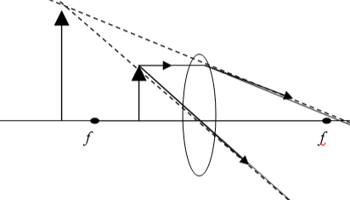
image object observer

A plutonium–239 nucleus undergoes fission when a neutron collides with it. Xenon–134 and zirconium–103 are produced together with some neutrons.
Write a nuclear equation for this fission reaction.
$${}_{94}^{239}{Pu+{}_{0}^{1}n→}{}_{54}^{134}{Xe}+{}_{40}^{103}{Zr}+3{}_{0}^{1}n$$

Calculate the energy released in this reaction.
In what form is this energy released?
(masses of: Pu–239 = 239.052163 u, Xe–134 = 133.905395 u, Zr–103 = 102.926599 u)
Mass before:
$$239.052163×1.6605402×{10}^{-27}+1.67492727×{10}^{-27}=3.986306538×{10}^{-25 }kg$$

Mass after:
$$\left(133.905395+102.926599\right)×1,6605402×{10}^{-27}+\left(3×1.67492728×{10}^{-27}\right)=3.982938285×{10}^{-25} kg$$
Change in mass:
$$Δm=3.368253×{10}^{-28} kg$$
Energy released:
$$E=mc^{2}=\left(3.368253×{10}^{-28}\right){\left(2.99792458×{10}^{8}\right)}^{2}=3.02724×{10}^{-11}J$$

This energy would initially be released in the form of gamma rays, and as the kinetic energy of the particles remaining.
Question 12a
State the principle of conversation of energy.
The principle of conservation of energy states that energy can not be created or destroyed but that it can be converted from one form into another.

A mass hanging at the end of a string of length 80 cm is given an initial horizontal velocity of 4 m s⁻¹.
Calculate
the velocity of the mass at position B
We need to find the height the mass has achieved:
35º
x 0.8

h

$$cos 35=\frac{x}{0.8}=0.8192$$
$$x=\left(.8192\right)\left(0.8\right)= .655 m$$
height gained:
$$h=0.145 m≈0.15 m$$
$$E_{k-B}=E_{k-A}-E_{p-B}$$

$$\frac{1}{2}mv_{B}^{2}=\frac{1}{2}mv_{A}^{2}-mgh$$

$$v_{B}^{2}=v_{A}^{2}-2gh=4^{2}-2\left(9.8\right)\left(0.15\right)=13.06$$

$$v_{B}=3.61 ms^{-1}$$

Calculate its centripetal acceleration at position B.
Centripetal acceleration:
$$a=\frac{v^{2}}{r}=\frac{13.06}{0.8}=16.33 ms^{-2}$$

Draw a labelled diagram to show the forces acting on the mass when it is at position B.

Tension (centripetal force)

weight

Question 12b
What is a semiconductor?
A semiconductor is a material whose resistivity lies between that of a conductor and an insulator

What is meant by doping a semiconductor?
Doping a semiconductor means that we add a small amount of an impurity to it, in order to increase its conductivity – either by adding extra free electrons or extra holes.

How can a semiconductor be doped so that
- its majority charge carriers are electrons,
- its majority charge carriers are holes?
Taking the example of silicon, which has 4 electrons in its outer shell and forms a crystal where all four electrons are shared with neighbours.
Electrons: n-type
When constructing a silicon crystal, we can introduce a small number of phosphorous atoms. These will try to fit into the overall crystal structure, sharing one electron with each of four neighbours. But They have five electrons in their outer shell and will therefore have one ‘extra electron’. This is likely to break free from the atom and to become available for conduction. As there are extra free electrons, conductivity is improved.

Holes: p-typing
If we add a small quantity of boron to a growing crystal of silicon, it will try to fit into the structure of the crystal. It only has three electron in its outer shell, however, so an extra ‘hole’ will be created. As holes act like positve charges (and as stepping stones for the moving electrons), this will also improve the conductivity.
The capacitance of a capacitor in a RAM chip is 90 fF It operates at a voltage of 1.2 V.
Calculate
the energy stored in the capacitor when it is fully charged,
Calculate the number of additional electrons that are on the negative plate of the capacitor as a result of it being fully charged.
Energy: $W=\frac{1}{2}CV^{2}=\frac{1}{2}\left(90×{10}^{-15}\right)\left({1.2}^{2}\right)=6.48×{10}^{-14}J$
Charge on each plate:
Rearranging $C=\frac{Q}{V}$, gives us:
The charge on each plate: $Q=CV=90×{10}^{-15}×1.2=1.08×{10}^{-13} C$

The no. of electrons, N, is:
$$N=\frac{charge on plate}{charge on electron}=\frac{1.08×10^{-13}}{1.602×{10}^{-19}}=674,157$$

Question 12c
Critical Angle
Total Internal Reflection
Explain the underlined terms.
The critical angle is the angle of incidence, as a light ray leaves a dense material and enters a less once, for which the corresponding angle of refraction is 90º
Total Internal Reflection occurs when the angle of incidence in a dense material is greater than the critical angle. Light is reflected at the meeting of the two materials.

A diver is 12 m below the surface in a pool of water. When he looks up he can see a circular window of light on the surface of the water.
Calculate the area of this disc of light.
12
r
C
C

To find C:
$n=\frac{1}{sin C}$, gives: $\sin^{-1}\frac{1}{n}=\sin^{-1}\frac{1}{1.33}=48.75^{o}$

$$Tan C=\frac{r}{12}$$
Radius: $r=12 tan C=12 tan 48.75=13.69 m$

And, $Area=πr^{2}=π{(13.7)}^{2}=590 m^{2}$

Use a labelled diagram to explain why the diver does not appear to be at a depth of 12 m when viewed by an observer outside the pool.
As light reflected from the diver emerges from the water it is refracted as shown. An observer above the water will believe that this light has travelled in straight lines from the point shown – which is the apparent depth of the diver. This is always less than the actual depth.
Real depth
Apparent depth

Question 12d
There are two families of hadrons. Name the two families and distinguish between them.
Hadrons can be sub-divided into Baryons and Mesons.
Baryons consist of three quarks or anti-quarks
Mesons consist of a quark and an antiquark.

Two protons, each with a velocity of 0.9c, travelling in opposite directions collide.
A neutral pion and two protons remain after the collision.
The single pion produced must be neutral. Explain why.
This is due to the conservation of electric charge. The total charge before the collision is + 2 (the charge on the protons). Afterwards the total charge must still be + 2. As this is the total charge on the two protons, the new particles created - which is in this instance a single pion – must have a charge of zero. The pion must be neutral.

Calculate the total kinetic energy of the three particles after the collision.
The total kinetic energy before is:
$$E_{k}=2×\frac{1}{2}mv^{2}=\left(1.672622×{10}^{-27}\right){\left(0.9×2.997925×{10}^{8}\right)}^{2}=1.218×{10}^{-10} J$$
From this energy, a pion is created. From this tables, p.48, we know that its mass is:
$$m=264×9.109383×{10}^{-31}=2.405×{10}^{-28 }kg$$
The energy required to make this particle is:
$$E=mc^{2}=\left(2.405×10^{-28}\right){\left(2.997925×{10}^{8}\right)}^{2}=2.162×{10}^{-11} J$$

The remaining energy is the kinetic energy of the particles:
$$E_{k}=1.218×{10}^{-10}-2.162×{10}^{-11}=1.002×{10}^{-10} J$$

The large hadron collider is a circular accelerator. How are the protons maintained in circular motion?
The protons are accelerated to a high speed using a strong electric field. They are forced to move in a circle by the use of magnetic fields. – making use of the phenomenon where a charged particle moving in a magnetic field will experience a force.
Following the left hand rule, this force will cause the particle to move in a circular path.

State the principal advantage of a circular accelerator over a linear accelerator.
The particles in the accelerator are caused to accelerate by use of strong electric fields. The longer the path followed, the greater the speed they can reach.
In a linear accelerator, the maximum distance they can travel – and hence their maximum speed/energy - is limited by the length of the tube. In a circular accelerator, the particles can retrace the same path over and over again, always gaining speed and energy, and therefore this limitation is reduced. They can achieve higher speeds and energies.
Greater energies prior to collision allow more particles to be created after the collision.

