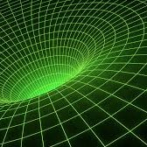
Physics Resource Bank

Junior Cycle Physics

Activities and Investigations

To Investigate the Need for Standard Units
Textbook Chapter | Equipment Required | JC Learning Outcome
 | Metre sticks | Students should be able to select and use appropriate measuring instruments  Students should be able to identify and measure/calculate length
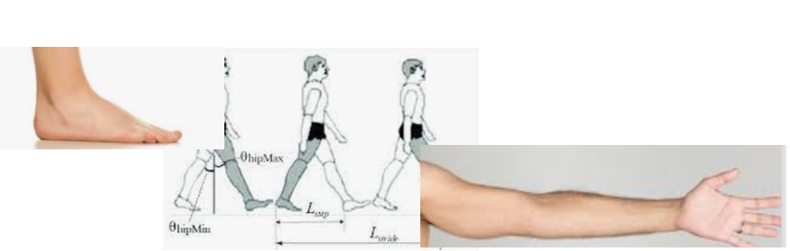

Most units for length began as simple-to-use human measurements using something like the length of …
- somebody’s foot
- somebody’s arm
- somebody’s stride
Working in groups, select a ‘unit’ of your own: typical ideas are the length of a pencil case or a textbook, somebody’s shoe, or the width of a finger etc – but you can pick your own
Take several measurements your new unit, as suggested below, and also with metres
What is your unit?
Item | No of units | Metres
Height of desk
Length of room
Height of door
Width of door

Compare your measurements to other groups
Which measurements agree and which disagree?.......................................................................
What is the benefit of having agreed units?..........................................................................

To Investigate Mass and Density
Textbook Chapter | Equipment Required | JC Learning Outcome
 | - Various weights, both in regular and irregular shapes  - Overflow cans  - Electronic balances (x6)  - Graduated cylinders | Students should be able to identify and measure/calculate length, area, mass, volume, density,
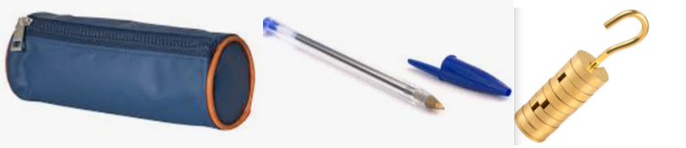

Introduction to mass and the use of an electronic balance
Guess the mass of each of these items and then check the weight with the electronic balance
item | Guess (include a unit!) | Actual mass

Area and Volume
For a rectangular solid that you are given, find the mass using a balance – and then measure the length, width and height before carrying out the calculations to find complete this table:
item | length | width | height | Total Surface Area | Volume
Show your work:

Now find the density of your solid:
$$density= \frac{mass}{volume}=$$

To find the density of a stone
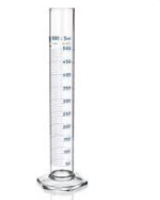
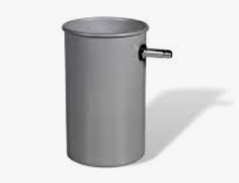
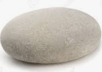

You will be given a small stone

Use an electronic balance to find the mass of the stone
Mass:

Find the volume of the small stone using an overflow can
Volume:

Use these figures to find the density of the stone:

Density:
(Have you remembered to use the correct units?)
Investigate Power
Textbook Chapter | Equipment Required | JC Learning Outcome
 | - Timer (phone is fine)  - Measuring tape / metre stick | Students should be able to identify and measure/calculate length, time, force
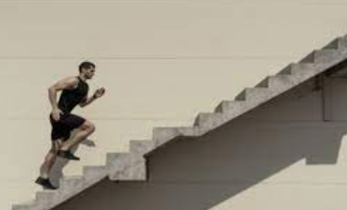

Who is the most powerful student in the class?
When you climb a stairs, you gain potential energy
The faster you climb it, the more power is generated

Volunteers agree to share their mass (what we usually all our ‘weight’) with the class, in kilogrammes
Working together, measure the height of a flight of stairs
Each volunteer runs up the flight of stairs as a student measures their time
The work done by the student is their energy gained, which is E = mgh.
The power generated is $Power= \frac{work}{timⅇ}$
Student name | Student mass (kg) | g | Height of stairs  (m) | Work done  (E = mgh) (J) | Time  (s) | Power  (W)
 |  | 10
 |  | 10
 |  | 10
 |  | 10
 |  | 10
 |  | 10

Who is the most powerful?..........................
To Investigate Velocity and Acceleration
Textbook Chapter | Equipment Required | JC Learning Outcome
 | - Timer (phone is fine)  - Measuring tape | Students should be able to identify and measure/calculate length, time, speed, acceleration
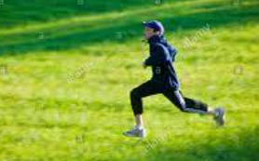

Measuring speed

Working as a group, measure out a distance of about 30 metres on a playing field.
Write down the exact distance
Mark beginning and end points (maybe use a book or a bag to mark each)
Students run between the two points as a timekeeper records their time
Calculate the average speed for each student

Runner | distance | time | speed$=\frac{distance}{time}$

Measuring acceleration

Working a group, mark out the pitch as shown here.
A bag can mark the positions of A, B, X and Y

Two time keepers are needed.

Volunteers run from the start line
One timekeeper measures the time from A to B
One timekeeper measures the time from X to Y

The final speed between X and Y is calculated: $final speed=\frac{10}{time (X to Y)}$

We know that the speed at the beginning is zero. So we can find the acceleration:
$a=\frac{final speed-0 }{time (A to B)}$

Runner | Time  (X to Y) | Time  (A to B) | final speed$=\frac{distance}{time (X to Y)}$ | $$a=\frac{final speed-0 }{time (A to B)}$$

To Investigate Forces and Friction
Textbook Chapter | Equipment Required | JC Learning Outcome
 | - Various spring balances  - Assorted weights with hooks  - Various surfaces (sandpaper, carpet etc) | Students should be able to identify and measure/calculate force  Students should be able to investigate patterns and relationships between physical observables
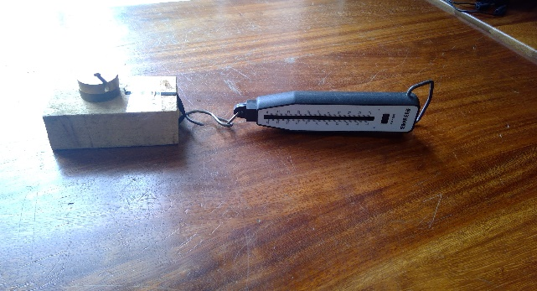

- Attach the spring balance to the weight as shown in the photo.
- As one student pulls gently in the direction shown, the other student watches the scale.
- Note down the force that’s required to just start the weight moving.
- This is the force that matches (and just exceeds) the force of friction that stops the object moving.

Repeat this procedure a few times, and take the average as the best measure of friction.
 | 1st trial | 2nd trial | 3rd trial | average
Friction

Repeat this procedure with extra weights added on top.
 | 1st trial | 2nd trial | 3rd trial | average
Weight =
Weight =
Weight =
What affect do you think increasing the weight has on friction?

Repeat it again, on various surfaces, such as sandpaper, carpet etc…
 | 1st trial | 2nd trial | 3rd trial | average
Surface 1
Surface 2
Surface 3
What affect do you think increasing the surface has on friction?

To Investigate Magnetism
Textbook Chapter | Equipment Required | JC Learning Outcome
 | Magnets (x12)  Plotting compasses (x 20-30)  Iron Filing in containers (x12) | Students should be able to investigate patterns and relationships between physical observables
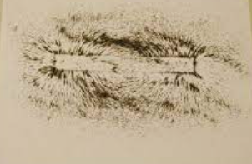
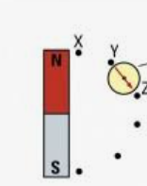

Iron Filings
Place a bar magnet under a sheet of paper
Gently sprinkle iron filings on the paper
Not the pattern that develops.
Move the magnet around under the paper. What happens to the iron filings?
Sketch your pattern here:

Plotting Compasses
Place a bar magnet on a piece of paper
Place a plotting compass near it. Mark the paper where the needle is pointing
Repeat this with several compasses (or use the same compass in different locations)
Sketch the pattern that develops with the dots on the paper?
To Investigate the Effects and Nature of Electric Charge
Textbook Chapter | Equipment Required | JC Learning Outcome
 | Polythene rods  Balloons  Van de Graaf Generator | Students should be able to identify and measure/calculate, force, potential difference, current
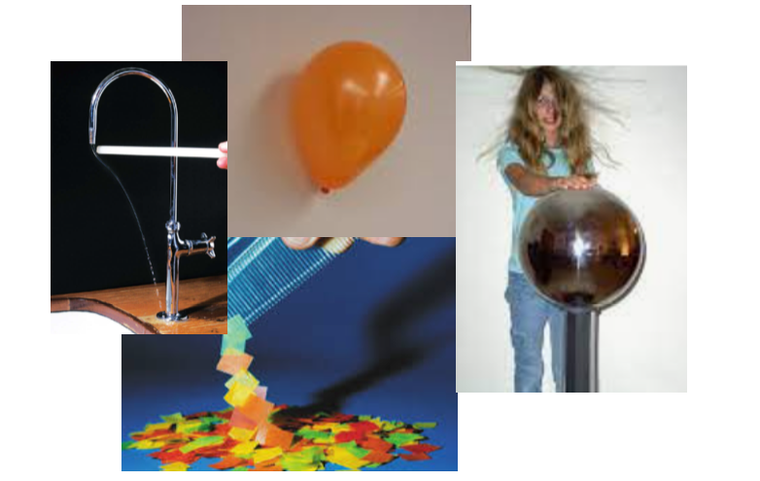

Tear up a piece of paper so that it is small sections, less than a centimetre in width
Rub a polythene rod against a dis-similar material. You could try your hair, or a jumper, or a tie.
Hold the rod close to the pieces of paper.
Does it pick them up?

Turn on a tap so that there is gentle, continuous flow.
Rub a polythene rod against your hair or a jumper.
Hold the rod close to the water flow.
Does the water flow change direction?

Rub an inflated balloon against your hair or a jumper
Hold it against a wall and let go.
Does it attach to the wall?
How long can it stay attached to the wall?
What do all these effects have in common?
Try to explain why they occur
To Investigate Voltage and the use of a Multimeter
Textbook Chapter | Equipment Required | JC Learning Outcome
 | - A selection of batteries  - Some ‘dead’ batteries  - Electric leads (x24)  - Multimeters (x12)  - Solar Panels (x12)  - Crocodile clips | Students should be able to identify and measure/calculate potential difference  Students should be able to design, build, and test a device that transforms energy from one form to another in order to perform a function; describe the energy changes and ways of improving efficiency
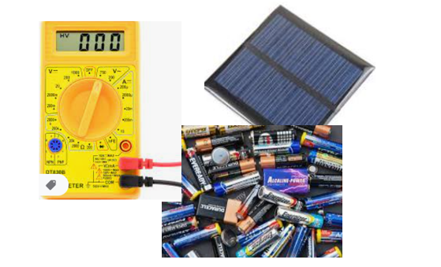

Use leads to attach a multimeter to the poles of a battery.
Vary the settings on the circular scale until you can see a voltage reading.
Does it match the label on the battery?
Use the same multimeter to measure the voltage output from various discarded (‘dead’) batteries.
Dead battery | Voltage output
Example 1
Example 2
Example 3
What can you conclude about dead batteries?

Use the same multimeter to measure the voltage output from a solar panel in various situations
Solar panel | Voltage output
Covered with your hand
Uncovered
Under electric light (from a phone light, for example)
Under sunlight
What can you conclude about the energy available from the sun?

To Investigate Electric Current
Textbook Chapter | Equipment Required | JC Learning Outcome
 | Power supply (x12)  Resistors (x12)  Electric leads (x 30-40)  Ammeters (x12)  Bulbs, in bulb holders (x15) | Students should be able to design and build simple electronic circuits  Students should be able to investigate patterns and relationships between physical observables

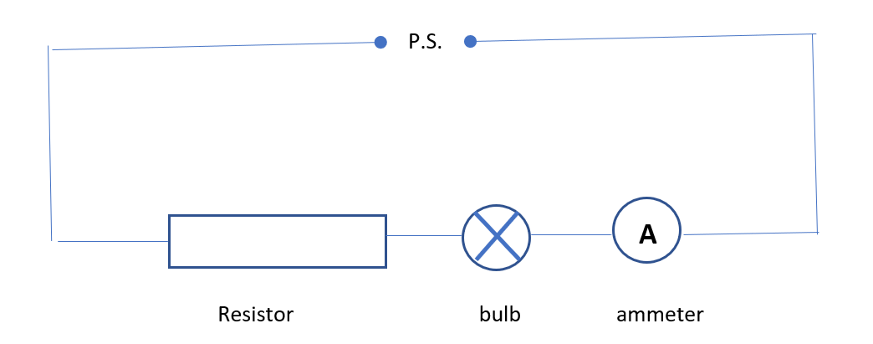Use the equipment your teacher gives you to set up a circuit like the one above.
Remember it won’t look neat and rectangular like the diagram. But use the wires to join things together in the same order as the diagram shows.
Once it’s set up and switched on, the bulb should come on. If it doesn’t, check…..
- that the wiring is right
- that your connections are tight
- that all the wires are working (you can try replacing them with other wires)
- that the components are working (you can try replacing them with other wires)
Once the bulb is on, note down the reading on the ammeter.
Now try increasing the voltage and see what happens to the bulb and the ammeter
Then try increasing the resistance and see what happens to the bulb and the ammeter.
Complete these sentences:

- When the voltage increases, the bulb ………………, and the current..……………
- When the resistance increases, the bulb ………………, and the current..……………

To Investigate Electrical Resistance
Textbook Chapter | Equipment Required | JC Learning Outcome
 | Resistors (x12)  LDRs (x12)  Power supply (x12)  Multimeters (x12) | Students should be able to identify and measure/calculate current, resistance
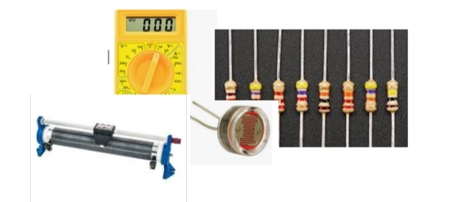

Resistance of a Rheostat
Set a multimeter to read resistance (search for the ‘Ω’ symbol)
Attach the leads to either end of a rheostat.
Does the reading on the meter match the label on the rheostat?

Attach one of the leads to the third connection on the rheostat.
Move the slider along the top.
What happens to the resistance?

What is an LDR?
Attach the leads to either end of an LDR. Take readings as shown here:
Resistance
LDR covered by a hand
LDR uncovered
LDR under electric light (from a phone light)
LDR under sunlight
What do you think the letters LDR stands for?
Where do you think they might be useful?

Reading the Resistor code
Commercial Resistors come colour coded so that engineers and technicians can tell what the resistance of each resistor is, or is supposed to be. This is the code:

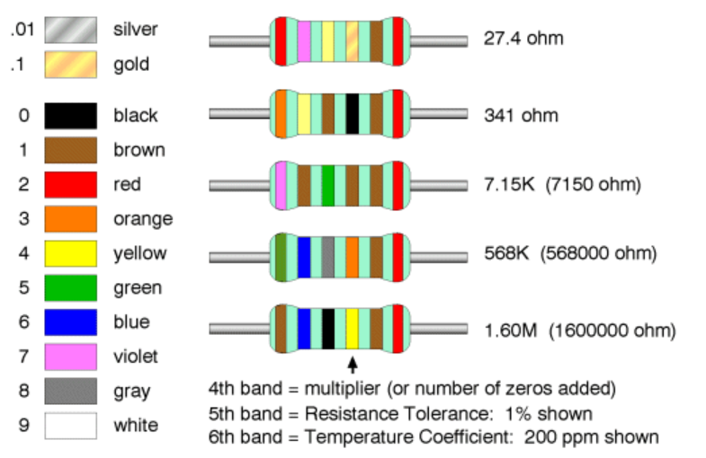

Using these codes, identify the resistance of each of these resistors:
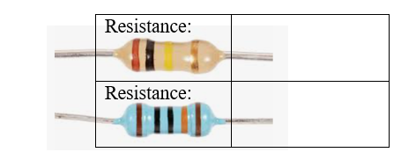

Your teacher will give you a resistor:
From the code, find its labelled resistance, and then check with a multimeter what its resistance actually is
Colours: | Labelled Value (from the colours): | Actual value (from the meter)

To Investigate and build electronic circuits
Textbook Chapter | Equipment Required | JC Learning Outcome
 | Locktronics kit (x6) | Students should be able to identify and measure/calculate, potential difference, current, resistance, electrical power  Students should be able to design and build simple electronic circuits

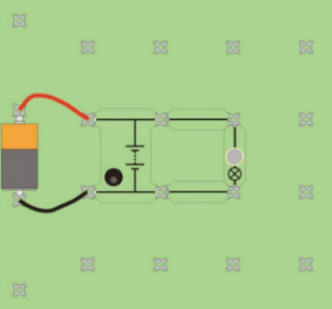
Using the Locktronic kit supplied, build these circuits:

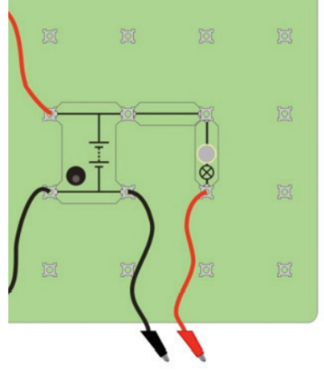
Try this one: You can use the crocodile clips to attach to various materials, and check if they are conductors or insulators:

See if you can get this one working:
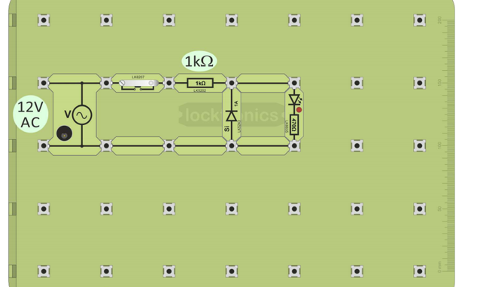

Can you design a circuit of your own?

