2015 q8
Define electric field strength.
Electric field strength is the force per unit positive charge at a point in an electric field, i.e.

Both Van de Graaff generators and gold leaf electroscopes are used to investigate static electricity in the laboratory.

Draw a labelled diagram of a gold leaf electroscope.
Describe how it can be given a negative charge by induction.

Uncharged electroscope. The cap and metal bar should be insulated from the case.
Cap (metal)
Gold/ Aluminium leaves
Metal bar
Case

If a charge exists on the leaves, they will repel from each other and stand out (dotted line).

To charge an electroscope by induction, you should bring a negatively charged rod close to the cap.

+++ _
- - - -

Negatively charged leaves

If the charge is negative, it will attract positive charges up to the cap, leaving a negative charge on the leaves. As the leaves now hold the same charge, they will repel each other and stand upright. The electroscope is charged.

To allow the charge to survive after removing the rod, you should:
- Earth the cap while the rod remains.
- Remove the connection to earth.
- Remove the rod.

A Van de Graaff generator can be used to demonstrate point discharge. Explain, with the aid of a labelled diagram, how point discharge occurs.

An electric charge will always tend to spread itself out as much as possible.

On a metal object, where charges are free to move, all electric charge will move to the outside of the object. If the object is spherical or smoothly curved as it is on a Van de Graaff generator the charge will be evenly spread over the outside surface.

Point Effect
Wherever an object is less curved, there will be a build-up of charge particularly at sharp points. This is the point effect.

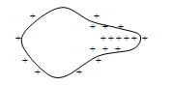
This can actually lead to the object becoming discharged, as the air surrounding the point becomes ionised (charged), and negative charges attach to the point and cancel the positive charge (or vice versa).

Describe an experiment to demonstrate point discharge.

Attach a Van de Graaff generator to an electroscope, as shown.
Charge the generator and note how the presence of the charge causes the leaves on the electroscope to diverge.

Bring a sharply pointed object, such as a needle, close to the generator.

Note how the leaves collapse, indicating the charge has been removed from the system.

This is a demonstration of point discharge.

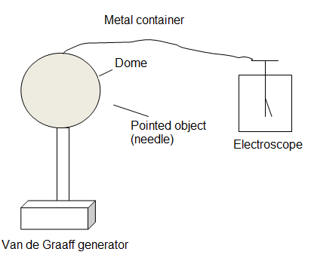

The polished spherical dome of a Van de Graaff generator has a diameter of 40 cm and a charge of +3.8 μC.

What is the electric field strength at a point 4 cm from the surface of the dome?

