Applied Maths: TY Module

Name:

Distance-Speed-Time
From Junior Cycle, you should remember the relationship between speed, distance and time.
You might have learned this using an image like that shown here for ‘Dad’s Silly Triangle’ – which can help you keep track of the formulae shown beneath it:

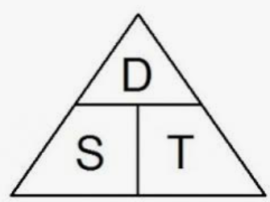

$s=\frac{d}{t}$ $t=\frac{d}{s}$ $d=st$

You can use them to answer questions like this:
If a car s travelling at 110 km/hr, how long will it take to travel 88 km?

If a bullet is travelling at 400 km/hr, what is its speed in metres per second?
Imagine the car travelling a distance of 400,000 m (400 km) in 3600 s (1 hour)
Try these calculations based on distance, speed and time
- If a car is travelling at 80 km/hr, how long will it take to travel from Dublin to Galway, a distance of 210 km?
- It took the Apollo 11 space craft approximately 3 days to travel from earth to the moon, which is 400, 000 km away.
    - What was its speed in kilometres per hour?
    - What was its speed in metres per second?
- If you travel in an airplane at 800 km/hr, how far will you travel in 5 hours?
- If a plane is flying at 800 km/hr, what is that speed in metres per second?
- Radio and TV signals can travel at the speed of light, which is 300, 000, 000 ms⁻¹. If a football game is being played in London and you are watching it in Dublin, a distance of 500 km away, what is the shortest possible delay in the signal reaching you?
- Taking the speed of light to be 300, 000, 000 ms⁻¹, how far can light travel in one year?

The Equations of Motion
The calculations above are all based on the idea of objects which are moving at a fixed speed. If we want to look at situations where moving objects can speed up or slow down – what is to say, where they accelerate, the maths gets more complicated. For situations like that we use the equations of motion.

In these equations, we use the following letters or symbols:

symbol | meaning | Unit
u | initial speed or velocity | ms⁻¹ (metres per second)
v | speed or velocity after a time t | ms⁻¹ (metres per second)
a | acceleration | ms⁻² (metres per second squared)
s | distance or displacement | m (metres)
t | time | s (seconds)

These measurements are all related by the following 4 formulae: the Equations of Motion
$$v=u+at$$
$$v^{2}=u^{2}+2as$$
$$s=ut+\frac{1}{2}at^{2}$$
$$s=\left(\frac{u+v}{2}\right)t$$

Sample Questions

A car is travelling at a speed of 20ms⁻¹ West. For a period of 5 seconds, it accelerates at a rate of 3ms⁻² in the same direction. What distance does it travel in this time?

The speed of a car increases from 3ms⁻¹ to 26ms⁻¹ over a period of 8 seconds. What is its acceleration and what distance does it travel in this time?

Questions:

1 A car starts from rest and increases its speed at 3ms⁻² for 5s. How far does it travel in that time? What is its speed after 5seconds?

2 Over a distance of 5 metres, the speed of a bicycle increases from 2ms⁻¹ to 5ms⁻¹. What is the magnitude of its acceleration in this period? How long does this take?

3 A car accelerates from 50km/hr to 100 km/hr over the course of 30seconds. What is the magnitude of its acceleration in this period?

4 A truck is travelling at 80km/hr and decelerates at a rate of 3ms⁻². How far does it travel before it comes to a rest? How long does this take?

5 A bird flying at 3 ms⁻¹ W is given an acceleration of 1 ms⁻¹ E. After 5seonds, what is its velocity? How far has it travelled in that time?

6 A car is travelling North at 25ms⁻¹ and decelerating at 5 ms⁻². After 7seconds, what is its speed and direction? How far is it from its starting point?

7 A skateboarder starts from rest and accelerates to a speed of `15ms⁻¹ over a distance of 20m. What is their acceleration?

8 An airplane travels 850m along a runway before taking off. If it starts from rest and accelerates at a constant rate for 20s before take-off, what is its speed when it leaves the ground?

9 In good weather cars travel on a stretch of motor way at an average speed of 105km/hr. It takes them 30 mins to cover the distance between two exits. On a wet day, the average speed falls to 80km/hr. How much longer does the journey take?

Extended Questions:
- A car drives between 2 points, P and Q, on a level road.
The car passes P at 7 ms⁻¹ and accelerates uniformly until it reaches a speed of 21 ms⁻¹
It then travels at a steady speed of 21 ms⁻¹ for 9.5 seconds
The car then decelerates steadily over a distance of 98 m until it passes point Q travelling at 7 ms⁻¹
- What is the initial acceleration?
- What is the total distance travelled from P to Q
- What is the average speed between P and Q

- A car drives between 2 points, P and Q, on a level road.
The car passes P at 5 ms⁻¹ and accelerates uniformly for 7 seconds until it reaches a speed of 26 ms⁻¹
It then travels at a steady speed of 26 ms⁻¹ for 234 m
It then decelerates steadily to rest over a distance of 52 m
What is
- the initial acceleration?
- the total distance travelled from P to Q
- the average speed between P and Q

Vectors and Scalars
In applied maths we separate all measurements into two categories: vectors and scalars.
Vectors have both magnitude and direction
Scalars have only got a magnitude.
Most measurements that you come across outside the world of science are scalars. Mass for example is a scalar. It is measured in kilogrammes and has no direction. Other scalar quantities are length, volume, time, energy and electric charge.
Examples of vector quantities are velocity, acceleration, momentum, force and weight. All of these have a direction associated with them. A typical measurement of force, for example, might be 10N, East.
One thing that can be confusing is that there are a number of closely related measurements, one of which is a vector and one of which is a scalar. Speed, for example, is a scalar. It is specified only in metres per second. The associated vector quantity is velocity which is measured in metres per second, and a direction
e.g. A speed could be 20 ms⁻¹, whereas a velocity would be something like 20 ms⁻¹, East
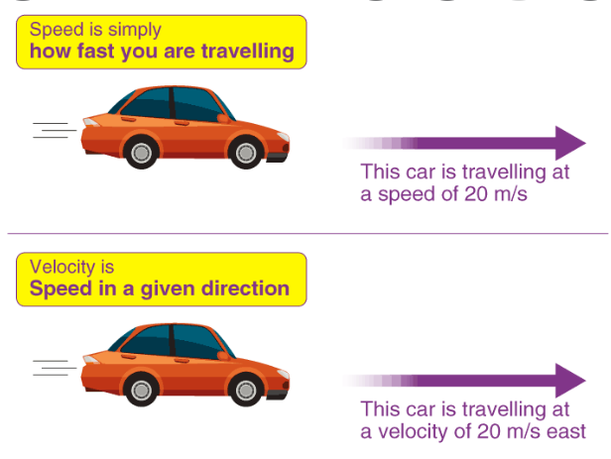
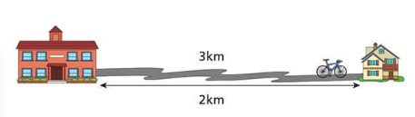
Another important difference is between distance and displacement. With displacement, we don’t take the path travelled into account. In the diagram below, a cyclist journeys from school to home along the route shown. When finished, he has travelled a total journey of 3km. But his displacement is measured in a straight line and is only 2km East.

When first introducing the idea of velocity, we often say that it is speed in a given direction. There are many situations where this is a reasonable simplification of the situation, but it is not quite true. Strictly the definitions of velocity and speed are:
$velocity=\frac{displacement}{time}$ $speed=\frac{distance }{time}$

Vector Addition
When adding vectors we are essentially looking to see how two or more vectors could be replaced with a single vector. We want to know how large that single vector would be, and in what direction it would point. It is easiest to picture this by looking at forces:

If two forces, one of 5N and one of 10N push in the same direction, they could obviously be replaced with a single force of 15N, pushing in the same direction: i.e.
10N
5N
…is the same as…
15N

We say that total force is given by
$$F_{T}=10+5=15N, to the right$$
If two forces, one of 5N and one of 10N push in opposite directions, they could obviously be replaced with a single force of 5N, pushing as shown: i.e.
5N
…is the same as…
5N
10N

We say that
$$F_{T}=10-5=5N, to the right$$

Note that when two forces were in the same direction , we took them both to be positive, but that when they were in opposite directions, we took one to be negative. This is something we will see a lot of in applied maths. It is very important in every situation to be clear about which direction you are thinking of as positive and which direction is negative.

Triangle Law

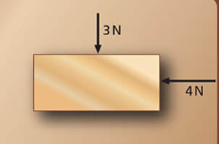
If forces are at an angle to each other, we can add them according to what is known as the triangle law: Let’s say an object is being pushed by two forces, of 3N and 4N whose directions are as shown in the diagram.
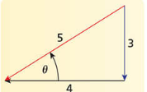

The object will move as if pushed by a single force of 5N, whose direction is as shown. The 5 N is found using a right angled triangle, and Pythagoras’ Theorem:

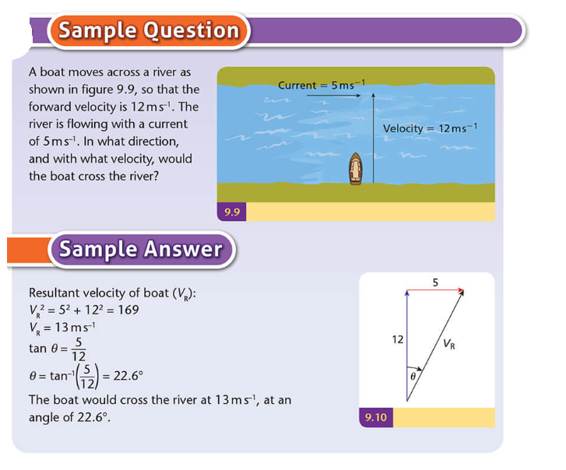

Questions
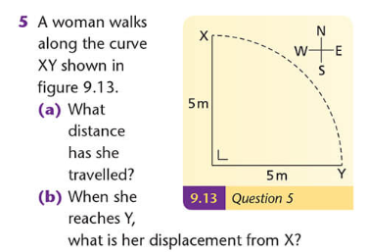
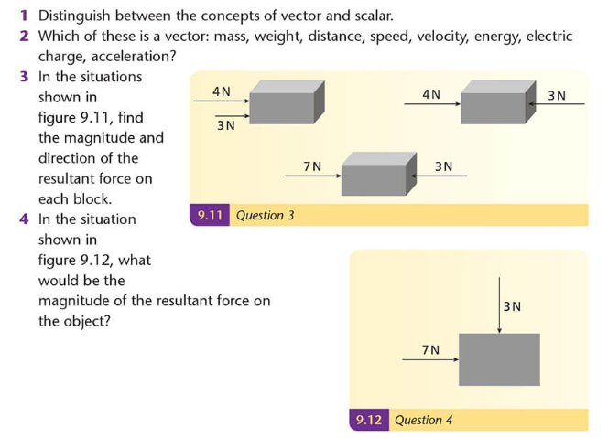
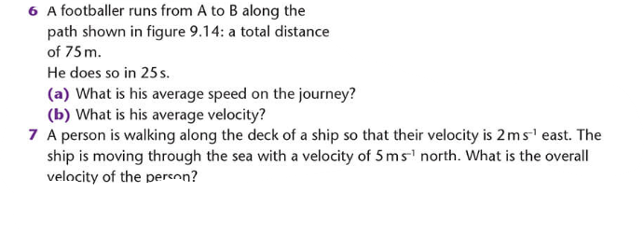
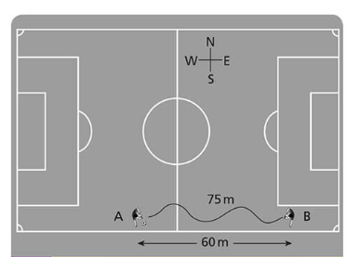
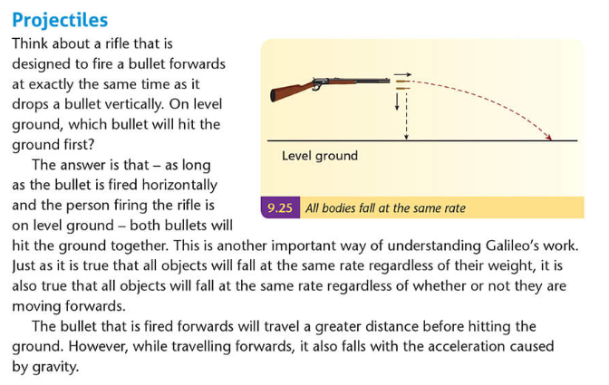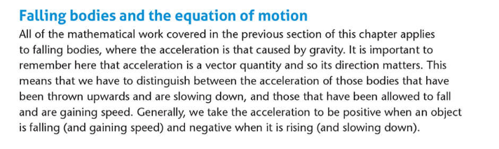
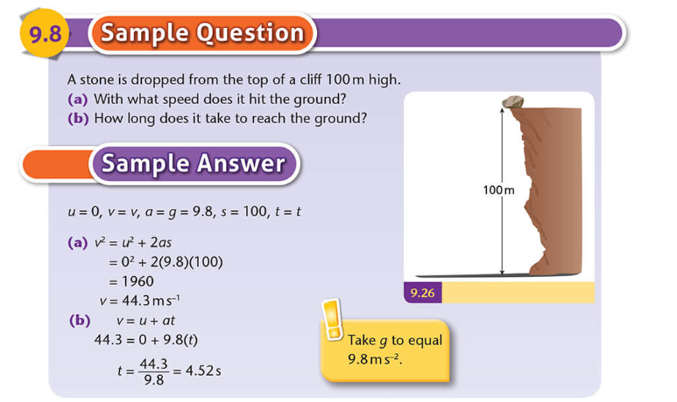

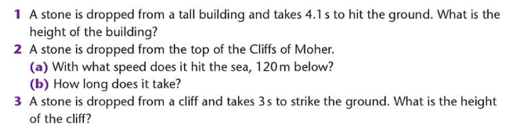
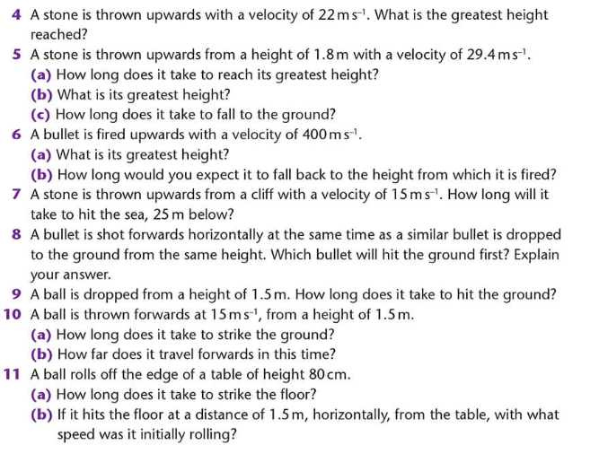
This booklet uses some material from PhysicsPlus, ©Edco and Tom Tierney
Physics Plus (edco.ie)

