2022 Leaving Cert Physics HL
Section B

Question 7
A spring of natural length 150 mm obeys Hooke’s law. When an object of mass 200 g is attached to it, the length of the spring increases to 185 mm.
- State Hooke’s law.
Hooke's Law states the restoring forc, F, on a spring is proportional to the extension, s, of the spring:
$$F=-ks$$
- Calculate the elastic constant of the spring.
Force: $weight=mg=\left(0.2\right)\left(9.8\right)=1.96$
Extension: $s=0.185-0.150=0.035$
$$F=-ks$$
$k=\frac{F}{s}=\frac{1.96}{0.035}=56$Nm⁻¹

The object is pulled down until the spring has a length of 200 mm. The object is then released. It moves with simple harmonic motion.
- Calculate the period of oscillation of the object.
$$T=\frac{2π}{ω}$$
$$w^{2}=\frac{k}{m}=\frac{56}{0.2}=280$$
Therefore:
$$T=\frac{2π}{\sqrt{28}0}=0⋅375 s$$

- Calculate the maximum acceleration of the object.
The maximum acceleration corresponds to the maximum displacement:
$a=ω^{2}s=\left(280\right)\left(.015\right)=4.2$ ms⁻¹
- What is the speed of the body when it has maximum acceleration?
At the maximum acceleration, the speed will be zero (0 ms⁻¹)
This is the moment when the weight is changing direction.

The object is now detached from the spring and attached to the end of a string of fixed length 11 cm. It is made to rotate in a vertical circle with constant angular velocity and with a period of 0.5 s.

- Derive an expression for the linear velocity of an object moving in circular motion in terms of its angular velocity and the radius of the circle.

Direction of linear motion
r
l
θ

An object in circular motion has a linear velocity, v, and an angular velocity, ω. The angular velocity, ω, is given by:
The direction of the linear motion is at a tangent to the circle and Iis constantly changing. Its magnitude is given by:
(as )
and substituting, we find: $v=rω$
- Calculate (a) the angular velocity, (b) the linear velocity of the object.
Angular velocity:
$ω=\frac{2π}{T}=\frac{2π}{0.5}=4π=12.57$ s⁻¹
Linear velocity
$v=rω=\left(0.11\right)\left(12.57\right)=1.38$ms⁻¹
- Calculate the minimum tension in the string.

Minimum tension: $T=F-W$
Centripetal force: $F=\frac{mv^{2}}{r}=\frac{(0.2){\left(1⋅38\right)}^{2}}{.11}=3.46 N$
Weight: $W=mg=\left(0.2\right)\left(9.8\right)=1.96 N$
Min Tension: $T=3⋅46-1.96=1.5 N$

- Draw a labelled diagram of the forces acting on the object when the string has its minimum tension.
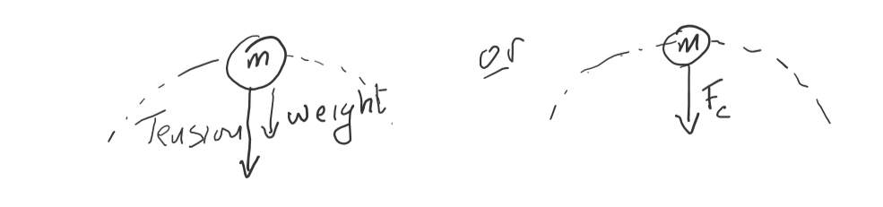
(the centripetal force is the sum of the tension on, and weight of, the mass)

Question 8
Semiconductors are essential in many electrical devices.
- Distinguish between conductors, insulators and semiconductors.
Conductors are materials with very low resistivity
Insulators are materials with very high resistivity – to the extent that is very difficult to measure. No current will flow, or a current so low that it can’t be measured.
Semiconductors are materials whose resistivity lies between the two extremes. A current will flow, but it tends to be low.

- What is meant by doping?
Doping is the process of adding an impurity to a material in such a way as to increase the number of free electrons or positive holes, and to therefore increase the conductivity.

- How does p-type doping differ from n-type doping?
In p-type doping an impurity is added which will leave a gap in the electronic binding structure of the crystal - or a ‘hole,’ which subsequently acts as if it was positively charged.
An example is Boron in Silicon.
In n-type doping an impurity is added which will leave an extra ‘free’ electron, which can then act as a charge carrier.
An example is phosphorous in silicon.

- A depletion layer exists in a p-n junction. Describe a depletion layer and explain how it forms.
In the region adjacent to the junction of the n and p-type material, the extra free electrons tend to occupy the extra free holes. This is known as the depletion layer. It acts as a block of insulating material in the middle of the diode.
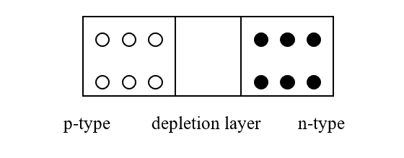
- Indicate on a diagram the sections of a p-n junction that are positively charged, negatively charged and neutral.

- Draw a circuit diagram to show this arrangement.
A diode in forward bias
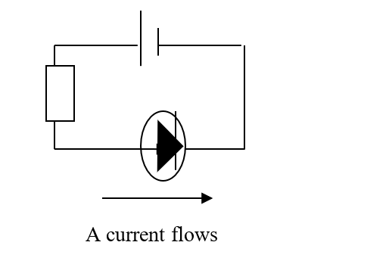
- Sketch a graph to show the variation of current with voltage for this arrangement. Indicate the junction voltage on your graph.

- In many electric circuits a resistor is placed in series with a diode. Explain why this may be necessary.

Semiconductor diodes are designed to run with a low current.
If a large voltage is applied - which would tend to drive a large current – the diode could be damaged. The resistor restricts the current and avoids this risk.

Question 9
(a) A metal sphere of diameter 5 cm holds a charge of –6 μC.

- Draw the electric field around the sphere.

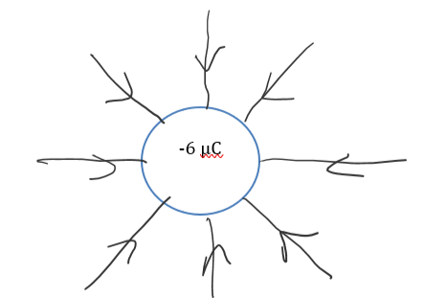

- Calculate the electric field strength at a distance of 3 cm from the surface of the sphere.
$$E=\frac{1}{4πε}\frac{Q}{d^{2}}=\frac{1}{4π8.854×{10}^{-12}}\frac{6×{10}^{-6}}{{(0.055)}^{2}}=17,826,927.15$$
The electric field: $E=1.78×{10}^{7}$ NC⁻¹

- A device that is designed to store energy when it holds a specific charge is called a capacitor.
- Describe an experiment to demonstrate that a charged capacitor stores energy.

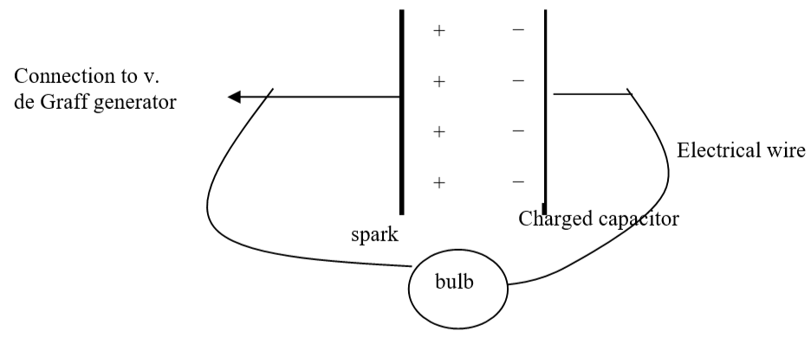
Method: Set up the apparatus as shown. Allow the capacitor to build up a charge.
Disconnect it from the generator and bring a conducting wire from each plate to the bulb.
Observation: The bulb flashes
Conclusion: The presence of light energy indicates that energy had been stored on the capacitor

- In terms of some or all of the symbols given, write an expression for (a) the charge on each plate of the capacitor, (b) the distance between the plates.

The charge (Q):
$$C=\frac{Q}{V}$$

Therefore, the charge, Q, is:
$$Q=CV$$
We also know that: W$=\frac{1}{2}CV^{2}$
Rearranging this, we can say: $C=\frac{2W}{V^{2}}$
Subbing this into the above equation for Q, yields:
$$Q=\frac{2W}{V^{2}}V=\frac{2W}{V}$$

The distance: d
From the tables, we can say that: $C=\frac{εA}{d}$, or:
$$d=\frac{εA}{C}$$
Subbing in the above equation for C:
$$d=\frac{εAV^{2}}{2W}$$

- Derive an expression for the effective resistance of two resistors in parallel.

In an arrangement like that shown: the total current, I, is:
$$I=I_{1}+I_{2}$$
Following Ohm’s Law ($I=\frac{V}{R}$)
$$\frac{V}{R_{T}}=\frac{V}{R_{1}}+\frac{V}{R_{2}}$$
As the potential drop from A to B is the same, regardless of the path followed, all values of V above are equal. Therefore:
$$\frac{1}{R_{T}}=\frac{1}{R_{1}}+\frac{1}{R_{2}}$$

- Calculate the current flowing (a) in resistor X, (b) in resistor Y.
Considering the pair of resistors in parallel:

$$\frac{1}{R_{p}}=\frac{1}{6}+\frac{1}{3}=\frac{1}{2}$$
The resistance of the combination is 2 Ω
The total resistance is then: $R_{T}=1+2=3$ Ω
The total current:
$I=\frac{V}{R}=\frac{12}{3}=4$ A
The total current flows through X, therefore:
I_{x} = 4 A
The current then splits between two resistors. The resistors are in the ratio: 6:3, or 2:1
The current will therefore split in the opposite ratio. i.e. 1:2
Y is the larger resistance and will take the smaller current. Therefore $I_{y}=\frac{1}{3}⋅4=1.33 A$

Question 10
Americium–241, a radioactive substance, is the key component of smoke detectors, where its ionising ability is used to help detect smoke particles. It is produced from plutonium–239 in nuclear reactors.

- What is meant by (a) radioactivity, (b) ionisation?

Radioactivity is the emission of either particles (such as alpha or beta particles) or electromagnetic radiation from the nucleus of an atom
Ionisiation is the addition or removal of electrons from an atom, so that the atom acquires a net charge,

- A nucleus of plutonium–239 can absorb two neutrons to produce plutonium–241. This isotope of plutonium then undergoes beta decay to produce americium–241.
Write a nuclear equation for the conversion of plutonium–239 into plutonium–241. $${Pu}_{94}^{239}+2n_{0}^{1}→{Pu}_{94}^{241}$$
- Write a nuclear equation for the conversion of plutonium–241 into americium–241.
$${Pu}_{94}^{241}→{Am}_{95}^{241}+e_{-1}^{0}$$
- Outline the differences between nuclear fission and nuclear fusion.
Nuclear Fission is the breaking up of a large nucleus into two smaller nuclei of similar size with the release of energy
Nuclear Fusion occurs when two small atomic nuclei join together to form a larger nucleus, accompanied by the release of energy
- What is the function of a moderator?
The neutrons emitted during fission tend to travel at very high speeds, and these neutrons, left as they are, would not create fission in other nuclei. A moderator is used to slow down the neutrons to speeds that are suitable for the creation of fission in other nuclei.
- State one example of a moderator.
Water is used as a moderator in many reactors. Cadmium is also commonly used.
- Why are nuclear fusion reactors not yet viable?
To maintain and control a fusion reaction over time (as would be required to build a fusion reactor) the fuel (a mix of isotopes of Hydrogen) must be heated to temperatures in the region of 100, 000, 000 ºC. This can be done using lasers.
The difficulty is that there is no container available where we can do this without the fuel leaking. All known solid materials will melt, and even vaporize, at temperatures far lower than those required.
Attempts have been made to contain the plasma (fuel) inside magnetic fields. But no institution has so far managed to do so over an extended period of time.
- Why are the alpha particles produced in the detector not considered a health hazard?
Alpha particles in air only have a range of about 2 cm. This means that they will rarely find their way out of the detector to cause any risk to humans
- Americium–241 undergoes alpha decay in a smoke detector. It has a half-life of 432 years. 241 g of americium–241 contains 6.0 × 10²³ nuclei. A typical smoke detector contains 0.29 μg of americium–241.

Calculate the decay constant for americium–241.

$$T=\frac{\ln{2}}{λ}$$
$λ=\frac{\ln{2}}{T}=\frac{0.693}{432×60×60×24×365}$ = $5.09×{10}^{-11} s^{-1}$
- Calculate the activity of the americium in the smoke detector.
$A=λN=(5.09×{10}^{-11})(\frac{..29×{10}^{-6}}{241})$($6×{10}^{23})=3.6749×{10}^{4} Bq$

Question 11
A particular fulacht fiadh contained 750 litres of water at an initial temperature of 4 °C. 50 stones were taken from the fire, at a temperature of 280 °C, and placed into the water. The stones had an average heat capacity of 8.5 kJ K⁻¹ each.

- What is meant by (a) heat capacity, (b) specific heat capacity?
The heat capacity of a body is the amount of energy needed to raise the temperature of the body by 1K.
The specific heat capacity, c, of a substance is the amount of energy required to raise the temperature of I kg of the substance by 1K.

- Calculate the highest temperature the water could have reached.
Heat lost (by the stones) = Heat gained (by the water)
$$CΔϑ=mcΔϑ$$

$$(8500)(50)(280-x)=(750)(4180)(x-4)$$

$$119, 000, 000-425, 000x=3, 135, 000x-12,540,000$$
$$3,560,000x=131,540,000$$
$x=36.95$ ºC

- Suggest a way of improving the design of the fulacht fiadh to make it more efficient.
In the description provided, we are told the water was held in a pit in the ground. The surrounding soil would have provided some natural insulation – but this could be improved perhaps with wool, or some other natural material being used to line the pit.
Also, a lid could have been added.
Both of these would have reduced heat lost to the surroundings, which would have made the heat transfer more efficient.

Using a smaller amount of water would have created a larger temperature change – which would allow the cooking to take place at a higher temperature.

The earliest harps and lyres were produced in the Bronze Age. Different strings in a lyre may have different lengths, different tensions and different diameters.
- Draw a labelled diagram to represent a stretched string vibrating at its third harmonic.

3rd harmonic:

A 65 cm string of mass 0.21 g is stretched between two points of a lyre which are 34.1 cm apart. It is required to vibrate at a fundamental frequency of 440 Hz.

- Calculate the tension that is applied to the string.

$$f=\frac{1}{2l}\sqrt{\frac{T}{μ}}$$

$$(440)=\frac{1}{2(.341)}\sqrt{\frac{T}{ 3.2×{10}^{-4}}}$$

$$300.1=\sqrt{\frac{T}{ 3.2×{10}^{-4}}}$$

$$90048.01=\frac{T}{ 3.2×{10}^{-4}}$$
$$T=28.82 N$$

- Determine the frequency of the string if the tension is now reduced by a factor of four.
Following $f=\frac{1}{2l}\sqrt{\frac{T}{μ}}$, we can see that reducing the tension by a factor of 4 will reduce the frequency by a factor of 2.
The frequency will be halved to 220 Hz
Archaeologists often use radiocarbon dating to estimate the age of wooden objects. They do this by measuring the ratio of carbon–14 to carbon–12 in a sample and comparing it to this ratio for the carbon in a living tree.
- C–14 and C–12 are both isotopes of carbon. What are isotopes?
Isotopes are atoms of the same element with differing mass numbers.
The ratio of C–14 to C–12 in a sample from an archaeological artefact is found to be one quarter the ratio found in a living tree.
- Is the artefact from the Bronze Age? Justify your answer.
If the activity is at ¼ of its original level – this corresponds to two half-lives.
The sample would be (approximately) 11, 460 years old
We are told in the question that the bronze age was about 5000 years ago
That would mean that the sample predates the bronze age.

Question 12
In 1932 Ernest Walton and John Cockcroft verified experimentally Einstein’s equation that relates mass and energy. They accelerated protons through a potential difference of 70 kV before allowing them to collide with lithium metal.

- Draw a labelled diagram of their apparatus.
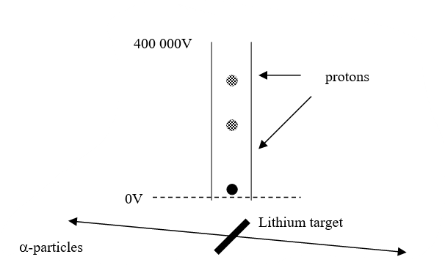

- Write a nuclear equation for the interaction between a proton and a nucleus of lithium–7.

The mass of the H-1 nuclide is given on page 83 of the Formulae and Tables booklet as 1.007825 u.
- Convert this mass to kg. (Give your answer to six decimal places.)

Mass of Hydrogen nuclide:
$$1.007825×1.6605402×10^{-27}=1.673 533 927×10^{-27} kg$$
- Explain the discrepancy between the value you have calculated and the value given for the mass of the proton on page 47 of the Formulae and Tables booklet.

The value given on page 47 is $1.672 621 71×10^{-27}kg$
The difference arises because the value on page 83 is the mass of a Hydrogen atom, which includes an electron as well as a proton. The mass on page 47 is just that of a proton.

The difference between the two is 9.12 $×10^{-31}$ kg – which corresponds closely to the mass of the electron.

- Calculate the kinetic energy of the proton as it collided with the metal
We are told that the protons are accelerated through 70 kV.
$$energy=qV$$
$$energy=\left(1.602 ×{10}^{-19}\right)\left(70,000\right)=1.12×{10}^{-14} J$$

- Calculate the mass lost (in kg) during the interaction,
Mass before:
$$1.672 671 71×10^{-27}+7.016 005×1.6605402×10^{-27}=1.332{×10}^{-26} kg$$
Mass after: $2×4.002603 ×1.6605402×10^{-27}=1.329{×10}^{-26} kg$
The difference in mass is therefore: $m=3 ×10^{-29} kg$

- Calculate the energy produced (in J) during the interaction,
The energy released from mass is $E=mc^{2}$
$$E=3 ×10^{-30}{(3 ×10^{8})}^{2}=2.7 ×10^{-12}J$$
- Calculate the speed of the alpha particles formed during the interaction.
The total energy available for kinetic energy is the energy produced from mass and the energy that was already there as the kinetic energy of the proton.
$E= 2.7 ×10^{-12}+1.12×{10}^{-14}=2.7112×{10}^{-12} J$
This will be split between the two alpha-particles. Therefore, the energy of each one is $1.3556×{10}^{-12} J$
Kinetic Energy follows: $E=\frac{1}{2}mv^{2}$
Therefore: $\frac{1}{2}mv^{2}$ = 1.3556$×{10}^{-12}$
$v=\sqrt{\frac{2×1.406×{10}^{-14}}{m}}= \sqrt{\frac{2×1.3556×{10}^{-12}}{6.644×{10}^{-27}}}=20,200,678.9$ms⁻¹
Rounding off, the speed of each alpha-particle is $2.02×{10}^{7}$ ms⁻¹
- A proton may be classified as a hadron. Explain why.
Hadrons are particles that consist of quarks. Protons are hadrons because they consist of 2 up-quarks and 1 down-quark

- A proton may also be classified as a baryon. Explain why.
Baryons are particles that consist of 3 quarks. Protons are baryons because they consist of 2 up-quarks and 1 down-quark
Question 13
- Diffraction is one of the wave properties of light. What is meant by diffraction?
Diffraction is the ability of a wave to spread out, or recover, after passing through a gap or past an obstacle

- (a) Draw a labelled diagram of an experiment to demonstrate the wave nature of light.
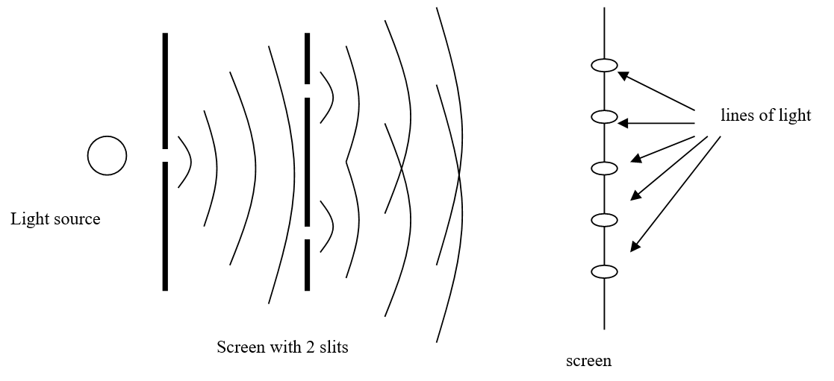
Method: A single light source is placed behind a screen. The light passes through this screen and encounters another, with two slits. A third and final screen is found beyond this one.
(b) What is observed in this experiment?
Observation: A pattern is found on it as shown above. The pattern can only be explained if light is a wave, which diffracts at each of the two slits, and creates an interference pattern as the resulting waves meet.
- How do the observations demonstrate the wave nature of light?
Diffraction and interference are wave characteristics. As the pattern can only be explained as the effects of diffraction and interference, this means that light must travel as a wave
- The eyepiece lens of Huygens’ telescope was a converging lens arranged so as to produce a virtual image. Draw a ray diagram to show how a converging lens can produce a virtual image.

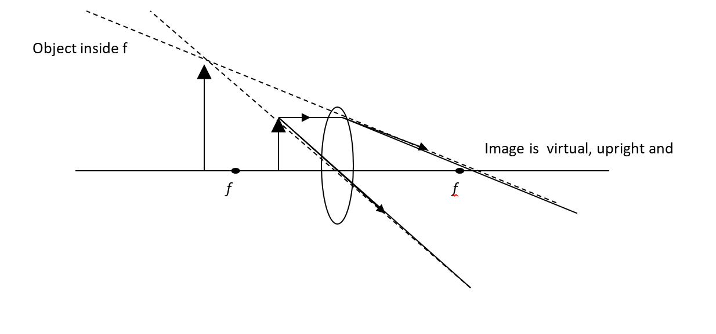
- The pendulum of Huygens’ clock oscillated with a period of 2 s. Calculate the length of this pendulum.
$$T=2π\sqrt{\frac{l}{g}}$$

$$2=2π\sqrt{\frac{l}{9.8}}$$
$$4=4π^{2}\frac{l}{9.8}$$
$$l=\frac{4\left(9⋅8\right)}{4π^{2}}=0.99 m$$

Titan orbits Saturn every 15.9 Earth days. The surface of Titan is 1.16 × 10⁹ m above the surface of Saturn.
- Calculate (a) the mass of Saturn,
radius of Saturn = 58200 km radius of Titan = 2570 km

$$T^{2}=\frac{4π^{2}R^{3}}{GM}$$
R = radius of motion
$R=\left(5⋅82×{10}^{7}\right)+\left(2⋅57×{10}^{6}\right)+(1.16 ×{10}^{9}$) = 1.22$×{10}^{9}$

$M=\frac{4π^{2}{(1.22×{10}^{9})}^{3}}{(6.67×{10}^{-11}){\left(15⋅9×60×60×24\right)}^{2}}={5.69 ×10}^{26}$ kg
(b) the acceleration due to gravity on the surface of Saturn,
$g=\frac{GM}{d^{2}}=\frac{(6.67×{10}^{-11})({5.69 ×10}^{26})}{{\left(5⋅82×{10}^{7}\right)}^{2}}=11.2$ ms⁻²
(c) the period that Huygens’ clock would have on the surface of Saturn.
On Saturn:
$$T=2π\sqrt{\frac{0.99}{11.2}}= 1.87 s$$

Question 14a
- Distinguish between a vector and scalar.
Both vectors and scalars are measurements.
Vectors have both magnitude and direction. Scalars just have magnitude.
- Draw a labelled diagram of the arrangement of the apparatus in an experiment to find the resultant of two vectors.
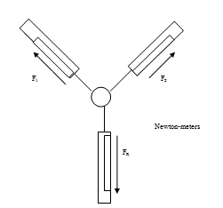
Method:
Set up apparatus as shown.
Note the readings on the first two Newton-meters, F₁ and F₂
Note the reading on the on the third meter, F_{r}
Observation:
According to Newton’s third law, F_{r} should be equal in magnitude but opposite in direction to the resultant of the two upper meters.
In this way you have experimentally measured the value of that resultant
An object is released with an initial velocity of 150 ms^{–1} at an angle of 20° to the horizontal.
- Resolve the velocity into horizontal and vertical components.
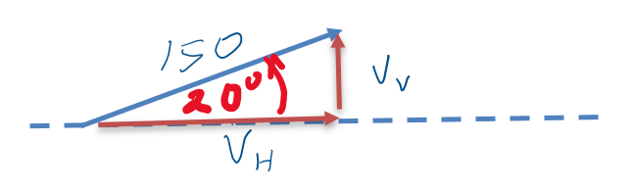
$v_{H}=150\cos{{20}^{0}}=140.95$ ms^{–1}
$v_{v}=150\sin{{20}^{0}}=51.30$ ms^{–1}

- Calculate the magnitude and direction of the velocity of the object after 8 s.
Assuming no friction, the horizontal velocity won’t change. But the vertical velocity will be affected by gravity.
Vertical:
$u=51.3, v=v, a= - 9.8, s=s, t=8$
$$v=u+at=51.3+\left(-9.8\right)\left(8\right)=-27.1$$
Height:
$s=\left(\frac{u+v}{2}\right)t$
$s=\left(\frac{51.3-27.1}{2}\right)\left(8\right)=96.8 m$
This means that after 8 seconds, the object is falling at 27.1 ms^{–1}, but that it still hasn’t hit the ground. It’s horizontal velocity will still be $140.95$ ms^{–1}

Resultant velocity

$$v_{R}^{2}=140⋅{95}^{2}+27⋅1^{2}=20601.31$$

v_{r} = 143.53 ms^{–1}
this is at an angle to the horizontal of $\tan^{-1}{\frac{27⋅1}{140⋅45}}=10.88$º

question 14b
- What is the Doppler effect?
The doppler effect is the apparent change in frequency of a wave due to the relative motion of the source or observer.

- Describe, with the aid of labelled diagrams, how the Doppler effect occurs.
When the source of a wave is stationary, the waves will spread out as concentric circles about the source. But if the source is moving, as shown in the diagram where the source is moving to the right, each wave-front has a different centre. And you can see how the waves become bunched up together in front of the source, creating a higher frequency and become spread out behind it, reducing the frequency.
It is important to note that the Doppler effect applies to all waves and not just to sound waves
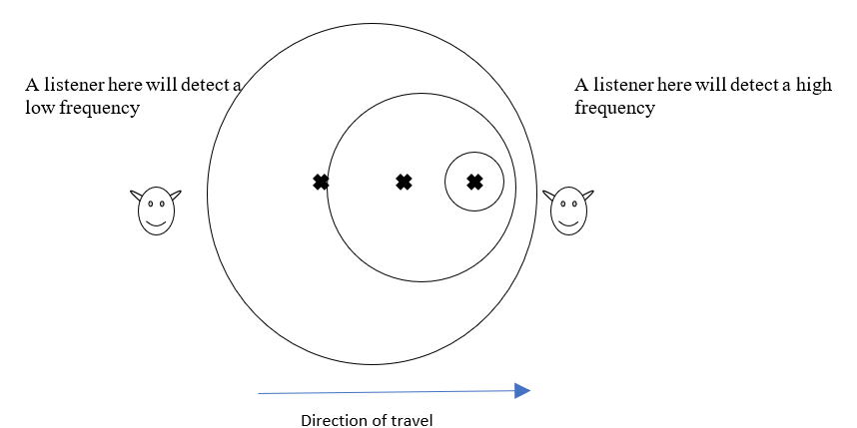
Pierre drops a child’s toy which emits sound of fixed frequency 500 Hz from the top of the Eiffel tower.
- Calculate the frequency Pierre observes after 3 seconds.
As it falls: $u=0, v=v, a=9.8, s=s, t=3$
After 3 seconds: $v=u+at=0+\left(9.8\right)\left(3\right)=29.4$ ms⁻¹
Using the equation for the Doppler Effect:
$f'=\frac{cf}{c+u}=\frac{(340)(500)}{340+29.4}=460.21$ Hz
Pierre would hear a frequency of 460.21 Hz

Question 14c
The explanation of the photoelectric effect by Albert Einstein led to the quantum revolution in physics.
- Describe a laboratory experiment to demonstrate the photoelectric effect.
The effect can be demonstrated by shining UV radiation onto a negatively charged electroscope. The leaves collapse, indicating that the electrons have been released.
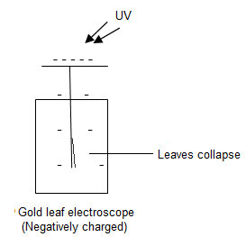
Using a positively charged electroscope, there is no effect.

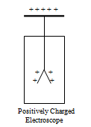
Leaves don’t collapse

Light of wavelength 450 nm is incident on a metal that has a work function of 2.4 eV.
- Calculate the maximum speed of the emitted electrons.
$hf=ϕ+E_{k}$
$f=c/λ={3×{10}^{8}}/{450×{10}^{-9}}=6.67×{10}^{14}$ Hz
Work function:$∅=2.4×1⋅602×{10}^{-19}=3.845×{10}^{-19} J$
Kinetic energy:
$E_{k}=hf-∅=\left(6.626×{10}^{-34}\right)\left(6.67×{10}^{14}\right)-3.845×{10}^{-19}= 5.745×{10}^{-20}$
Also, $E_{k}=\frac{1}{2}mv^{2}$

Therefore: $v=\sqrt{\frac{2E_{\overline{k}}}{m}}= \sqrt{\frac{2(5.745×{10}^{-20})}{9.109×{10}^{-31}}}=355, 160$ms⁻¹

It is observed that as the wavelength of the incident light increases, the speed of the emitted electrons decreases and eventually no electrons are emitted.
- Explain these observations.

Einstein's explanation of the effect was that light consists of tiny particles, little bundles of energy, called photons.
The energy in each photon is given by: E = hf
where f = frequency of light
h = Planck’s constant
Each photon hits one electron and gives its energy to that electron. If the photon contains sufficient energy, i.e. if it is above the work function, Φ, (or the threshold frequency (f_{o})) - the electron can then escape from the metal and travel to the anode.
As each photon can strike only one electron, increasing the energy (or frequency) of the photon does not increase the number of electrons released and therefore, does not affect the current. Any extra energy the photon has is given to the electron as kinetic energy.
In the case mentioned, as the wavelength is increasing, the frequency is decreasing, and the energy of the incident photons is decreasing. This reduces the speed of the electrons as they cross the gap and therefore it reduces the current.
When the frequency falls beneath the threshold frequency, this means that the energy falls below the work function. No electrons escape, and no current flows.

Question 14d
- State the laws of electromagnetic induction.
Faraday’s Laws states that when there is a change in the magnetic flux linking a coil, an emf is induced in that coil. The strength of the emf is proportional to the rate of change of the flux linking the coil.
Lenz’s Law states that the direction of an induced current is such as to oppose the change causing it
A strong magnet is suspended from the end of a string and oscillates in a plane with a constant amplitude.
- Describe what is observed when a sheet of copper metal is placed under the oscillating magnet. Explain this observation.
When the sheet of copper is placed under the magnet, the oscillations will quickly decrease in magnitude and then stop altogether.
- Describe what would be observed if instead of the copper, a sheet of plastic was placed under the oscillating magnet. Explain this observation.
Without the copper there, the oscillations will continue indefinitely. The presence of a plastic sheet will have no effect on it.
The reason why the copper sheet stops the oscillations is due to electromagnetic induction. As the magnet passes, the copper is inside a changing magnetic field.
- this will induce what is known as an eddy current in the metal (where electrons move in small circular patterns within the metal)
- the eddy currents create a magnetic field
- this magnetic field will oppose the motion – in keeping with Lenz’s Law: as a north pole approaches a north pole will be created that will slow the magnet down; when the north pole recedes, a south pole is created that will also slow the magnet.
- on this way, the magnet is quickly brought to rest.
- none of this happens without the copper sheet, so with a plastic sheet the oscillations will continue indefinitely.

As the north pole approaches…

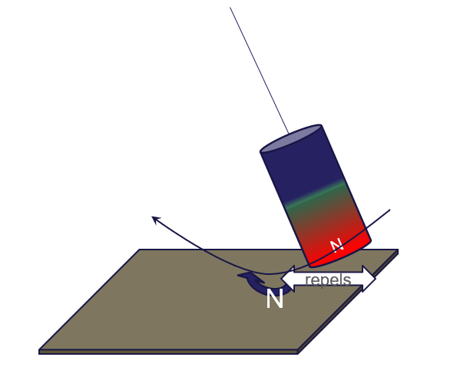
As the north pole recedes, the eddy current switches direction, and….
